MINISTRY OF EDUCATION AND TRAINING

FPT UNIVERSITY
Capstone Project Document

The Platform Provide Shoe Cleaning Service

GFA24SE59
Group Members | Lê Ngô Hiệp Quốc – Team Leader  Nguyễn Minh Hiếu – Member  Phan Danh Ngọc – Member  Hà Thị Phương Thảo – Member
Supervisor | Ms. Trần Ngọc Như Quỳnh
Capstone Project code

Ho Chi Minh, December 2024 –
Table of Contents

Acknowledgement 3
Definition and Acronyms 4
I. Project Introduction 5
1. Overview 5
2. Product Background 5
3. Existing Systems 5
4. Business Opportunity 10
5. Software Product Vision 10
6. Project Scope & Limitations 10
II. Project Management Plan 13
1. Overview 13
2. Management Approach 15
3. Responsibility Assignments 17
4. Project Communications 17
5. Configuration Management 18
III. Software Requirement Specification 19
1. Product Overview 19
2. User Requirements 19
3. Functional Requirements 25
4. Non-Functional Requirements 49
5. Requirement Appendix 49
IV. Software Design Description 59
3. Detail Design 59
4. Ranking Algorithm 84
V. Software Testing Documentation 84
1. Scope of Testing 84
2. Test Strategy 87
3. Test Plan 88
4. Test Cases & Test Reports 89
VI. Release Package & User Guides 90
1. Deliverable Package 90
2. Installation Guides 90
3. User Manual 93

Acknowledgement
We would like to begin by expressing our heartfelt gratitude to Ms. Trần Ngọc Như Quỳnh for her unwavering guidance and support throughout the implementation of this project. Her insightful suggestions and invaluable recommendations have greatly contributed to enhancing the overall quality of our work.
Our deepest thanks also go to the dedicated lecturers of FPT University, whose profound knowledge and guidance have been instrumental in shaping our learning journey. In particular, we extend our sincere appreciation to Mr. Lâm Hữu Khánh Phương, Mr. Nguyễn Thế Hoàng, Mr. Nguyễn Trọng Tài, Ms. Nguyễn Thị Cẩm Hương, Mr. Đỗ Tấn Nhàn, and all other lecturers who generously shared their expertise. Their constructive feedback and encouragement have been crucial in helping us identify and address our mistakes, ultimately enabling us to complete this project successfully.
We are deeply grateful to our families and friends for their constant support and encouragement. Their unwavering belief in us has been a source of strength during the most challenging times of this journey.
Finally, we would like to acknowledge that, as this project is our first major project, our lack of experience and familiarity with some technologies may have resulted in errors or shortcomings. We sincerely hope for your understanding and forgiveness for any mistakes we may have made.
Thank you all for your dedication and collaboration over the past four months. Your contributions have been invaluable, and we deeply appreciate the commitment and teamwork that made this journey possible.
With sincere thanks and best regards,

Definition and Acronyms
Acronym | Definition
BR | Business Rule
ERD | Entity Relationship Diagram
GUI | Graphical User Interface
PM | Project Manager
SDD | Software Design Description
SPMP | Software Project Management Plan
SRS | Software Requirements Specification
UAT | User Acceptance Testing
UC | Use Case
API | Application Programming Interface
FE | Feature
LI | Limitation
UI | User Interface
SI | Software Interface
CR | Common Requirement
MSG | Message
Table 1 - Definition and Acronyms

I. Project Introduction

1. Overview

1.1 Project Information
- Project name: The Platform Provides Shoe Cleaning Services
- Project code:
- Group name:
- Software type: Web App

1.2 Project Team
Full Name | Role | Email | Mobile
Tran Ngoc Nhu Quynh | Lecturer
Le Ngo Hiep Quoc | Leader
Nguyen Minh Hieu | Member
Phan Danh Ngoc | Member
Ha Thi Phuong Thao | Member

2. Product Background
The market for shoe care has expanded dramatically in recent years, and many stores now provide shoe care and cleaning services. The absence of a unified platform to link various services, however, is a significant problem for retailers as well as customers. Customers frequently have to look for specific establishments, which makes comparing offerings, costs, and wait times inconvenient. Shops also have difficulties effectively handling orders and expanding their consumer base. The demand for a centralised solution from both retailers and customers gave rise to the concept for this platform. Customers demand a platform that makes it simple for them to swiftly and transparently search for, compare, and schedule shoe care services. However, to scale their business, manage orders, and simplify services, retailers require a tool.

3. Existing Systems

3.1 Giffan
Brief Description: Giffan is an online shoe sales platform in Vietnam, specialising in selling shoes and providing professional shoe care services. It offers a wide variety of shoes with many different designs, and also provides high-quality shoe cleaning, care and repair services.
Website: https://giffan.vn/
System Actors:
- Customers
- Staff
- Administrators

Features:
- Shoe Sales: The platform provides a wide variety of shoe designs, meeting most of the needs of customers.
- Shoe Cleaning Services: Providing professional shoe cleaning packages for all types of shoes, using the best tools, solutions and methods for customers.
- Shoe care service: Service used to care for and help restore shoes that are in poor condition, helping the shoes become newer and more durable.
- Order Tracking: Customers can track the status of their shoe purchases or shoe care service orders from the time of ordering until the completion of delivery.
Pros:
- Comprehensive shoe care service: Including cleaning, restoration and care, helping customers' shoes always be in the best condition and most durable.
- Diverse Shoe Selection: A full range of shoe types, colours and sizes, meeting most of customers' purchasing needs.
- Professional Customer Support: A team of experienced staff is always ready to advise on how to choose shoes, care and maintain shoes.
Cons:
- Long Waiting Times: Shoe cleaning, care and restoration services can take a long time to complete, especially for complex shoes such as leather shoes.
- High Cost for Premium Services: Premium cleaning or care services can be expensive and do not include shipping costs, making them difficult for many customers on a tight budget.
How this Informs " Shoe Cleaning and Restoration Management ":
- Comprehensive Services: Can be expanded to bundled care packages, where customers can choose long-term service packages when purchasing shoes or services.
- Order Tracking: Enables order tracking, which can be improved to detail the steps from when the order is placed until the customer receives the finished product. This helps customers know exactly where their order is.
- Subscription-Based Services: Offer incentives to long-term customers with various privileges and benefits corresponding to each milestone.

3.2 HERAMO
Brief Description: HERAMO is an online service that specialises in shoe care and cleaning, making sure that clients' shoes are kept spotless and in optimal condition. The majority of shoe varieties, including leather and high-end shoes, are cleaned and restored by HERAMO. HERAMO uses expert techniques to get shoes back to almost like-new condition while guaranteeing that the quality lasts a long time.
Website: https://heramo.com/
System Actors:
- Customers
- Staff
- Administrators

Features:
- Shoe cleaning: In-depth cleaning services that revitalise worn-out shoes by eliminating stubborn stains.
- Maintenance: Upkeep and repair services, such as minor repairs and leather replenishment.
- Pickup and delivery: To save clients time, HERAMO provides door-to-door pickup and return services.
- Care consultation: The personnel offer suggestions on how to maintain shoes to increase their longevity.
Pros:
- Expert maintenance guarantees that shoes are constantly in optimal shape. convenient customer pickup and return service.
- Employs environmentally responsible practices and shoe-friendly materials.
- Knowledgeable employees equipped to handle designer footwear.
Cons:
- Specialty shoes may come with hefty service fees.
- Processing time is contingent upon the state of the shoe and the kind of care needed.
- Major cities are the primary focus of service coverage.
How this informs "Shoe Cleaning and Maintenance Management":
- Increases the effectiveness of shoe maintenance using high-quality goods and cutting-edge techniques.
- Enhances client trust by expert assistance and high standards of excellence.
- Offers advice and consulting on shoe maintenance, assisting clients in making well-informed preservation decisions.
- Constantly enhances maintenance procedures to guarantee the highest level of service quality.

3.3 ShoeWash
Brief Description: In Canada, ShoeWash is a specialty service provider that specialises in expert shoe maintenance, restoration, and cleaning. From high-end shoes to casual sneakers, the company makes sure that all kinds of footwear receive the best possible care by using eco-friendly ingredients and industry-leading processes. It offers professional cleaning and restoration services to people who want to prolong the life of their shoes.
Website: https://shoewash.ca/
System Actors:
- Customers
- Staff (Shoe cleaning and restoration specialists)
- Administrators
- External Partners (Suppliers, Consultants)

Features:
- Shoe Cleaning & Restoration: Complete services for all types of shoes that include stain removal, deep cleaning, and restoration.
- Eco-Friendly Products: Non-toxic, environmentally safe cleaning agents that are safe for shoes and the surroundings are used.
- Pickup & Delivery Service: Within service regions, consumers can conveniently have their shoes picked up and delivered right to their doorstep.
- Shoe customization: Recolouring or material repairs to give worn-out shoes a new appearance are examples of customization services.
Pros:
- A broad range of footwear can be cleaned and restored with special knowledge.
- Eco-friendly goods encourage safety and sustainability.
- Customers save time with convenient pickup and delivery services.
- Options for customization improve the appearance and durability of shoes.
Cons:
- The availability of services could be restricted to particular regions within Canada.
- Some clients might find the premium pricing prohibitive.
- Extended periods for intricate restorations or personalization.
- Offers a methodical and environmentally sustainable approach to shoe restoration and upkeep.
- Uses specialist processes to provide a high-quality output, increasing client happiness.
- Provides additional convenience through pickup and delivery, boosting customer experience.
- Consistent use of environmentally friendly items is consistent with rising environmental awareness.
How this Affects "Shoe Cleaning and Restoration Management":
- Offers an organised and environmentally responsible method for preserving and repairing footwear.
- Deliveries and pickups provide more convenience and enhance the client experience.
- Makes use of specific methods to guarantee an excellent outcome and raise client delight.
- Consistently using environmentally friendly items is in line with rising environmental awareness.

3.4 Thumbtack
Brief Description: Thumbtack is a service marketplace that links clients with nearby experts in a range of fields, such as events, wellness, and home renovation. The website makes it easier for customers to hire specialists for a range of services by assisting them in finding reliable individuals for activities.
Website: https://www.thumbtack.com/
System Actors:
- Customers
- Service Providers (Professionals)
- Administrators
- External Partners
Features:
- Service Matching: Using sophisticated algorithms, clients and experts are matched according to project specifications, budget, and geography.
- Customer Reviews & Ratings: Verified customer reviews and ratings assist users in selecting trustworthy professionals.
- Booking & Payment: The platform offers easy scheduling and payment alternatives.
- Business Tools for Professionals: Professionals can utilise various business management tools such as invoicing, reputation development, and customer communication.
Pros:
- A wide range of services are offered by numerous sectors.
- Transparent customer evaluations and reviews increase confidence in the calibre of the services.
- User-friendly platform with direct payment and scheduling tools.
- Professionals can efficiently manage clients with the use of business tools.
Cons:
- Service quality varies depending on the professional, thus ratings must be carefully considered.
- Restricted to specific geographical areas, potentially limiting the accessibility of services.
- Professional fees may have an impact on the cost.
- Makes it easier and more dependable for clients to get in touch with nearby experts.
- Ongoing platform improvements help keep the marketplace competitive and responsive to user needs.
How this Affects "Service Marketplace Management":
- Enables a dependable, efficient method of matching clients with nearby experts.
- Client testimonials and ratings promote credibility and support high-quality service.
- Professionals and customers alike benefit from effective business tools.
- Constant platform enhancements support the market's ability to remain competitive and user-responsive.

3.5 Conclusion
In summary, existed providers are doing well in their service such as supporting 2-way shoe transportation, diversity service and support advisory for the customer. However, it also comes with certain limitations. First, most of the providers are small, individual businesses, which limits their regional coverage, making it challenging to reach a broader customer base. Second, the platform lacks a rating and feedback system from previous bookings, which deprives new customers of valuable insights into the quality of products and services. Lastly, the platform does not specialise in shoes, resulting in a limited range of services tailored to footwear care and customization.

4. Business Opportunity
From the needs of provider and customer, the Platform Provides Shoe Cleaning Services was born with the aim of creating a bridge between customers and stores through a direct platform, helping users to easily search for stores and services that suit their needs, easily compare different services and stores, have a quick look through reviews and save time searching. Stores can reach more customers, easily track orders, increase profits and reputation, and optimize promotional and operational processes. The platform not only meets the increasing demand for shoe-related services, but also creates conditions for small retail stores to become popular and develop. Therefore, this is an opportunity for The Platform Provides Shoe Cleaning Services to initially approach this potential market.

5. Software Product Vision
For the service provider, the platform not only provides a place to advertise their service which help they attract potential customer and build their own brand business but also provide a powerful tool that help they manage their listings, promotions, services, orders and optimize operating process to grow their business. On the other hand, the platform gives customer a market where they can easily find service for their needs, tool to track their service order and the overall feedback and rating system helps improve service quality which ensure the highest users’ demand.

6. Project Scope & Limitations

6.1 Major Features
Guest:
- FE-01: Login by platform’s account, OTP code or Google account.
- FE-02: Register to become customer or owner.
- FE-03: Reset password.
- FE-04: View, search all available shoe service information such as basic cleaning, deep cleaning, specialised cleaning for different shoe materials (e.g., leather, suede), …
- FE-05: View, search all available Service Providers information of the platform.
Customer:
- FE-06: Manage personal information:
- View personal information.
- Update personal information.
- Disable account.
- Owner register.
- FE-07: Manage personal service order:
- View service order.
- Create new service order.
- Update service order.
- Cancel service order.
- View service order history.
- Feedback a finished service order.
- FE-08: View personal feedback.
- FE-09: Display information about service's promotion.
- FE-10: Manage personal cart:
- Add new service to cart.
- Update cart.
- Remove service from cart.
- FE-11: Notify to customer through email about their orders, support ticket.
- FE-12: Provide a Customer Support System:
- View personal ticket.
- Create a new ticket
- Cancel a ticket.
Owner, Employee:
- FE-13: Provide business dashboard contain statistic of: profit, order, feedback rating.
- FE-14: Manage business’s information.
- FE-15: Manage business’s services:
- View services.
- Add new service.
- Update service.
- Disable service.
- View material.
- Create material.
- Update material.
- Disable material.
- Create promotion.
- Update promotion.
- Disable promotion.
- FE-16: Track and manage customer orders, including status and order history.
- FE-17: Provide a statistic screen of business such as profit, order amount.
- FE-18: Provide a support system for reporting violations or support issues that arise.
- FE-19: Allow to view business transaction.
- FE-20: Register business’s subscription:
- FE-21: Manage business’s branch:
- View branches.
- Add new branch.
- Update branch.
- Disable branch.
- FE-22: Manage business’s employee:
- View employees.
- Add new employee.
- Delete employee.
- Assign employee to branch.
- FE-23: Support multiple banking payment:
- VnPay.
- MoMo.
- FE-24: GHN Shipping integration.
Moderator:
- FE-25: Manage support ticket:
- View platform support tickets.
- Assign support ticket.
- Update support ticket.
- FE-26: Validate service feedback.
Admin:
- FE-27: Provide platform dashboard contain statistic of: profit, user, order
- FE-28: Manage platform transaction:
- View platform transactions.
- Create transaction.
- Update transaction.

- FE-29: Manage system user:
- View platform’s user information.
- Create new Moderator user.
- Update user status.
- FE-30: Provide a statistic dashboard about platform information such as booking, posting, profit, raising, log, ...
- FE-31: Manage platform settings:
- Manage platform’s provider subscription pack: view, create, update fee.
- Manage platform’s provider feature pack: view, create, update fee.
- FE-32: Manage word blacklist for feedback validation:
- Add new word to blacklist.
- Delete word from blacklist.
- Export blacklist to excel file.
- Import blacklist from file.

6.2 Limitations & Exclusions
LI-1: The original system was limited to accepting online payments only VnPay and MoMo.
LI-2: There are no multilingual variations of the initial version; it only supports Vietnamese.
LI-3: The ability to log into via third party system is not widely supported by the present system. Users can only access the system by registering an account or logging in via Google.

II. Project Management Plan

1. Overview

1.1 Scope & Estimation
# | WBS Item | Complexity |  | Est. Effort  (man-days)
1 | Requirement analysis |  |  | 7
1.1 | Analyze the context and background of the product | Medium |  | 1
1.2 | Research and analyze existed system | Simple |  | 1
1.3 | Define the user requirement and business process | Complex |  | 3
1.4 | Analyze the business opportunity | Medium |  | 2
2 | Technical Learning |  |  | 14
2.1 | Learn CI/CD tool and third-party | Medium |  | 14
3 | Design database |  |  | 6
3.1 | Design concept model | Medium |  | 3
3.2 | Design logical model (ERD) | Medium |  | 2
3.3 | Design physic model (Database) | Medium |  | 1
4 | Document writing |  |  | 26
4.1 | Project Introduction Report | Medium |  | 2
4.2 | Project Management Plan Report | Medium |  | 3
4.3 | Software Requirement Specification Report | Complex |  | 5
4.4 | Software Design Document Report | Complex |  | 5
4.5 | Test Document Report | Complex |  | 7
4.6 | Software User Guide Report | Simple |  | 1
4.7 | Final Project Report | Medium |  | 3
5 | Client User Interface Design |  |  | 10
5.1 | Design web UI | Complex |  | 10
6 | Implement User Interface |  |  | 20
6.1 | Implement web UI | Complex |  | 20
7 | Implement Administrator Features |  |  | 12
7.1 | Manage user feature | Medium |  | 2
7.2 | Manage platform feature |  |  | -
7.2.1 | Manage subscription pack feature | Medium |  | 2
7.2.2 | Manage feature pack feature | Medium |  | 2
7.3 | Manage platform transaction feature | Medium |  | 2
7.4 | Manage support ticket feature | Medium |  | 2
7.5 | Validate feedback feature | Medium |  | 3
8 | Implement Client Features |  |  | 29
8.1 | Authentication/Authorization features | Medium |  | 2
8.2 | Manage business information feature |  |  | -
8.2.1 | Manage promotion features | Medium |  | 2
8.2.2 | Manage subscription features | Medium |  | 2
8.2.3 | Manage service features | Medium |  | 2
8.3 | Manage order features | Medium |  | 2
8.4 | Manage feedback features | Medium |  | 2
8.5 | Manage account’s information features | Simple |  | 1
8.6 | Manage cart feature | Medium |  | 2
8.7 | Manage payment feature | Complex |  | 7
8.8 | Chatting | Complex |  | 7
9 | Deploy System |  |  | 4
9.1 | Deploy front-end | Medium |  | 2
9.2 | Deploy back-end | Medium |  | 2
10 | Testing |  |  | 15
10.1 | Unit test | Medium |  | 3
10.2 | Integration Test | Complex |  | 5
10.3 | System test | Complex |  | 7
11 | Improvement | - |  | 14
11.1 | Fixing Bugs | Medium |  | 7
11.2 | Implement Addition Features | Medium |  | 7
12 | Closing |  |  | 10
11.1 | Maintaining | Medium |  | 7
11.2 | Prepare slide for thesis defence | Medium |  | 3
Total Estimated Effort (man-days) |  |  | 163

1.2 Project Objectives
# | Testing Stage | No. of Defects | % of Defect | Notes
1 | Unit Test | <10 | 10%
2 | Integration Test | <20 | 30%
3 | System Test | <15 | 15%

1.3 Project Risks
# | Risk Description | Impact | Possibility | Response Plans
1 | The team identifies too many features or requirements at the start, making the project too large to complete within time and resource limits. | High | Low | Discuss with mentor about the scope of the topic
2 | Failing to prioritize tasks lead us to inefficient use of time and resources, where critical tasks may be delayed, while less important tasks consume valuable resources. | High | Medium | Regularly review and adjust task priorities as the project progresses.
3 | Delays in task completion or unexpected issues can cause the project to fall behind schedule, potentially missing critical deadlines. | High | High | Forecast factors that could cause delays and create plans to address them before they become major issues.

2. Management Approach

2.1 Project Process
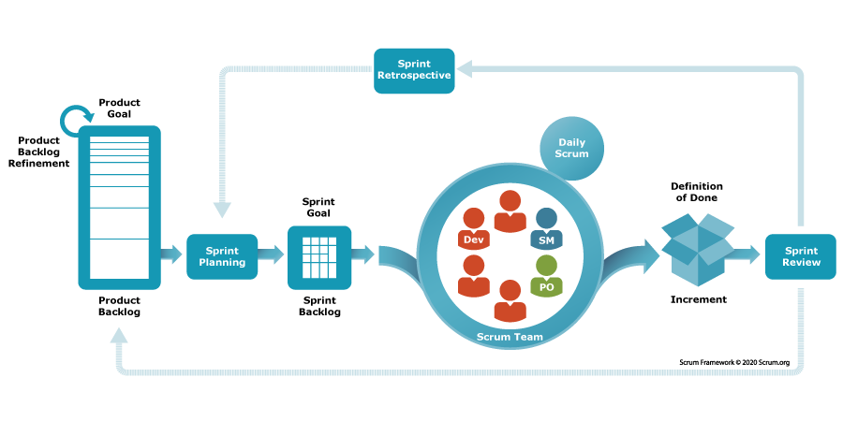
Scrum Framework Process Picture
The TP4SCS project is implemented by using the Scrum framework, the software development process model base on the Agile methodology due to several advantages reasons:
- First, because of being reviewed and feedback frequently by mentor and council, the requirement of the project will be changed continuously. So that the flexibility and adaptability characteristic of Scrum model will help the team to change goals or product requirements in the development process easily.
- Second, this is a large-scale project contain many complex and hard task to do. By break down and focus on small part makes it easier for the team to handle and fix errors early, which lead to the quality increment of the final release.
- Last, project have to review frequently and require done in a specified time, which require a continuously performance of the team. Because of this, the team need to meetings regularly to create a clear working process and stay informed.

2.2 Quality Management

2.2.1 .NET Coding Conventions
Convention of name:
- For the variable's name, use camelCase. Example: routeType, nextStation,etc.
- For function name, class name, use PascalCase. Example: GetAllStations, GetCurrentLocation, etc.
- Use meaningful names for variables.
- Avoid using Abbreviations. Example: use: UserGroup userGroup, do not use: UserGroup usrGrp
- Do use noun or noun phrases to name a class.
- Do prefix interfaces with the letter I.
Convention of layout:
- Write only one statement/declaration per line.
- Indent continuation one tab stop (four spaces).
- Add at least one blank line between method definitions and property definitions.
- Use parentheses to make clauses in an expression apparent.
Using C# Code Convention From: C# Convention

2.2.2 React Coding Conventions
Convention of name:
- Use PascalCase for React component names (ex: MyComponent.jsx).
- Use uppercase letters and underscores to assign constants. (ex: const MAX = 10; )
- Function and method names use camelCase
Convention of layout:
- Do not let a line be longer than 80 characters.
- Place the flow control statements in curly braces.
- Format code using React format
Using React Code Convention From: React Convention

2.3 Training Plan
Training Area | Participants | When, Duration | Waiver Criteria
Working Process | All Members | Week 1, 1 Days | Mandatory
GitHub | All Members | Week 5, 1 Days | Mandatory
Firebase | All Members | Week 4, 7 Days | Mandatory

3. Responsibility Assignments
Responsibility | QuocLNH | NgocPD | HieuNM | ThaoHTP
Back-End for system | x |  | x
Front-End for web |  | x |  | x
Server |  |  | x
Others | x | x | x | x

4. Project Communications
Communication  Item | Who/ Target | Purpose | When, Frequency | Type, Tool, Method(s)
Team  Collaboration | All Members | Discuss project documents and code | Daily  (5 days/week) | Google Docs, Discord, Github, Messenger, Face-to-face meetings
 |  | Coordinate remote work activities |  | Face-to-face meetings, Discord, Messenger
 |  | Share opinions and address challenges
 |  | Report daily work status to the project leader |  | Google Sheet, Discord
Advisor  Consultations | Mentor | Review project documentation and code | Weekly  (2 days/week) | Face-to-face meetings, Google Meet, Zalo, Email
 |  | Provide guidance and orientation for project objectives
 |  | Offer constructive feedback on project developments
 |  | Assess overall project progress and results
Team  Retrospectives | All Members | Reflect on project performance and teamwork | Weekly | Face-to-face meetings, Discord
Team  Collaboration | All Members | Discuss project documents and code | Daily (5 days/week) | Google Docs, Discord, Github, Messenger, Face-to-face meetings

5. Configuration Management

5.1 Document Management
We use Google Drive to organize and store project documentation:
- All diagrams, images, report files and media files are uploaded into categorized folders to ensure easy access and efficient management.
- Only authorized team members can access. Regular backups ensure data security and protection.
- Turn on version history to keep track of changes, restoring previous iterations and identifying the creators and dates of updates.

5.2 Source Code Management
We use GitHub to store source code and divide it into Front-end and Back-end, Mobile sources. It allows members to collaborate on source code efficiently and conveniently and easily resolve conflicts, especially useful when looking back and quickly identifying changes that members have made.
We set these rules when using Git:
- Consider carefully and take responsibility before pushing code to the repository.
- Take detailed, clear notes when pushing code to the repository.
- Fetch, review, and resolve common merge conflicts.
- Promote frequent code pushes to reduce complicated conflicts.
- To ensure security and quality, impose code reviews and limit write access to important branches.

5.3 Tools & Infrastructures
Category | Tools / Infrastructure
Technology | React 18.3.1 (Front-end), ASP.NET 8 (Back-end)
Database | SQLServer
IDEs/Editors | Visual Studio Code, Visual Studio 2022
Diagramming | DrawIO
Documentation | Microsoft Office, Google Docs/Sheets
Version Control | GitHub (Source Code), Google Drive (Documents)
Deployment server | Vietnix, Vercel
Project management | Google Sheets, Jira

III. Software Requirement Specification

1. Product Overview
The shoe cleaning service platform is a system that connects consumers and businesses that provide shoe care and cleaning services. Providing cleaning services based on the needs of customers is made simple with an easy-to-use ordering system. Service providers can become suppliers on the system and promote their services online by purchasing packages.
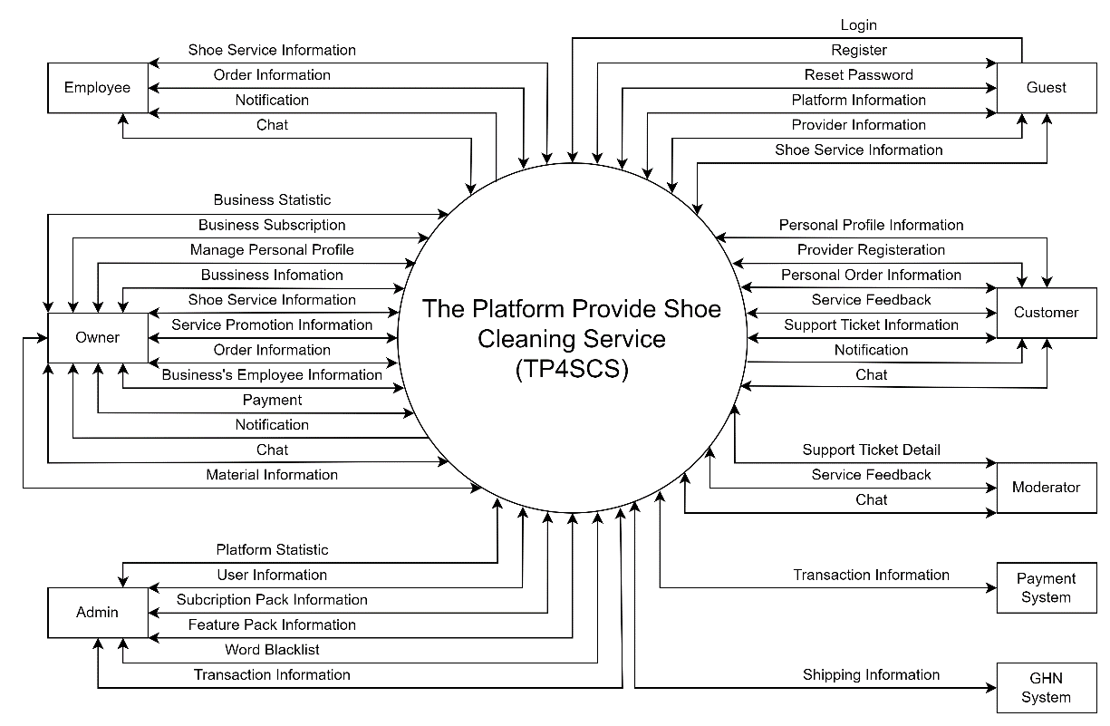

2. User Requirements

2.1 Actors
# | Actor | Description
01 | Admin | The administrator is responsible for managing the system related to managing accounts in the system including the accounts of: Moderator, Shop Owner, Employee, Customer. As well as managing ranking, subscription and transaction.
02 | Moderator | Moderator is responsible for managing and resolving complaints from Shop Owners and Customers.
03 | Owner | Owners can manage their business information, view and manage employee information, manage services and promotions.
04 | Employee | A business's employee is authorized to track and process orders, as well as advise customers.
05 | Customer | Customers are people who use the functions on the platform such as: Becoming a shop owner, managing personal information, managing shopping carts and orders, receiving notifications from the platform as well as managing feedback and support ticket.
06 | Guest | Guest are are customers who can visit the application without login.

2.2 Use Cases

2.2.1 Diagram(s)
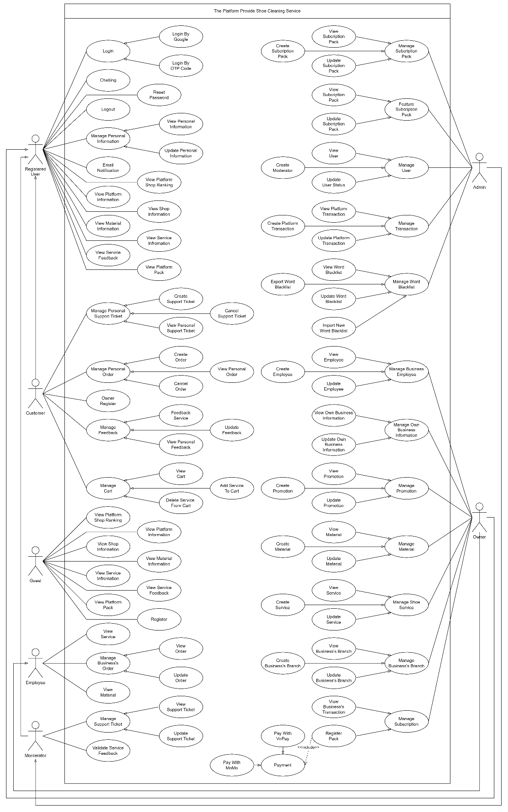

2.2.2 Descriptions

2.2.2.1 Guest:
# | Use Case | Actors | Use Case Description
01 | Register | Guest | Register a customer or owner account to login to system
02 | View Platform Shop Ranking | Guest | View platform’s top 10 performance of business by month
03 | View Shop Information | Guest | View shop profile information of the platform
04 | View Service Information | Guest | View service information of the platform
05 | View Material Information | Guest | View service list of material information
06 | View Service Feedback | Guest | View service’s feedback information of the platform
07 | View Platform Pack | Guest | View platform subscription pack and feature information
08 | View Platform Information | Guest | View the specific information of the platform

2.2.2.2 Customer:
# | Use Case | Actors | Use Case Description
01 | View Personal Support Ticket | Customer | View account sent support ticket information
02 | Create Support Ticket | Customer | Create new support ticket
03 | Cancel Support ticket | Customer | Cancel pending support ticket
04 | View Personal Order | Customer | View account service order information
05 | Create Order | Customer | Create service order
06 | Cancel Order | Customer | Cancel pending service order
07 | Owner Register | Customer | Register to become business’s owner in the platform
08 | View Personal Feedback | Customer | View sent service feedback information
09 | Feedback Service | Customer | Create new ordered service feedback
10 | Update Feedback | Customer | Update sent service feedback
11 | View Cart | Customer | View personal cart information
12 | Add To Cart | Customer | Add more service to personal cart
13 | Delete To Cart | Customer | Remove service from personal cart

2.2.2.3 Registered User:
# | Use Case | Actors | Use Case Description
01 | Login | Customer,  Owner,  Employee,  Moderator,  Admin | Login to the system with registered account
02 | Login By Google | Customer,  Owner,  Employee,  Moderator,  Admin | Login to the system with Google account
03 | Login By OTP Code | Customer,  Owner,  Employee,  Moderator,  Admin | Login to the system with OTP code
04 | Logout | Customer,  Owner,  Employee,  Moderator,  Admin | Logout the platform
05 | Reset Password | Customer,  Owner,  Employee,  Moderator,  Admin | Reset password without login by sending reset link through email
06 | View Personal Information | Customer,  Owner,  Employee,  Moderator,  Admin | View account profile information
07 | Update Personal Information | Customer,  Owner,  Employee,  Moderator,  Admin | Update account profile information
08 | Chatting | Customer,  Owner,  Employee,  Moderator,  Admin | Chatting with others using platform chat system
09 | Email Notification | Customer,  Owner,  Employee,  Moderator,  Admin | Send platform notification through email

2.2.2.4 Owner:
# | Use Case | Actors | Use Case Description
01 | View Own Business Information | Owner | View own information of registered business
02 | Update Own Business Information | Owner | Update own information of registered business
03 | View Promotion | Owner | View service’s promotion information
04 | Create Promotion | Owner | Create service’s promotion
05 | Update Promotion | Owner | Update service’s promotion information
06 | View Material | Owner | View service’s material information
07 | Create Material | Owner | Create new service material
08 | Update Material | Owner | Update service’s material information
09 | View Service | Owner | View business’s service information
10 | Create Service | Owner | Create new service for business
11 | Update Service | Owner | Update business’s service information
12 | View Business’s Branch | Owner | View business’s branch information
13 | Create Business Branch | Owner | Create new branch for business
14 | Update Business Branch | Owner | Update business’s branch information
15 | View Business’s Employee | Owner | View business’s employee information
16 | Create Business Employee | Owner | Create new employee for business
17 | Update Business Employee | Owner | Update business’s employee information
18 | View Business’s Transaction | Owner | View processed business’s transaction information
19 | Register Pack | Owner | Register a subscription pack or feature pack in the platform
20 | Pay With VnPay | Owner | Process payment using VnPay
21 | Pay With MoMo | Owner | Process payment using MoMo

2.2.2.5 Employee:
# | Use Case | Actors | Use Case Description
01 | View Service | Employee | View branch’s available service information
02 | View Material | Employee | View service’s available material information
03 | View Order | Employee | View branch’s order information
04 | Update Order | Employee | Update branch’s order information

2.2.2.6 Moderator:
# | Use Case | Actors | Use Case Description
01 | View Support Ticket | Moderator | View platform’s sent support ticket information
02 | Update Support Ticket | Moderator | Update support ticket information
03 | Validate Service Feedback | Moderator | Validate content and asset of service feedback

2.2.2.7 Admin:
# | Use Case | Actors | Use Case Description
01 | View Subscription Pack | Admin | View platform’s subscription pack information
02 | Create Subscription Pack | Admin | Create new subscription pack
03 | Update Subscription Pack | Admin | Update platform’s subscription pack information
04 | View Feature Pack | Admin | View platform’s feature pack information
05 | Update Feature Pack | Admin | Update platform’s feature pack information
06 | View User | Admin | View platform’s user account information
07 | Create Moderator | Admin | Create new moderator account for platform
08 | Update User Status | Admin | Update platform’s user account status
09 | View Platform’s Transaction | Admin | View platform’s transaction information
10 | Create Platform’s Transaction | Admin | Create new transaction
11 | Update Platform’s Transaction | Admin | Update platform’s transaction information
12 | View Word Blacklist | Admin | View platform’s word blacklist
13 | Export Word Blacklist | Admin | Export word blacklist to excel file
14 | Update Word Blacklist | Admin | Update platform’s word blacklist
15 | Import New Word Blacklist | Admin | Import new word blacklist to the platform

3. Functional Requirements

3.1 System Functional Overview

3.1.1 Screen Flow

3.1.1.1 Guest Screen Flow
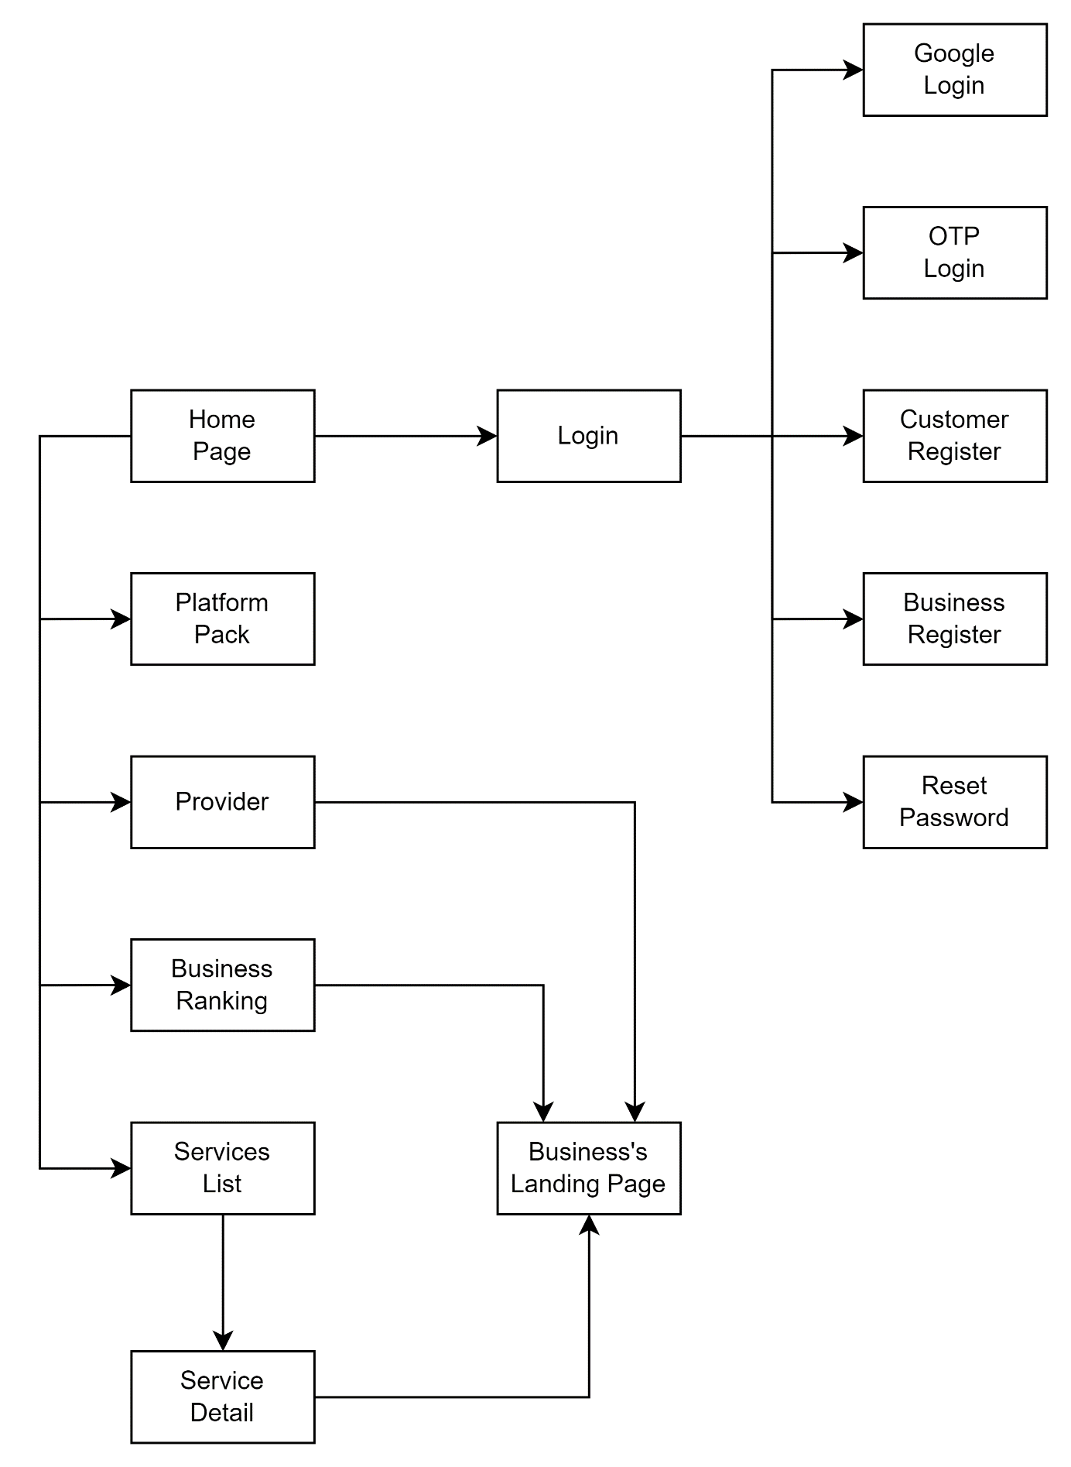

3.1.1.2 Admin Screen Flow
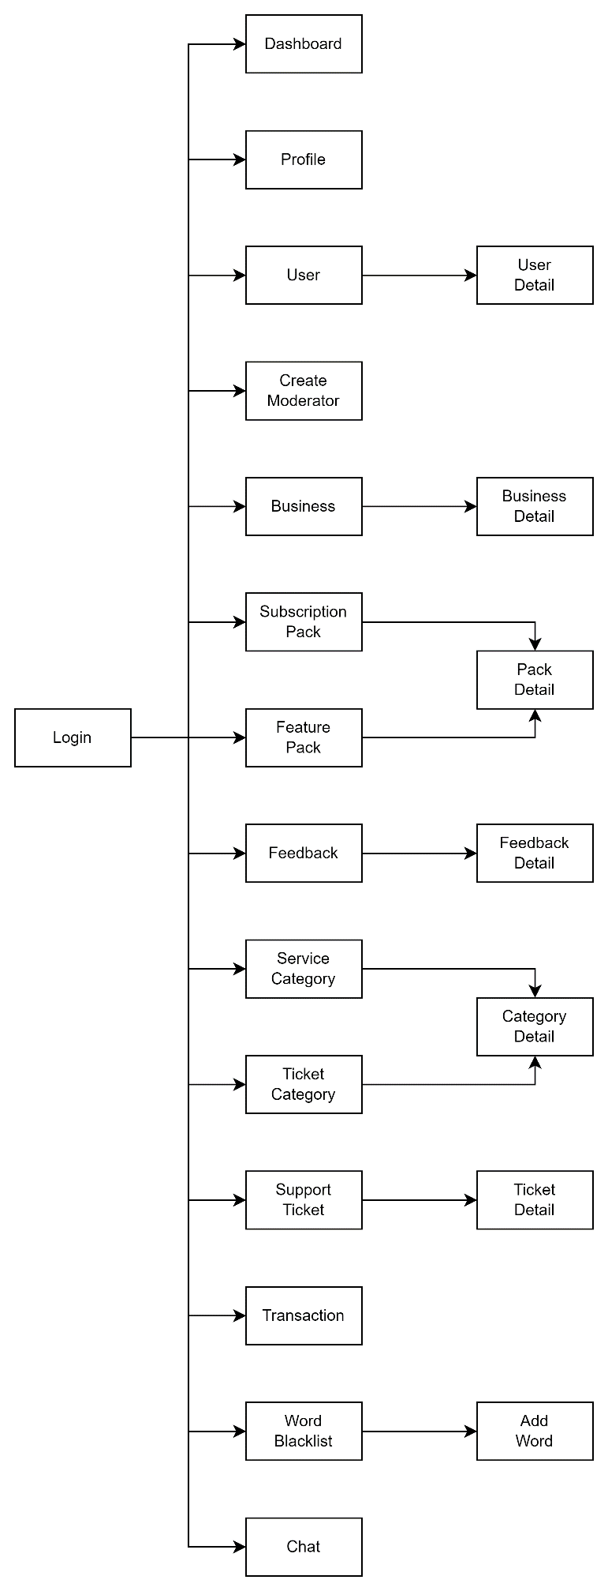

3.1.1.3 Business Screen Flow
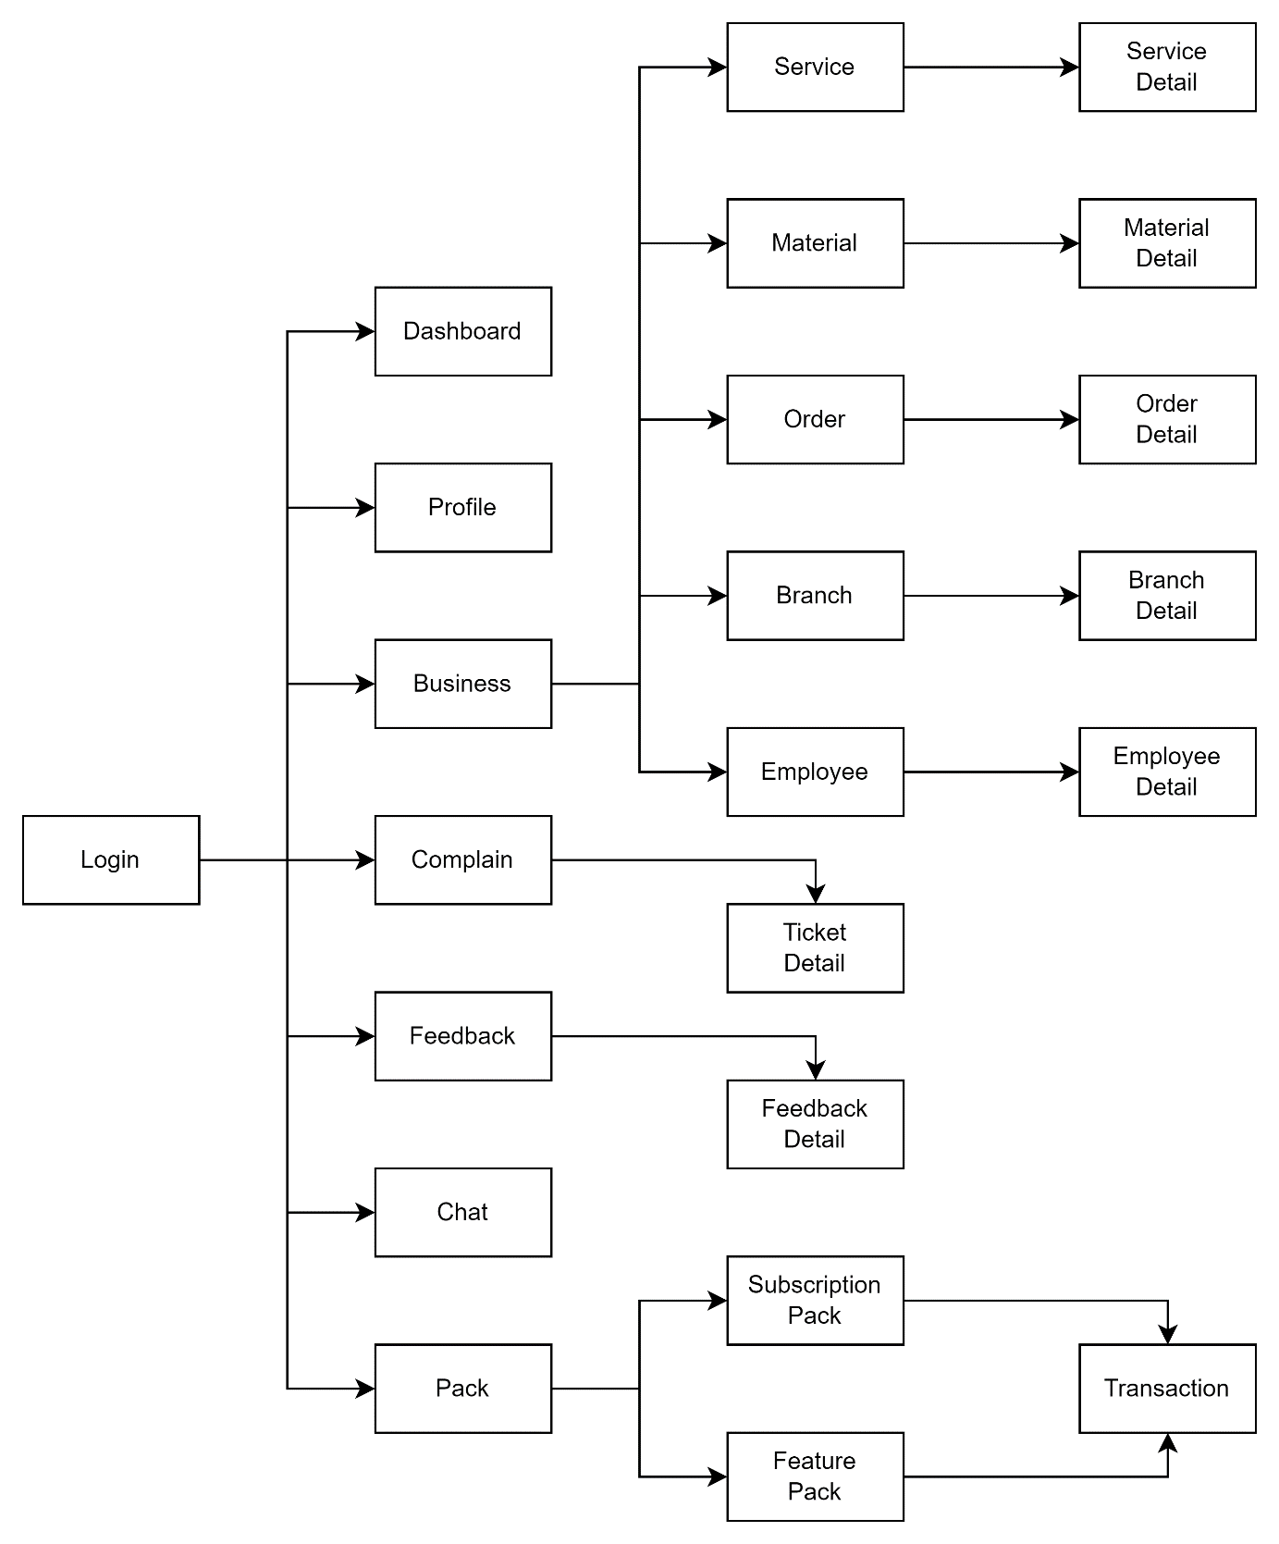

3.1.1.4 Customer Screen Flow
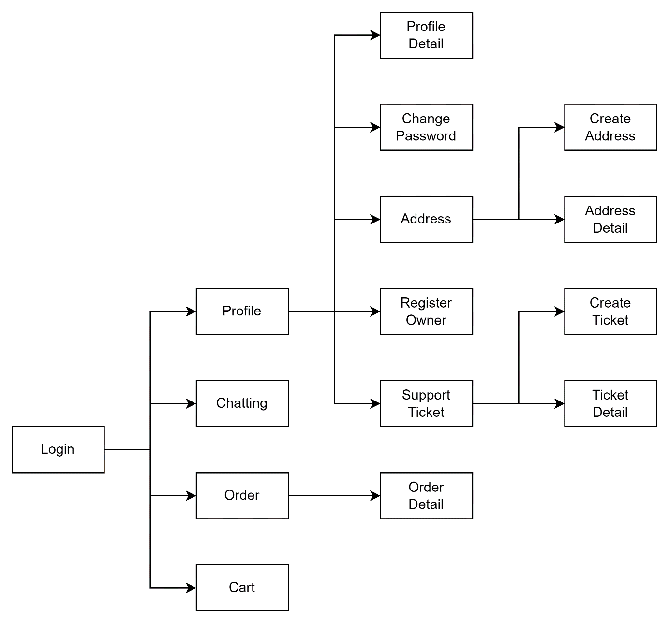

3.1.2 Screen Authorization
Screen | Guest | Customer | Owner | Employee | Moderator | Admin
Home Page | X | X | X | X | X | X
Platform Pack | X | X | X | X | X | X
Provider | X | X | X | X | X | X
Business Ranking | X | X | X | X | X | X
Business’s Landing Page | X | X | X | X | X | X
Service List | X | X | X | X | X | X
Service Detail | X | X | X | X | X | X
Customer Register | X
Business Register | X
Login |  | X | X | X | X | X
Google Login |  | X | X | X | X | X
OTP Login |  | X | X | X | X | X
Reset Password |  | X | X | X | X | X
Profile |  | X | X | X | X | X
Profile Detail |  | X | X | X | X | X
Change Password |  | X | X | X | X | X
Support Ticket |  | X | X | X | X | X
Create Ticket |  | X | X | X
Ticket Detail |  | X | X | X | X | X
Address |  | X
Create Address |  | X
Address Detail |  | X
Owner Register |  | X
Chat |  | X | X | X | X | X
Order |  | X | X | X | X | X
Order Detail |  | X | X | X | X | X
Cart |  | X
Cart Detail |  | X
Dashboard |  |  | X |  |  | X
Business |  |  | X |  |  | X
Service |  |  | X | X
Material |  |  | X | X
Material Detail |  |  | X | X
Branch |  |  | X
Branch Detail |  |  | X
Employee |  |  | X
Employee Detail |  |  | X
Complain |  |  | X |  | X | X
Feedback |  |  | X |  | X | X
Feedback Detail |  |  | X |  | X | X
Pack |  |  | X |  |  | X
Subscription Pack |  |  | X |  |  | X
Feature Pack |  |  | X |  |  | X
Transaction |  |  | X |  |  | X
User |  |  |  |  |  | X
User Detail |  |  |  |  |  | X
Create Moderator |  |  |  |  |  | X
Service Category |  |  |  |  |  | X
Ticket Category |  |  |  |  |  | X
Category Detail |  |  |  |  |  | X
Word Blacklist |  |  |  |  |  | X
Add Word |  |  |  |  |  | X

3.1.3 Non-Screen Function
# | Feature | System Function | Description
01 | Send Mail | Send Email | The system will send mail in the following case:  - Order Notification  - Ticket Notification  - Verify Email Link  - OTP Login Code  - Reset Password Link

3.1.4 Entity Relationship Diagram

3.1.2.1 Concept Model
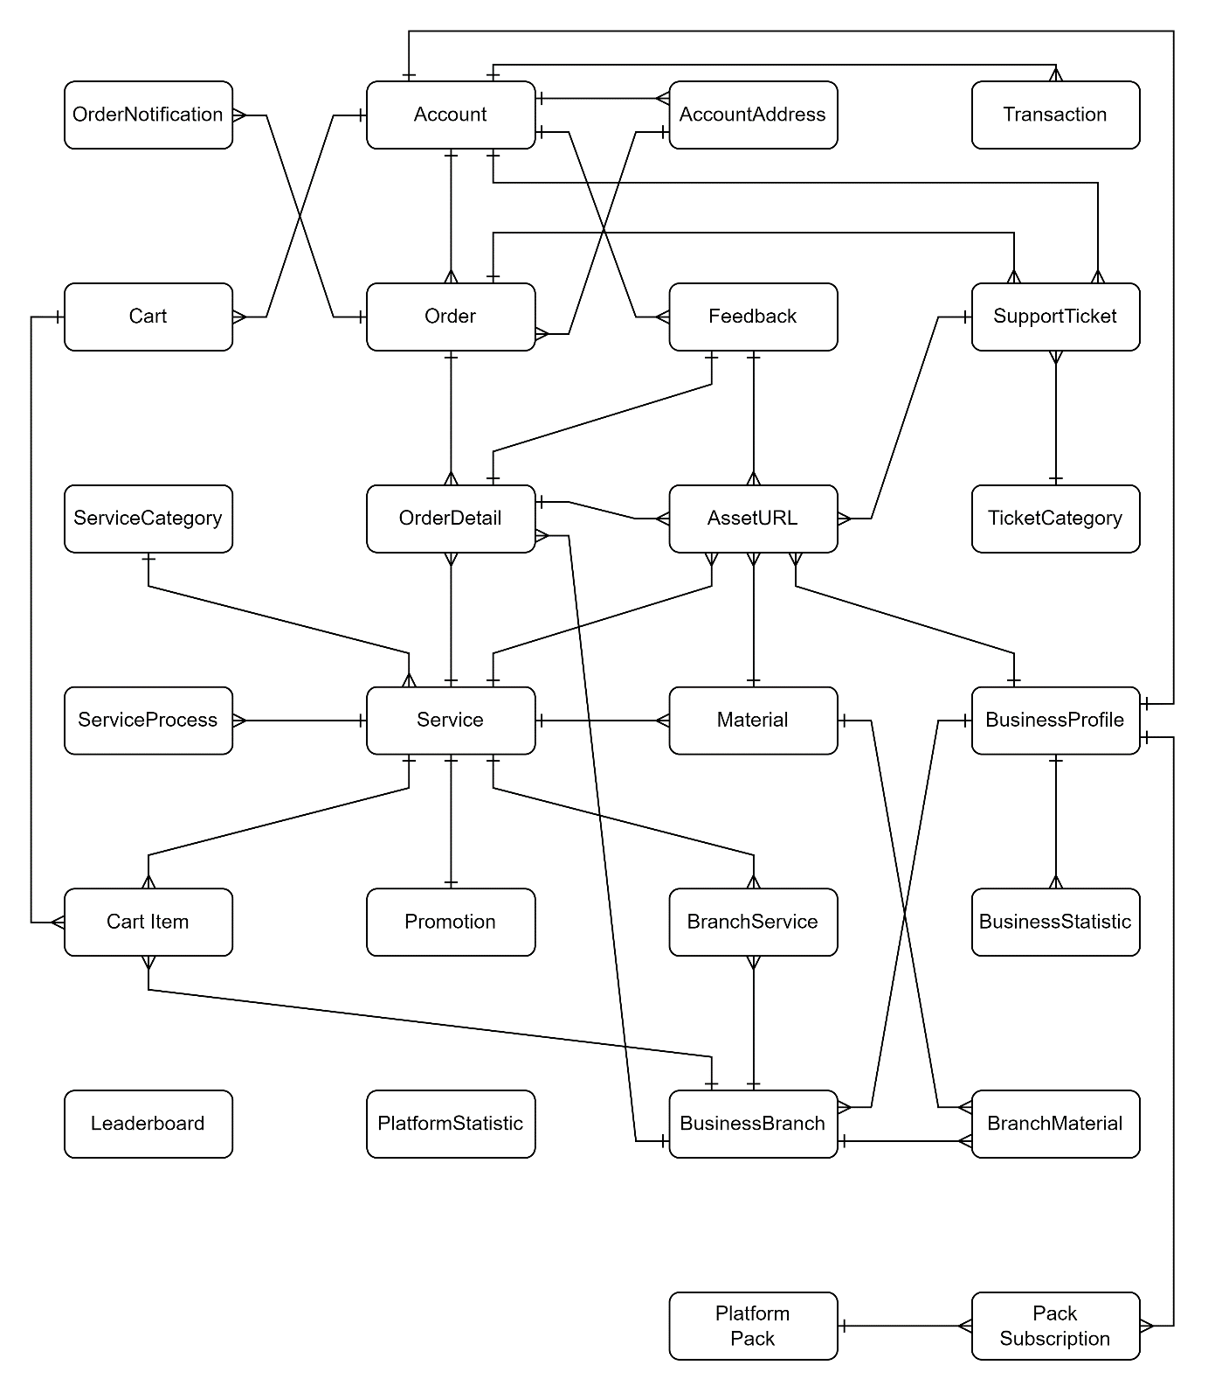

3.1.2.2 Logical Model
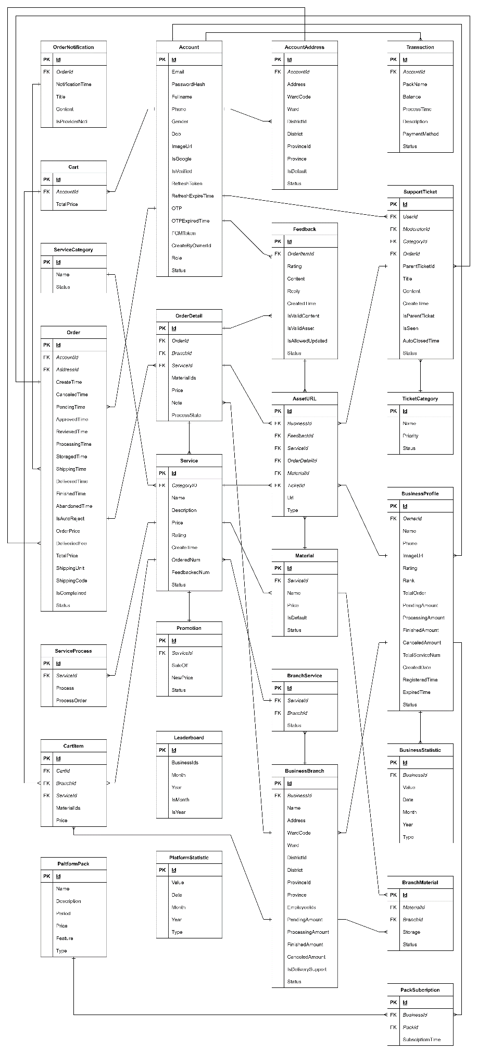

Entities Description
# | Entity | Description
01 | Account | Store user’s account information in platform
02 | AccountAddress | Store user’s address in platform
03 | AssetURL | Store image or video URL of BusinessProfile, Feedback and Service entities
04 | BranchMaterial | Store information of material has in branch
05 | BranchService | Store information of service has in branch
06 | BuisnessBranch | Store branch information of BusinessProfile entity
07 | BusinessProfile | Store business information in platform
08 | BusinessStatistic | Store business statistic information in platform
09 | Cart | Store account’s cart in platform
10 | CartItem | Store items have been added to Cart entity
11 | Feedback | Store service feedback of customer in platform
12 | Leaderboard | Store platform top 10 business ranking information
13 | Material | Store service require or addition material
14 | Order | Store order information in platform
15 | OrderDetail | Store order items of Order entity
16 | OrderNotification | Store order’s notification context in platform
17 | PackSubscription | Store business registered feature pack information
18 | PlatformPack | Store platform pack information: subscription pack and feature pack
19 | PlatformStatistic | Store platform statistic information
20 | Promotion | Store sale off information of Service entity
21 | Service | Store service information in platform
22 | ServiceCategory | Store category information of service in platform
23 | ServiceProcess | Store process information of service in platform
24 | SupportTicket | Store submitted support ticket information in platform
25 | TicketCategory | Store category information of support ticket in platform
26 | Transaction | Store transaction information in platform

3.2 Guest Feature
# | Actor | Function Name | Purpose | Data Requirements | Data  Validation | Business Rule
01 | Guest,  Customer,  Owner,  Moderator,  Admin | View Platform Pack | View all platform pack’s information | N/A | N/A
02 | Guest,  Customer,  Owner,  Moderator,  Admin | View Provider List | View platform business list | N/A | N/A
03 | Guest,  Customer,  Owner,  Moderator,  Admin | View Business Ranking | View platform top10 business by month | N/A | N/A
04 | Guest,  Customer,  Owner,  Moderator,  Admin | View Business Detail | View business detail information | Business Id | Business Id:  + Type: Text Field (int)
05 | Guest,  Customer,  Owner,  Moderator,  Admin | View Service List | View platform service list | N/A | N/A
06 | Guest,  Customer,  Owner,  Moderator,  Admin | View Service Detail | View service detail information | Service Id | Service Id:  + Type: Text Field (int)
07 | Customer,  Owner,  Moderator,  Admin | Login | Login to platform using system account | Email  Password | Email  + Type: Text Field (string)  + Max Length = 50  Password  + Type: Text Field (string)  + Min Length = 8  + Max Length = 16 | BR-03  BR-05  BR-06  BR-07  BR-08  BR-09
08 | Customer,  Owner,  Moderator,  Admin | Login By Google | Login to platform using Google account | N/A | N/A
09 | Customer,  Owner,  Moderator,  Admin | Login By OTP | Login to platform using OTP code | Email  OTP Code | Email  + Type: Text Field (string)  + Max Length = 50  OTP Code  + Type: Text Field (int)  + Min Length = 6  + Max Length = 6 | BR-03
10 | Guest | Customer Register | Register new customer account | Email  Phone  Full Name  Birth Day  Gender  Password  Confirm Password | Email  + Type: Text Field (string)  + Max Length = 50  Phone  + Type: Text Field (string)  + Min Length = 10  + Max Length = 10  Full Name  + Type: Text Field (string)  + Max Length = 50  Birth Day  + Type: Text Field (date)  Gender  + Type: Text Field (string)  Password  + Type: Text Field (string)  + Min Length = 8  + Max Length = 16  Confirm Password  + Type: Text Field (string)  + Min Length = 8  + Max Length = 16 | BR-02  BR-03  BR-04  BR-10
11 | Guest | Owner Register | Register new owner account and business profile | Email  Phone  Full Name  Birth Day  Gender  Password  Confirm Password  Business Name  Business Phone | Email  + Type: Text Field (string)  + Max Length = 50  Phone  + Type: Text Field (string)  + Min Length = 10  + Max Length = 10  Full Name  + Type: Text Field (string)  + Max Length = 50  Birth Day  + Type: Text Field (date)  Gender  + Type: Text Field (string)  Password  + Type: Text Field (string)  + Min Length = 8  + Max Length = 16  Confirm Password  + Type: Text Field (string)  + Min Length = 8  + Max Length = 16  Business Name  + Type: Text Field (string)  + Max Length = 50  Business Phone  + Type: Text Field (string)  + Min Length = 10  + Max Length = 10 | BR-02  BR-03  BR-04  BR-10
12 | Customer,  Owner,  Moderator,  Admin | Reset Password | Change password without login to the platform | Email  New Password  Confirm Password | Email  + Type: Text Field (string)  + Max Length = 50  New Password  + Type: Text Field (string)  + Min Length = 8  + Max Length = 16  Confirm Password  + Type: Text Field (string)  + Min Length = 8  + Max Length = 16 | BR-03

3.3 Registered User Feature
# | Actor | Function Name | Purpose | Data Requirements | Data  Validation | Business Rule
01 | Customer,  Owner,  Employee,  Moderator,  Admin | Logout | Delete authorization token from the system | N/A | N/A
02 | Customer,  Owner,  Employee,  Moderator,  Admin | View Profile Detail | View personal account detail information | Account Id | Account Id  + Type: Text Field (int)
03 | Customer,  Owner,  Employee,  Moderator,  Admin | Update Profile | Update personal account information | Account Id  Full Name  Gender  Birth Day | Account Id  + Type: Text Field (int)  Full Name  + Type: Text Field (string)  + Max Length = 50  Birth Day  + Type: Text Field (date)  Gender  + Type: Text Field (string) | BR-02  BR-04
04 | Customer,  Owner,  Employee,  Moderator,  Admin | Change Password | Change personal account password | Account Id  Old Password  New Password  Confirm Password | Account Id  + Type: Text Field (int)  Old Password  + Type: Text Field (string)  + Min Length = 8  + Max Length = 16  New Password  + Type: Text Field (string)  + Min Length = 8  + Max Length = 16  Confirm Password  + Type: Text Field (string)  + Min Length = 8  + Max Length = 16 | BR-05  BR-06  BR-07  BR-08  BR-09
05 | Customer,  Owner,  Employee,  Moderator,  Admin | Chat | Chat with other account of the system | Sender Id  Receiver Id  Content | Sender Id  + Type: Text Field (int)  Receiver Id  + Type: Text Field (int)  Content  + Type: Text Field (string)
 | Customer,  Owner,  Employee,  Moderator,  Admin | View Support Ticket Category | View category information of the support ticket | N/A | N/A
 | Customer,  Owner,  Employee | View Sent Support Ticket | View account sent support ticket | Account Id | Account Id  + Type: Text Field (int)
 | Customer,  Owner,  Employee,  Moderator,  Admin | View Support Ticket Detail | View support ticket detail | Ticket Id | Ticket Id  + Type: Text Field (int)
 | Customer,  Owner,  Employee | Create Support Ticket | Create new support ticket | Ticket Id  Title  Content  Asset | Ticket Id  + Type: Text Field (int)  Title  + Type: Text Field (string)  + max Length = 100  Content  + Type: Text Field (string)  Asset  + Type: Text Field (string)
 | Customer,  Owner,  Employee,  Moderator,  Admin | Update Support Ticket | Update new information of a support ticket | Ticket Id  Status | Ticket Id  + Type: Text Field (int)  Status  + Type: Text Field (string)

3.4 Customer Feature
# | Actor | Function Name | Purpose | Data Requirements | Data  Validation | Business Rule
01 | Customer | View Personal Address | View created address of the account | Account Id | Account Id  + Type: Text Field (int)
02 | Customer | View Address Detail | View address detail information | Address Id | Address Id  + Type: Text Field (int)
03 | Customer | Create New Address | Create new address to account | Account Id  Address  Ward  District  Province  Is Default | Account Id  + Type: Text Field (int)  Address  + Type: Text Field (string)  Ward  + Type: Text Field (string)  District  + Type: Text Field (string)  Province  + Type: Text Field (string)  Is Default  + Type: Text Field (bool)
04 | Customer | Update Address | Update address information | Account Id  Address  Ward  District  Province  Is Default | Account Id  + Type: Text Field (int)  Address  + Type: Text Field (string)  Ward  + Type: Text Field (string)  District  + Type: Text Field (string)  Province  + Type: Text Field (string)  Is Default  + Type: Text Field (bool)
05 | Customer | View Personal Order | View created order of the account | Account Id | Account Id  + Type: Text Field (int)
06 | Customer | View Order Detail | View order detail information | Order Id | Order Id  + Type: Text Field (int)
07 | Customer | Cancel Order | Cancel a booked order | Order Id | Order Id  + Type: Text Field (int)
08 | Customer | View Personal Cart | View account cart information | Account Id  Cart Id | Account Id  + Type: Text Field (int)  Cart Id  + Type: Text Field (int)
09 | Customer | Add To Cart | Add new service to account cart | Cart Id  Branch Id  Service Id  Material Ids | Cart Id  + Type: Text Field (int)  Branch Id  + Type: Text Field (int)  Service Id  + Type: Text Field (int)  Material Ids  + Type: Text Field (string)
10 | Customer | Remove From Cart | Remove added service from account cart | Cart Id  Cart Item Id | Cart Id  + Type: Text Field (int)  Cart Item Id  + Type: Text Field (int)
11 | Customer | Cart Checkout | Create a new order from cart | Cart Id | Cart Id  + Type: Text Field (int)

3.5 Business Feature
# | Actor | Function Name | Purpose | Data Requirements | Data  Validation | Business Rule
01 | Owner | View Dashboard | View business statistic information | Business Id | Business Id  + Type: Text Field (int)
02 | Owner | View Business’s Service | View business’s service list | Business Id | Business Id  + Type: Text Field (int)
03 | Owner,  Employee | View Branch’s Service | View branch’s service list | Branch Id | Branch Id  + Type: Text Field (int)
04 | Owner,  Employee | View Service Detail | View service detail information | Service Id | Service Id  + Type: Text Field (int)
05 | Owner | Create Service | Create new service | Service Information:  Branch Ids  Category Id  Name  Description  Price  Status  New Price  Asset URLs:  - Url  - Type  Service Processes  - Process  - Process Order  Business Id | Branch Ids  + Type: Array of integers (int[])  Price  Category Id  + Type: Text Field (int)  Name  + Type: Text Field (string)  Description  + Type: Text Field (string)  Price  + Type: Text Field (decimal)  + Min Value: 1  New Price  + Type: Text Field (decimal)  + Min Value: 1  +Constraint: New Price < Price  Status  + Type: Text Field (string)  Business Id  + Type: Text Field (int) | BR-04
06 | Owner | Update Service | Update service information | Service Information:  Branch Ids  Category Id  Name  Description  Price  Status  New Price  Asset URLs:  - Url  - Type  Service Processes  - Process  - Process Order  Business Id | Branch Ids  + Type: Array of integers (int[])  Price  Category Id  + Type: Text Field (int)  Name  + Type: Text Field (string)  Description  + Type: Text Field (string)  Price  + Type: Text Field (decimal)  + Min Value: 1  New Price  + Type: Text Field (decimal)  + Min Value: 1  +Constraint: New Price < Price  Status  + Type: Text Field (string)  Business Id  + Type: Text Field (int) | BR-04
07 | Owner | View Business’s Material | View business’s material list | Business Id | Business Id  + Type: Text Field (int)
08 | Owner,  Employee | View Branch’s Material | View branch’s material list | Branch Id | Branch Id  + Type: Text Field (int)
09 | Owner,  Employee | View Material Detail | View material detail information | Material Id | Material Id  + Type: Text Field (int)
10 | Owner | Create Material | Create new material | Material Information:  Branch Ids  Service Id  Name  Price  Status  Asset URLs:  - Url  - Type  Business Id | Branch Ids  + Type: Array of integers (int[])  Price  Service Id  + Type: Text Field (int)  Name  + Type: Text Field (string)  Price  + Type: Text Field (decimal)  + Min Value: 1  Price  Status  + Type: Text Field (string)  Business Id  + Type: Text Field (int) | BR-04
11 | Owner | Update Material | Update material information | Material Information:  Branch Ids  Service Id  Name  Price  Status  Asset URLs:  - Url  - Type  Business Id | Branch Ids  + Type: Array of integers (int[])  Price  Service Id  + Type: Text Field (int)  Name  + Type: Text Field (string)  Price  + Type: Text Field (decimal)  + Min Value: 1  Price  Status  + Type: Text Field (string)  Business Id  + Type: Text Field (int) | BR-04
12 | Owner,  Employee | View Branch’s Order | View branch’s order list | Branch Id | Branch Id  + Type: Text Field (int)
13 | Owner,  Employee | View Order Detail | View order detail information | Order Id | Order Id  + Type: Text Field (int)
14 | Owner,  Employee | Process Order | Update order process information | Order Id  Status  Is Ship  Delivery Fee  Pending Time  Approved Time  Received Time  Processing Time  Storage Time  ShippingTime  Delivered Time  Finished Time  Abandoned Time | Order Id  + Type: Text Field (int)  Status  + Type: Text Field (string)  Is Ship  Status  + Type: Text Field (bool)  Delivery Fee  + Type: Text Field (decimal)  + Min Value: 0
15 | Owner | View Business’s Branch | View business’s branch list | Business Id | Business Id  + Type: Text Field (int)
16 | Owner | View Branch Detail | View branch detail information | Branch Id | Branch Id  + Type: Text Field (int)
17 | Owner | Create Branch | Create new branch | Business Id  Name  Address  Ward Code  District Id  Province Id | Business Id  + Type: Text Field (int)  Name  + Type: Text Field (string)  Address  + Type: Text Field (string)  Ward Code  + Type: Text Field (string)  District Id  + Type: Text Field (int)  Province Id  + Type: Text Field (int) | BR-04
18 | Owner | Update Branch | Update branch information | Business Id  Name  Address  Ward Code  District Id  Province Id  Status | Business Id  + Type: Text Field (int)  Name  + Type: Text Field (string)  Address  + Type: Text Field (string)  Ward Code  + Type: Text Field (string)  District Id  + Type: Text Field (int)  Province Id  + Type: Text Field (int)  Status  + Type: Text Field (string)
19 | Owner | View Business’s Employee | View business’s employee list | Business Id | Business Id  + Type: Text Field (int)
20 | Owner | View Employee Detail | View employee detail information | Account Id | Account Id  + Type: Text Field (int)
21 | Owner | Create Employee | Create new employee | Owner Id  Email  Full Name  Phone  Gender  Dob  Branch Id | Owner Id  + Type: Text Field (int)  Email  + Type: Text Field (string)  + Max Length = 50  Full Name  + Type: Text Field (string)  + Max Length = 50  Phone  + Type: Text Field (string)  + Min Length = 10  + Max Length = 10  Gender  + Type: Text Field (string)  Branch Id  + Type: Text Field (int)  Dob  + Type: Text Field (Datetime) | BR-02  BR-03  BR-04  BR-10
22 | Owner | Update Employee | Update employee information | Account Id  Full Name  Dob | Account Id  + Type: Text Field (int)  Dob  + Type: Text Field (Datetime)  Full Name  + Type: Text Field (string)  + Max Length = 50
23 | Owner | Delete Employee | Delete employee from business | Account Id | Account Id  + Type: Text Field (int)
24 | Owner,  Employee | View Service Feedback | View order feedback information | Feedback Id | Feedback Id  + Type: Text Field (int)
25 | Owner,  Employee | Reply Feedback | Reply to order feedback | Feedback Id | Feedback Id  + Type: Text Field (int)
26 | Owner | VnPay Payment | Process payment using VnPay | Business Id  Pack Id | Business Id  + Type: Text Field (int)  Pack Id  + Type: Text Field (int)
27 | Owner | MoMo Payment | Process payment using MoMo | Business Id  Pack Id | Business Id  + Type: Text Field (int)  Pack Id  + Type: Text Field (int)
28 | Owner | View Business’s Pack Subscription | View business’s registered feature pack | Business Id | Business Id  + Type: Text Field (int)
29 | Owner | View Business’s Transaction | View business transaction | Business Id | Business Id  + Type: Text Field (int)

3.6 Admin Feature
# | Actor | Function Name | Purpose | Data Requirements | Data  Validation | Business Rule
01 | Admin | Platform Dashboard | View platform statistic information | N/A | N/A
02 | Admin | View Users | View system user list | N/A | N/A
03 | Admin | View User Detail | View user detail information | Account Id | Account Id  + Type: Text Field (int)
04 | Admin | Update User Status | Update system user status | Account Id  Status | Account Id  + Type: Text Field (int)  Status  + Type: Text Field (string)
05 | Admin | Create Moderator | Create new moderator to system | Email  Full Name  Phone  Gender  Birth Day | Email  + Type: Text Field (string)  + Max Length = 50  Phone  + Type: Text Field (string)  + Min Length = 10  + Max Length = 10  Full Name  + Type: Text Field (string)  + Max Length = 50  Birth Day  + Type: Text Field (date)  Gender  + Type: Text Field (string) | BR-02  BR-03  BR-04  BR-10
06 | Admin | View Businesses | View platform’s businesses list | N/A | N/A
07 | Admin | View Business Detail | View business profile information | Business Id | Account Id  + Type: Text Field (int)
08 | Admin | Update Business Status | Update platform’s business status | Business Id  Status | Business Id  + Type: Text Field (int)  Status  + Type: Text Field (string)
09 | Admin | Update Pack | Update platform’s pack information | Pack Id  Name  Period  Price | Pack Id  + Type: Text Field (int)  name  + Type: Text Field (string)  + Max Length = 50  Period  + Type: Text Field (int)  + Min Value = 1  + Max Value = 12  Price  + Type: Text Field (decimal) | BR-04
10 | Admin,  Moderator | View Feedbacks | View feedbacks list | N/A | N/A
11 | Admin,  Moderator | View Feedback Detail | View feedback detail | Feedback Id | Feedback Id  + Type: Text Field (int)
12 | Admin,  Moderator | Validate Feedback | Validate feedback content and assets | Feedback Id  Is Valid Content  Is Valid Asset | Feedback Id  + Type: Text Field (int)  Is Valid Content  + Type: Text Field (bool)  Is Valid Asset + Type: Text Field (bool)
13 | Admin | View Categories | View service, ticket category list | N/A | N/A
14 | Admin | View Categories Detail | View category detail | Category Id | Category Id  + Type: Text Field (int)
15 | Admin | Update Service Category | Update service category detail | Category Id  Name  Status | Category Id  + Type: Text Field (int)  Name  + Type: Text Field (string)  + Max Length = 50  Status  + Type: Text Field (string) | BR-04
16 | Admin | Update Ticket Category | Update ticket category detail | Category Id  Name  Priority  Status | Category Id  + Type: Text Field (int)  Name  + Type: Text Field (string)  + Max Length = 50  Priority  + Type: Text Field (int)  + Min Value = 1  + Max Value = 5  Status  + Type: Text Field (string)
17 | Admin,  Moderator | View Support Tickets | View support ticket list | N/A | N/A
18 | Admin,  Moderator | View Support Ticket Detail | View ticket detail | Ticket Id | Ticket Id  + Type: Text Field (int)
19 | Admin,  Moderator | Update Support Ticket | Update support ticket information | Ticket Id  Status | Ticket Id  + Type: Text Field (int)  Status  + Type: Text Field (string)
20 | Admin | View Transaction | View platform transaction | N/A | N/A
21 | Admin | View Word Blacklist | View system word blacklist | N/A | N/A
22 | Admin | Add Word | Add new word to black list | Word  Note | Word  + Type: Text Field (string)  Note  + Type: Text Field (string)
23 | Admin | Delete Word | Remove word from blacklist | Word | Word  + Type: Text Field (string)
24 | Admin | Export Word Blacklist | Export word blacklist to excel file | N/A | N/A
25 | Admin | Import Word Blacklist | Create new work blacklist by excel file | File | File  + Type: stream

4. Non-Functional Requirements

4.1 External Interfaces
- Language used in the application is Vietnamese
- UI can be responsive on multiple screens, allowing the main content to display without scrolling horizontal appearance

4.2 Quality Attributes

4.2.1 Usability
- Language used in the application is Vietnamese.
- UI can be responsive on multiple screens, allowing the main content to display without scrolling horizontal appearance.

4.2.2 Reliability
- Language used in the application is Vietnamese.
- The web application for the customers should be simple and easy to use without training.

4.2.3 Security
- System is designed based on 3-layer architecture. Every component in the system is easy to maintain and develop.
- Naming conventions for classes, attributes, methods are meaningful which can explain the purpose of the variable.
- The platform should have high availability, ensuring that it is accessible to users most of the time.

5. Requirement Appendix

5.1 Business Rules
ID | Rule Definition
BR-01 | Accounts that violate the policy will be warned or permanently banned depending on the severity of the violation.
BR-02 | Birthday must be valid and cannot be present day.
BR-03 | Email address must be valid and not have been used to register an account before.
BR-04 | Name must be less than 50 characters.
BR-05 | Password must be at least 8 characters.
BR-06 | Password must contain at least 1 lowercase letter.
BR-07 | Password must contain at least 1 number.
BR-08 | Password must contain at least 1 special characters (!, @, #,...).
BR-09 | Password must contain at least 1 uppercase letter.
BR-10 | Phone number must be correct format and not have been used to register an account before.
BR-11 | Terms and conditions must be accepted to register.
BR-12 | Customer can cancel order or change shipping information only when order is not confirmed.
BR-13 | Customer can complaint or send refund ticket only when order is not completed.
BR-14 | Customer can feedback a service after the order is finished.
BR-15 | Customer can only feedback once each order items.
BR-16 | Customer must be logged before order a service.
BR-17 | Customers have the right to refuse to receive or create the complaint ticket if order show any signs of damage.
BR-18 | Customers need to check the information is correct before ordering.
BR-19 | Customers need to provide full photos and videos when making a complaint.
BR-20 | Customers need to record a video of the checking of order so that the system can handle any problems.
BR-21 | If order will be shipped fail 2 times, order will be storage at provider's store.
BR-22 | Order will be automatic mark complete after 7 days from shipped day.
BR-23 | The refund ticket will be automatic closed after 7 days when successfully refunded money.
BR-24 | There must be a valid reason for canceling the order.
BR-25 | Business's phone number must be of the primary branch and not have been used to register a provider before.
BR-26 | Owner/Employee can cancel order after 3 times customer does not response.
BR-27 | Owner/Employee can disable business only when finished all pending order.
BR-28 | Owner/Employee have to record a video checking shoes status before processing service.
BR-29 | Owner/Employee have to support customer when problem occurs.
BR-30 | Owner/Employee have to transparent and public warranty and return policy.
BR-31 | Owner/Employee have to update order status base on their process.
BR-32 | Owner/Employee must be at least 18 years old.
BR-33 | Owner/Employee must confirm order within 24 hours or the order will be automatic canceled.
BR-34 | Owner/Employee must be contact to customer to confirm order.
BR-35 | Owner/Employee must actively refund money if the complaint is approved.
BR-36 | Owner/Employee must register a subscription pack before posting a service to platform.
BR-37 | Owner/Employee can modify order item for customer.
BR-38 | The service must have at least 1 photo or video and be described in detail to be able to create.
BR-39 | Once registered, there will be no refund if you want to stop using the platform.
BR-40 | After the old package expires, if payment is not made on time, the package will be automatically canceled.
BR-41 | Moderator can be close ticket after customer does not response in 24 hours.

5.2 Application Messages List

5.2.1 Customer Application Messages List
# | Message code | Message Type | Context | Content
01 | MSG-01 | In red, under the text box | Gmail or password is not correct when clicking sign-in | Tài khoản mật khẩu không đúng
02 | MSG-02 | In red, under the text box | An error occurred when the server processed the login request | Đã có lỗi xảy ra. Vui lòng thử lại sau.
03 | MSG-03 | In red, under the text box | Input-required fields are empty when login | <Field name> không được để trống
04 | MSG-04 | Toast message | Login successfully | Đăng nhập thành công
05 | MSG-05 | In red, under the text box | Input-required fields are empty when register | <Field name> không được để trống
06 | MSG-06 | In red, under the text box | Register with the phone number already exist in the system | Số điện thoại đã được đăng ký
07 | MSG-07 | In red, under the text box | Register with the email already exist in the system | Email đã được đăng ký
08 | MSG-08 | In red, under the text box | Register with a incorrect format field | Định dạng <Field name> không hợp lệ
09 | MSG-09 | In red, under the text box | Register with date of birth under 18 years old | Người dưới 18 tuổi không được đăng ký tài khoản
10 | MSG-10 | In red, under the text box | Register with invalid format password | Mật khẩu phải có ít nhất 8 ký tự, 1 chữ hoa, 1 chữ thường, 1 số và 1 ký tự đặc biệt
11 | MSG-11 | In red, under the text box | Register with password and confirmation password do not match | Mật khẩu không trùng khớp
12 | MSG-12 | In line | Register successfully | Đăng ký thành công
13 | MSG-13 | In red, under the text box | Order failed | Đã có lỗi xảy ra khi đặt hàng. Vui lòng thử lại!
14 | MSG-14 | Toast message | Add to cart failed when customer not login first | Vui lòng đăng nhập trước khi thêm vào giỏ hàng
15 | MSG-15 | Toast message | Order failed when the internet is overdue | Đã có lỗi xảy ra khi đặt hàng. Vui lòng thử lại!
16 | MSG-16 | Toast message | Add to cart successfully | Đã thêm vào giỏ hàng.
17 | MSG-17 | In red, under the text box | Input-required fields are empty when feedback | <Field name> không được để trống
18 | MSG-18 | Toast message | Feedback successfully | Gửi đánh giá thành công!
19 | MSG-19 | In red, under the text box | Edit profile with the phone number already exist in the system | Số điện thoại tồn tại trong hệ thống
20 | MSG-20 | In red, under the text box | Edit profile with the email already exist in the system | Email đã tồn tại trong hệ thống
21 | MSG-21 | In red, under the text box | Edit profile with a incorrect format field | Định dạng <Field name> không hợp lệ
22 | MSG-22 | Toast message | Edit profile successfully | Chỉnh sửa thông tin thành công
23 | MSG-23 | In red, under the text box | Invalid image | Đăng tải ảnh bị lỗi. Xin vui lòng thử lại sau.
24 | MSG-24 | In red, under the text box | Invalid image | Ảnh không đúng định dạng. Xin vui lòng thử lại!
25 | MSG-25 | In red, under the text box | Invalid image. | Dung lượng ảnh tối đa không thể lớn hơn 5MB. Xin vui lòng thử lại
26 | MSG-26 | In red, under the text box | Change password | Mật khẩu phải có ít nhất 8 ký tự, 1 chữ hoa, 1 chữ thường, 1 số và 1 ký tự đặc biệt
27 | MSG-27 | In red, under the text box | Change password | Mật khẩu cũ không hợp lệ
28 | MSG-28 | In red, under the text box | Change password | Mật khẩu mới và xác nhận mật khẩu mới không khớp. Vui lòng thử lại!
29 | MSG-29 | Toast message | Change password | Bạn đã thay đổi mật khẩu thành công!
30 | MSG-30 | In line | There is not any search result | Không tìm thấy nội dung
31 | MSG-31 | Pop up | No order selected for checkout | Bạn chưa chọn dịch vụ nào! Vui lòng chọn dịch vụ để đặt hàng
32 | MSG-32 | Pop up | No shipping method selected for checkout | Vui lòng chọn phương thức giao hàng

5.2.2 Owner Application Messages List
# | Message code | Message Type | Context | Content
01 | MSG-01 | In red, under the text box | Gmail or password is not correct when clicking sign-in | Thông tin đăng nhập không hợp lệ. Vui lòng thử lại.
02 | MSG-02 | In red, under the text box | An error occurred when the server processed the login request | Đã có lỗi xảy ra. Vui lòng thử lại sau.
03 | MSG-03 | In red, under the text box | Input-required fields are empty when login | <Field name> không được để trống
04 | MSG-04 | Toast message | Login successfully | Đăng nhập thành công
05 | MSG-05 | In red, under the text box | Edit profile with the phone number already exist in the system | Số điện thoại tồn tại trong hệ thống
06 | MSG-06 | In red, under the text box | Edit profile with the email already exist in the system | Email đã tồn tại trong hệ thống
07 | MSG-07 | In red, under the text box | Edit profile with a incorrect format field | Định dạng <Field name> không hợp lệ
08 | MSG-08 | Toast message | Edit profile successfully | Chỉnh sửa thông tin thành công
09 | MSG-09 | In red, under the text box | Change password | Mật khẩu phải có ít nhất 8 ký tự, 1 chữ hoa, 1 chữ thường, 1 số và 1 ký tự đặc biệt
10 | MSG-10 | In red, under the text box | Change password | Mật khẩu cũ không hợp lệ
11 | MSG-11 | In red, under the text box | Change password | Mật khẩu mới và xác nhận mật khẩu mới không khớp. Vui lòng thử lại!
12 | MSG-12 | Toast message | Change password successfully | Bạn đã thay đổi mật khẩu thành công!
13 | MSG-13 | Toast message | Create material failed | Đã có lỗi xảy ra khi tạo phụ kiện. Vui lòng thử lại sau
14 | MSG-14 | Toast message | Create material successfully | Tạo phụ kiện thành công
15 | MSG-15 | Toast message | Update material failed | Đã có lỗi xảy ra khi cập nhật phụ kiện. Vui lòng thử lại sau
16 | MSG-16 | Toast message | Update material successfully | Cập nhật vật liệu thành công
17 | MSG-17 | Toast message | Create service failed | Đã có lỗi xảy ra khi tạo dịch vụ. Vui lòng thử lại sau
18 | MSG-18 | Toast message | Create service successfully | Tạo dịch vụ thành công
19 | MSG-19 | Toast message | Update service failed | Đã có lỗi xảy ra khi cập nhật dịch vụ. Vui lòng thử lại sau
20 | MSG-20 | Toast message | Update service successfully | Cập nhật dịch vụ thành công
21 | MSG-21 | Toast message | Create branch failed | Đã có lỗi xảy ra khi tạo chi nhánh. Vui lòng thử lại sau
22 | MSG-22 | Toast message | Create branch successfully | Tạo chi nhánh thành công
23 | MSG-23 | Toast message | Update branch failed | Đã có lỗi xảy ra khi cập nhật chi nhánh. Vui lòng thử lại sau
24 | MSG-24 | Toast message | Update branch successfully | Cập nhật chi nhánh thành công
25 | MSG-25 | In red, under the text box | Register package | Đăng ký gói để tạo mới
26 | MSG-26 | Toast message | Create employee failed | Đã có lỗi xảy ra khi tạo nhân viên. Vui lòng thử lại sau
27 | MSG-27 | Toast message | Create employee successfully | Tạo nhân viên thành công
28 | MSG-28 | Toast message | Delete employee successfully | Xóa nhân viên thành công
29 | MSG-29 | Toast message | Delete employee failed | Đã có lỗi xảy ra khi xóa nhân viên. Vui lòng thử lại sau
30 | MSG-30 | Toast message | Update status order failed | Đã có lỗi xảy ra khi cập nhật trạng thái đơn hàng. Vui lòng thử lại sau
31 | MSG-31 | Toast message | Update status order successfully | Cập nhật trạng thái đơn hàng thành công
32 | MSG-32 | Toast message | Update order failed | Đã có lỗi xảy ra khi cập nhật đơn hàng. Vui lòng thử lại sau
33 | MSG-33 | Toast message | Update order successfully | Cập nhật đơn hàng thành công
34 | MSG-34 | Toast message | Update ticket failed | Đã có lỗi xảy ra khi cập nhật khiếu nại. Vui lòng thử lại sau
35 | MSG-35 | Toast message | Update ticket successfully | Cập nhật khiếu nại thành công
36 | MSG-36 | Toast message | Register package fail | Đã có lỗi xảy ra khi đăng kí gói. Vui lòng thử lại sau
37 | MSG-37 | Toast message | Register package successfully | Đăng ký gói thành công

5.2.3 Employee Application Messages List
# | Message code | Message Type | Context | Content
01 | MSG-01 | In red, under the text box | Gmail or password is not correct when clicking sign-in | Thông tin đăng nhập không hợp lệ. Vui lòng thử lại.
02 | MSG-02 | In red, under the text box | An error occurred when the server processed the login request | Đã có lỗi xảy ra. Vui lòng thử lại sau.
03 | MSG-03 | In red, under the text box | Input-required fields are empty when login | <Field name> không được để trống
04 | MSG-04 | Toast message | Login successfully | Đăng nhập thành công
05 | MSG-05 | In red, under the text box | Edit profile with the phone number already exist in the system | Số điện thoại tồn tại trong hệ thống
06 | MSG-06 | In red, under the text box | Edit profile with the email already exist in the system | Email đã tồn tại trong hệ thống
07 | MSG-07 | In red, under the text box | Edit profile with an incorrect format field | Định dạng <Field name> không hợp lệ
08 | MSG-08 | Toast message | Edit profile successfully | Chỉnh sửa thông tin thành công
09 | MSG-09 | In red, under the text box | Change password | Mật khẩu phải có ít nhất 8 ký tự, 1 chữ hoa, 1 chữ thường, 1 số và 1 ký tự đặc biệt
10 | MSG-10 | In red, under the text box | Change password | Mật khẩu cũ không hợp lệ
11 | MSG-11 | In red, under the text box | Change password | Mật khẩu mới và xác nhận mật khẩu mới không khớp. Vui lòng thử lại!
12 | MSG-12 | Toast message | Change password successfully | Bạn đã thay đổi mật khẩu thành công!
13 | MSG-13 | Toast message | Update material failed | Đã có lỗi xảy ra khi cập nhật phụ kiện. Vui lòng thử lại sau
14 | MSG-14 | Toast message | Update material successfully | Cập nhật vật liệu thành công
15 | MSG-15 | Toast message | Update service failed | Đã có lỗi xảy ra khi cập nhật dịch vụ. Vui lòng thử lại sau
16 | MSG-16 | Toast message | Update service successfully | Cập nhật dịch vụ thành công
17 | MSG-17 | Toast message | Update status order failed | Đã có lỗi xảy ra khi cập nhật trạng thái đơn hàng. Vui lòng thử lại sau
18 | MSG-18 | Toast message | Update status order successfully | Cập nhật trạng thái đơn hàng thành công
19 | MSG-19 | Toast message | Update order failed | Đã có lỗi xảy ra khi cập nhật đơn hàng. Vui lòng thử lại sau
20 | MSG-20 | Toast message | Update order successfully | Cập nhật đơn hàng thành công
21 | MSG-21 | Toast message | Update ticket failed | Đã có lỗi xảy ra khi cập nhật khiếu nại. Vui lòng thử lại sau
22 | MSG-22 | Toast message | Update ticket successfully | Cập nhật khiếu nại thành công

5.2.5 Moderator Application Messages List
# | Message code | Message Type | Context | Content
01 | MSG-01 | In red, under the text box | Gmail number or password is not correct when clicking sign-in | Tài khoản mật khẩu không đúng
02 | MSG-02 | In red, under the text box | An error occurred when the server processed the login request | Đã có lỗi xảy ra. Vui lòng thử lại sau.
03 | MSG-03 | In red, under the text box | Edit profile with the email already exist in the system | Email đã tồn tại trong hệ thống
04 | MSG-04 | Toast message | Edit profile successfully | Chỉnh sửa thông tin thành công
05 | MSG-05 | In red, under the text box | Create something with empty input required fields | <Field name> không được để trống
06 | MSG-06 | In red, under the text box | Create something with invalid input required fields | Định dạng <Field name> không hợp lệ
07 | MSG-07 | In red, under the text box | Create something with duplicate input required fields | <Field name> đã được sử dụng
08 | MSG-08 | Toast message | Create something successfully | Tạo <Something> thành công
09 | MSG-09 | Toast message | Create something unsuccessfully | Tạo <Something> không thành công
10 | MSG-10 | Toast message | Update feedback status successfully | Cập nhật thành công
11 | MSG-11 | In red, under the text box | Send response for support ticket but enter empty content | Vui lòng nhập nội dung phản hồi

IV. Software Design Description

3. Detail Design

3.1 Create Service

3.1.1 Class Diagram

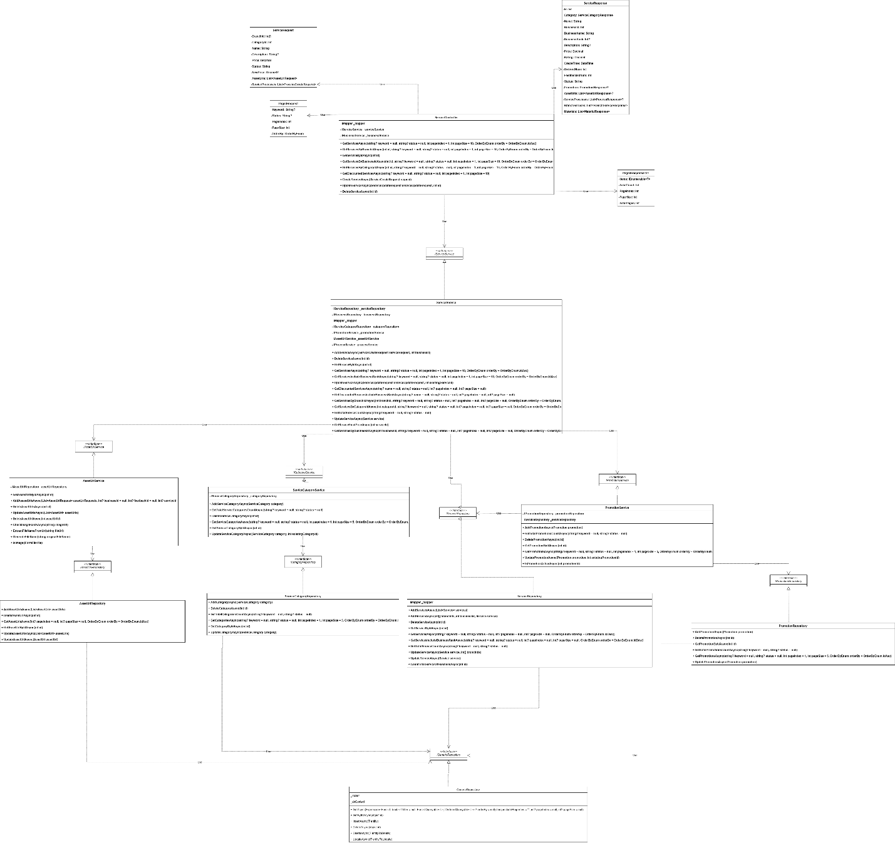

3.1.2 Sequence Diagram

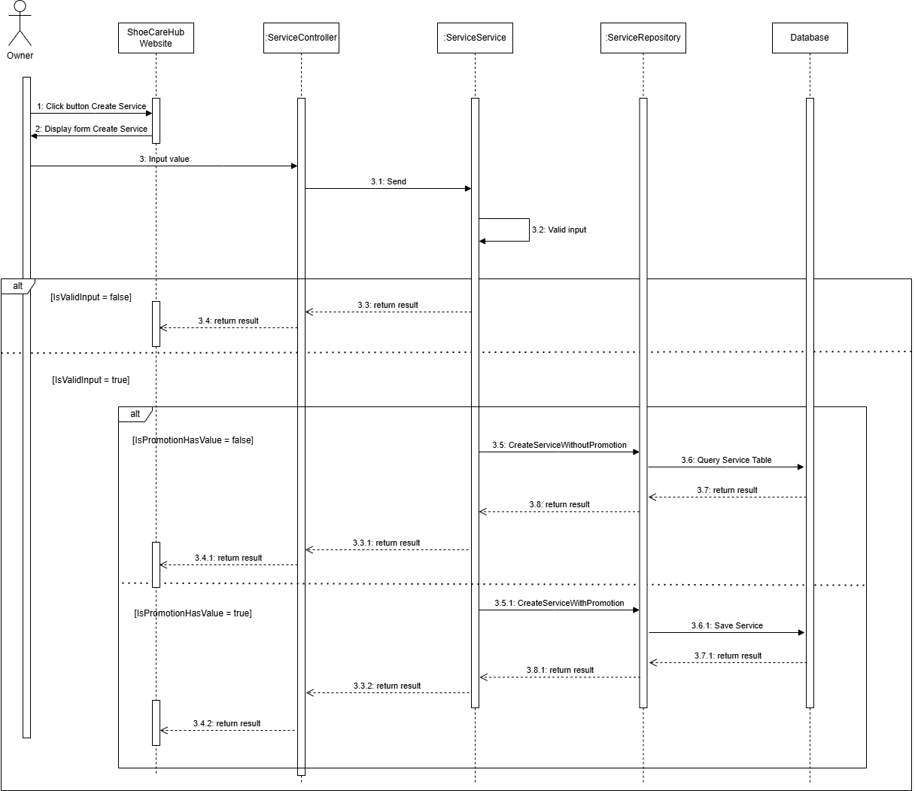

3.1.3 Activity Diagram

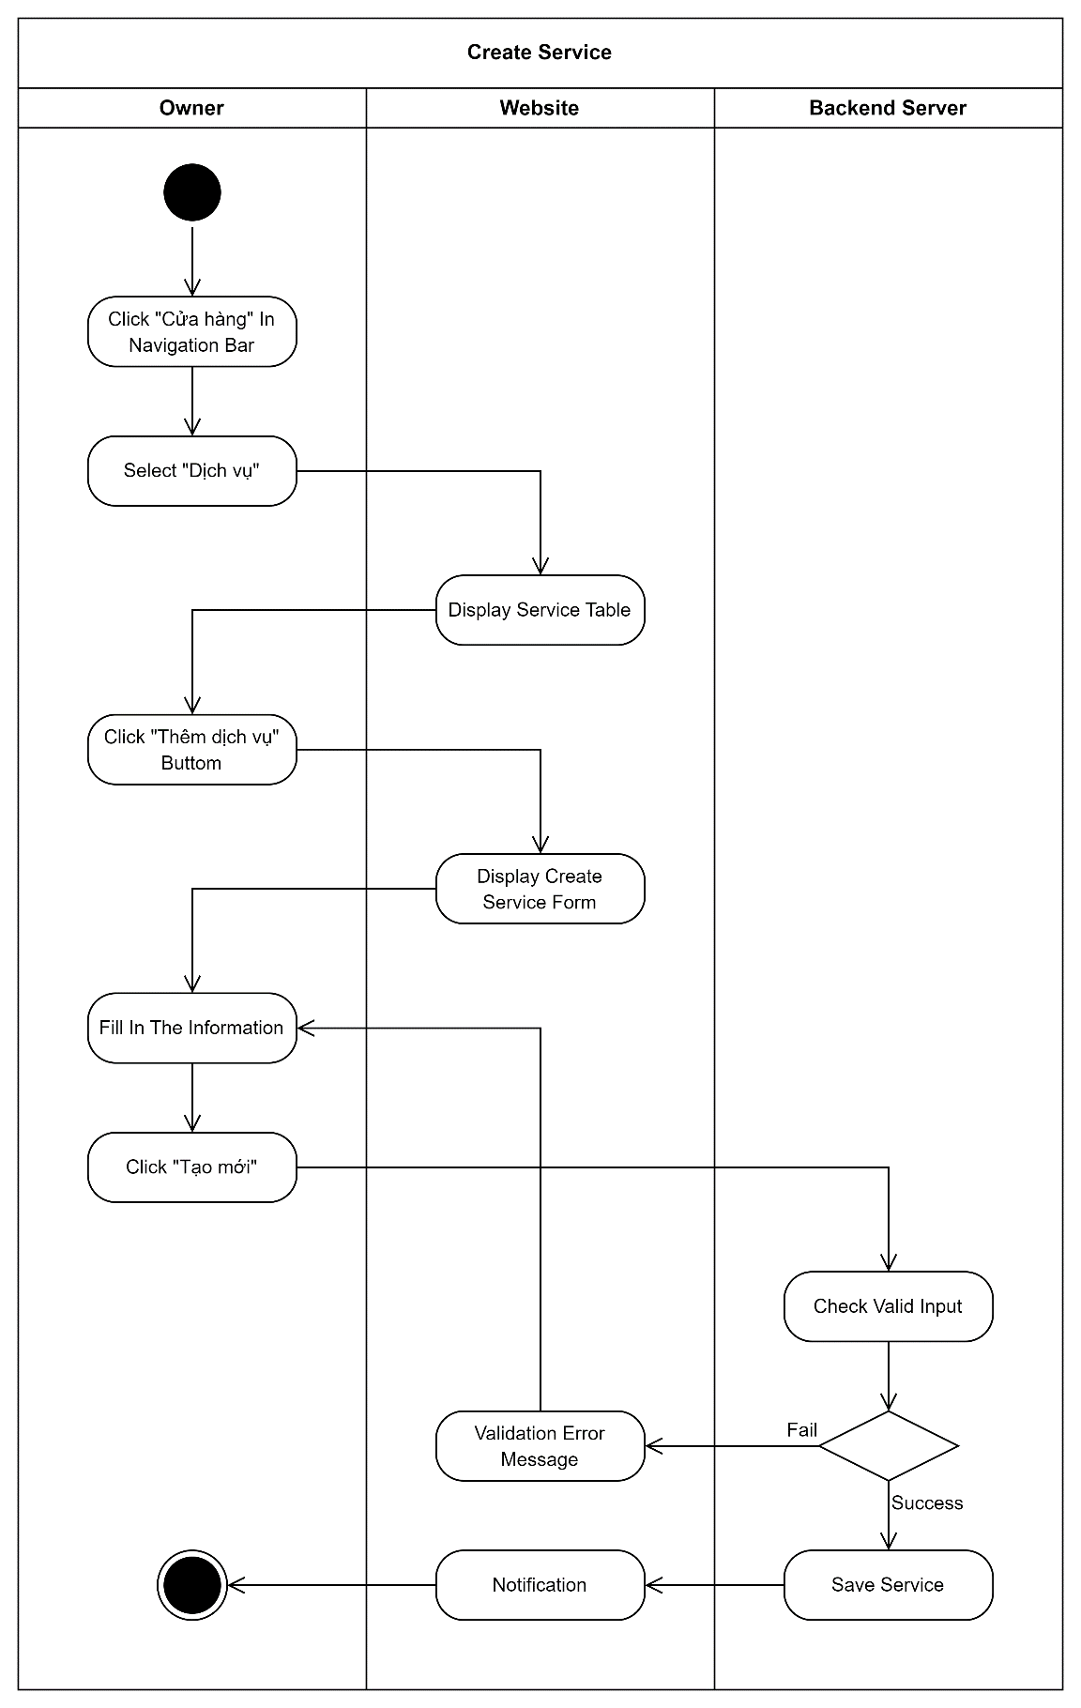

3.2 Add To Cart

3.2.1 Class Diagram

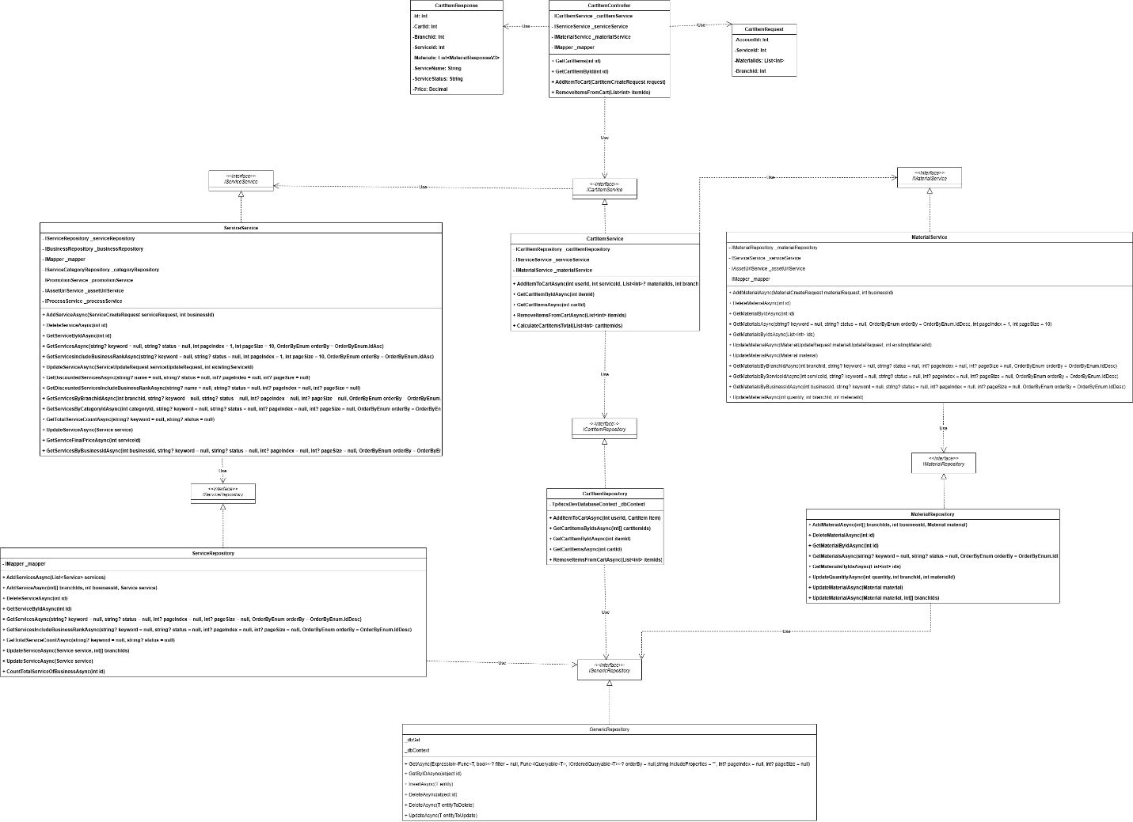

3.2.2 Sequence Diagram
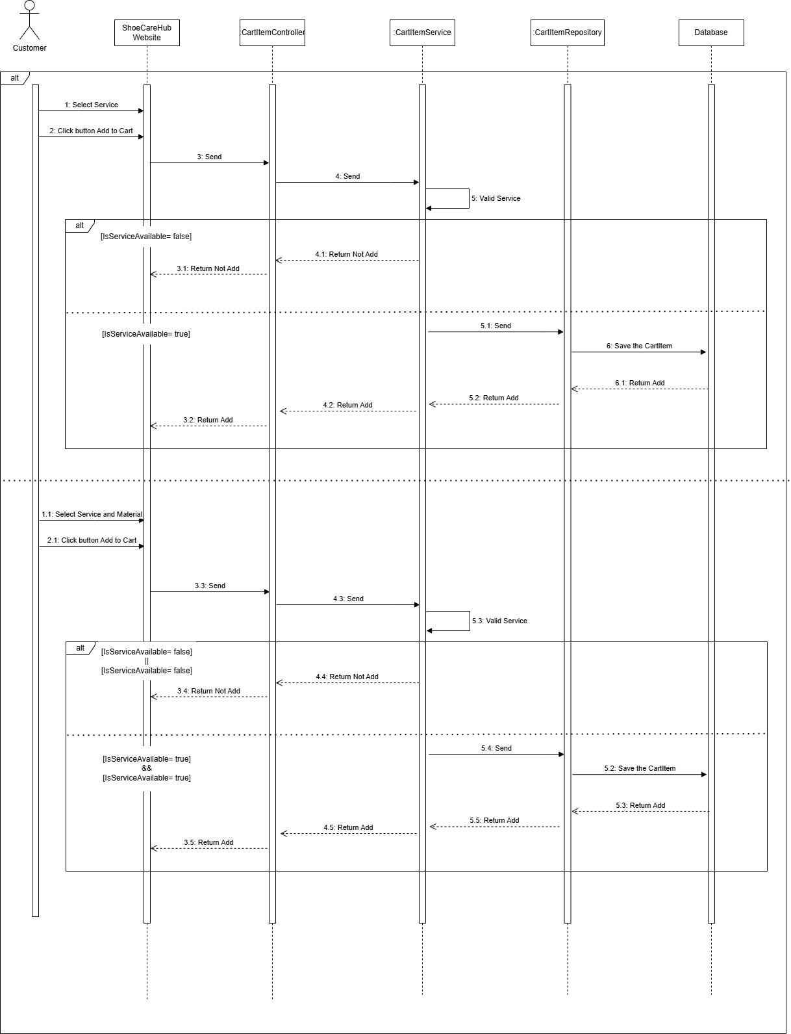

3.2.3 Activity Diagram
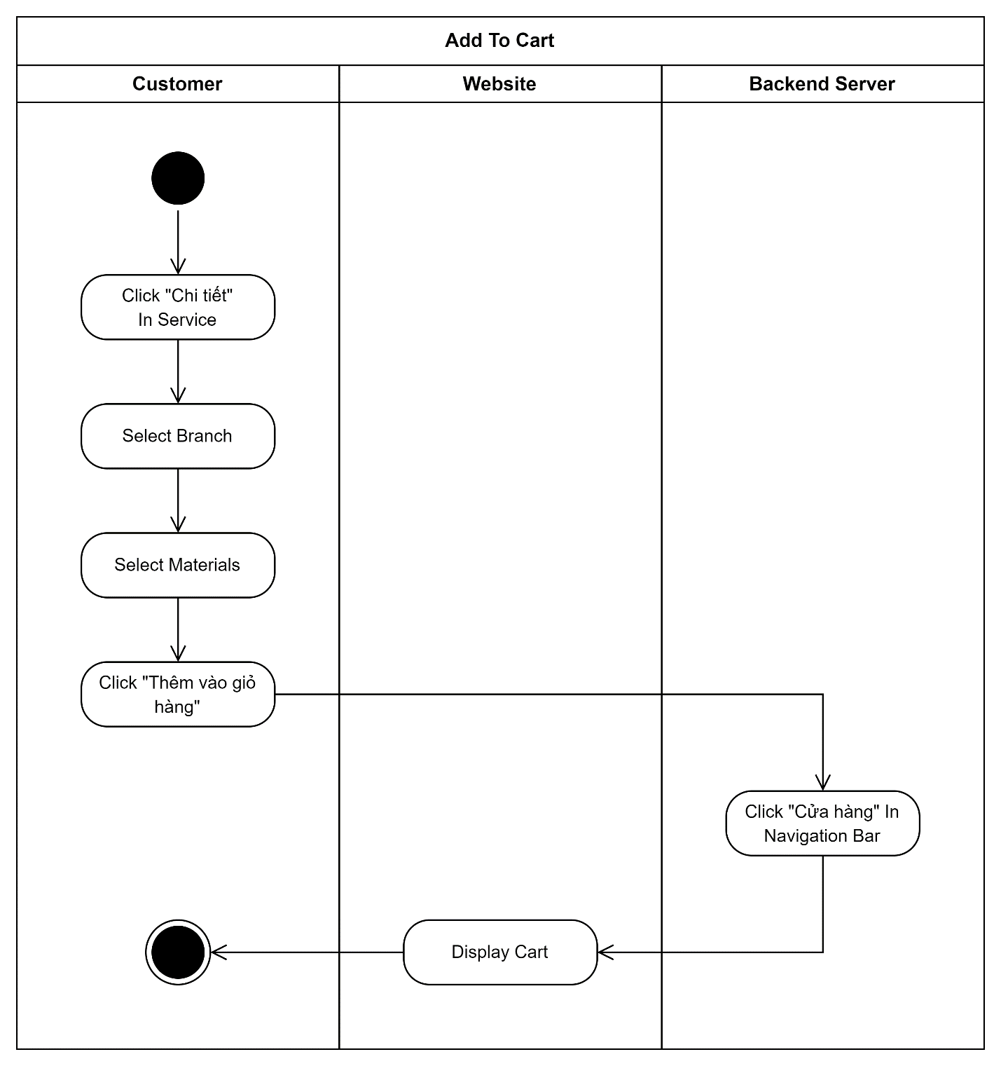

3.3 Create Material

3.3.1 Class Diagram

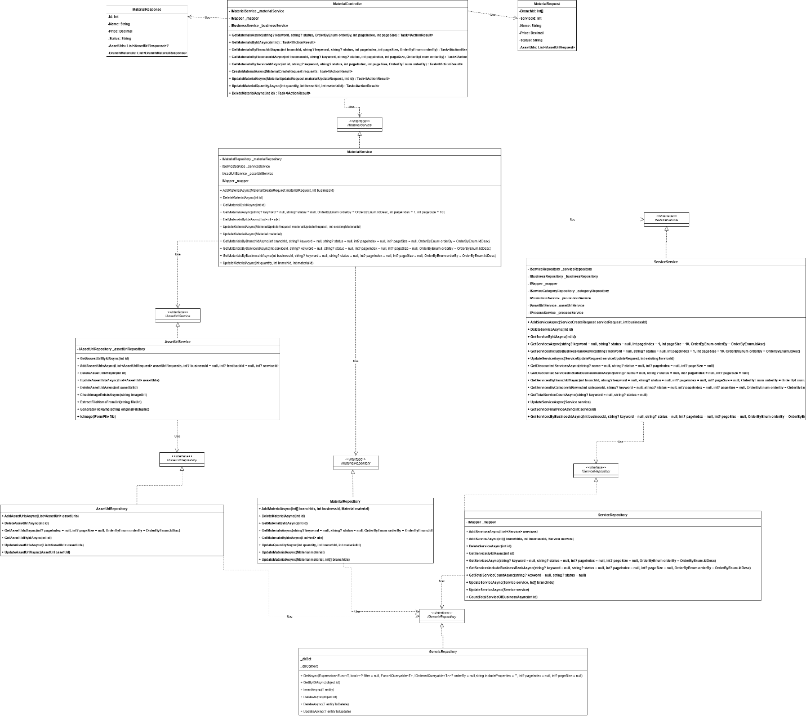

3.3.2 Sequence Diagram

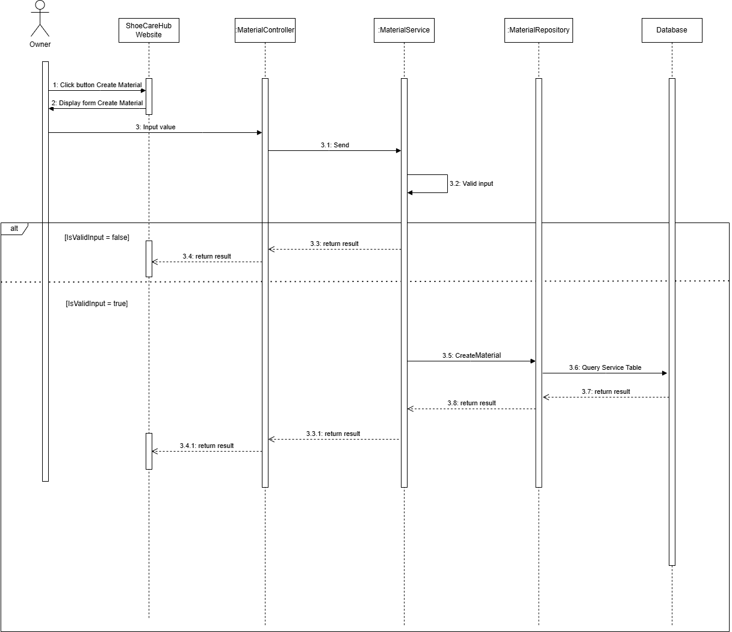

3.3.3 Activity Diagram
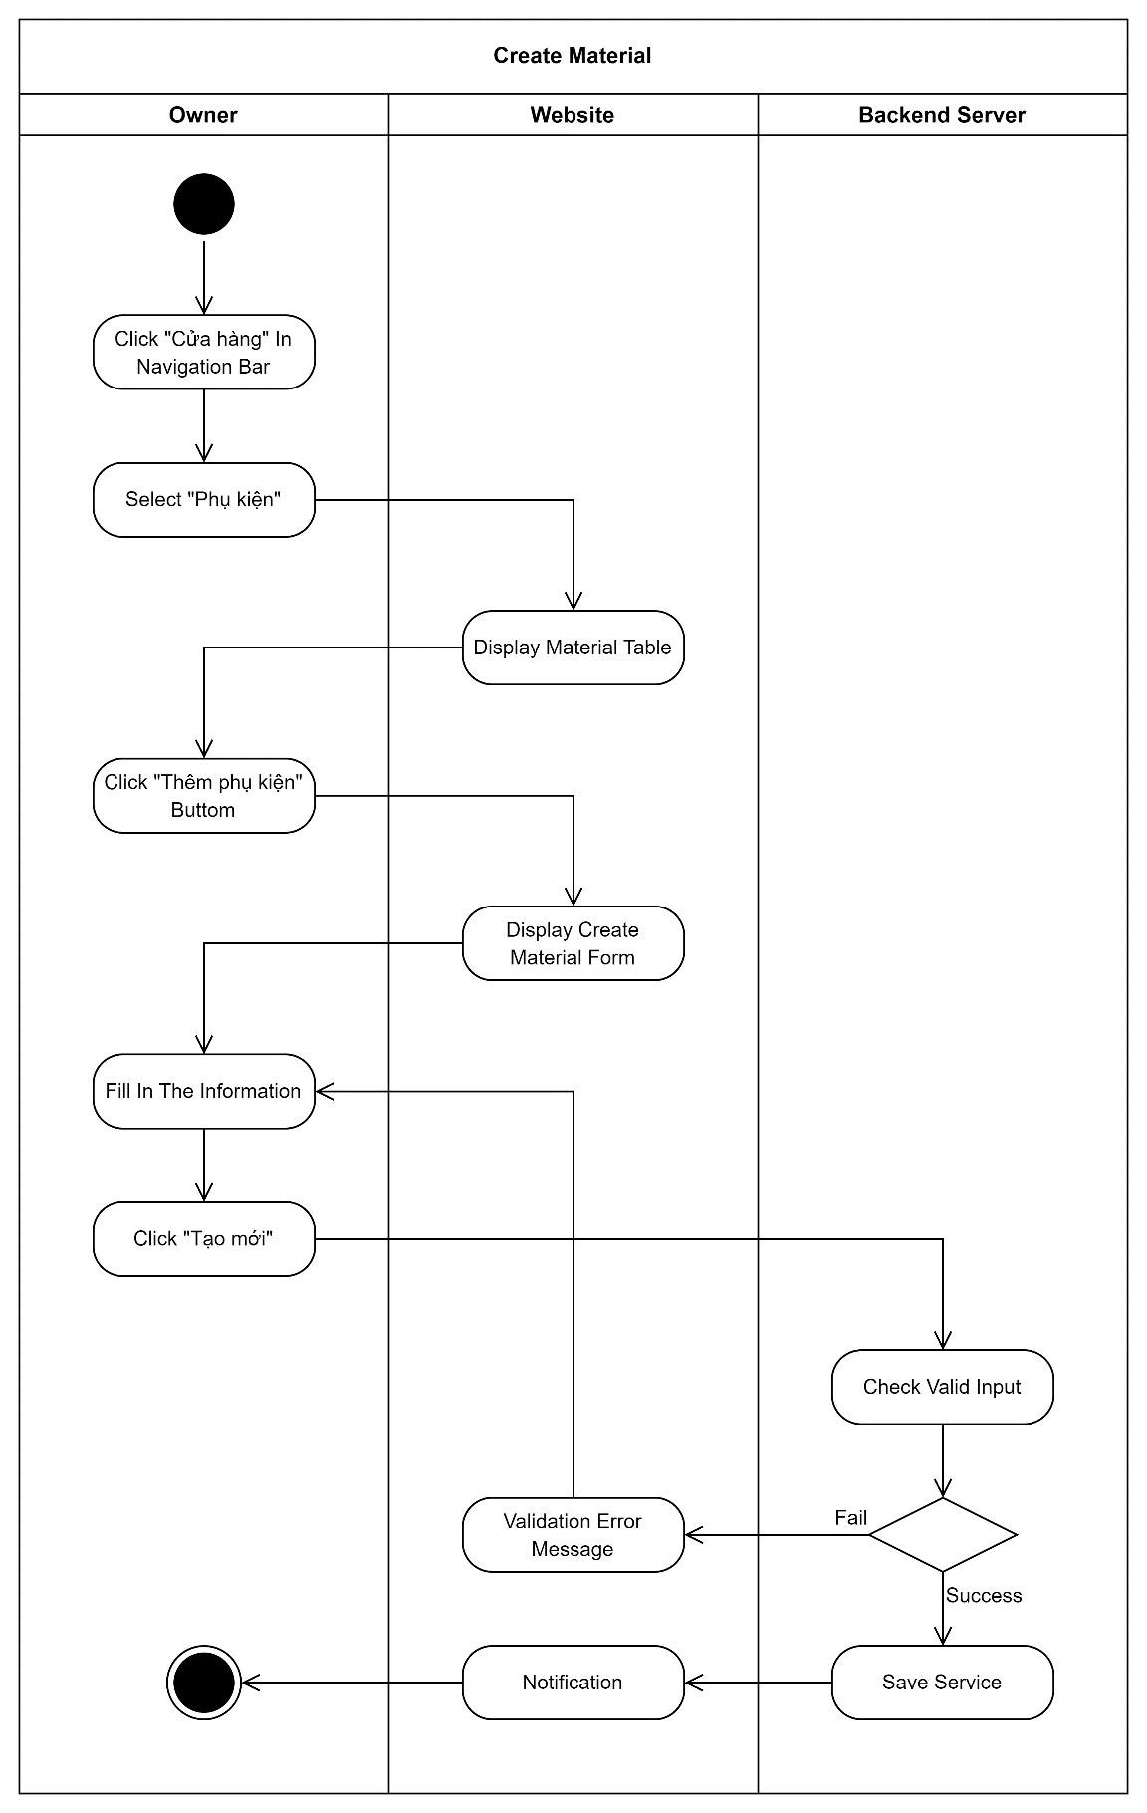

3.4 Check out

3.4.1 Class Diagram

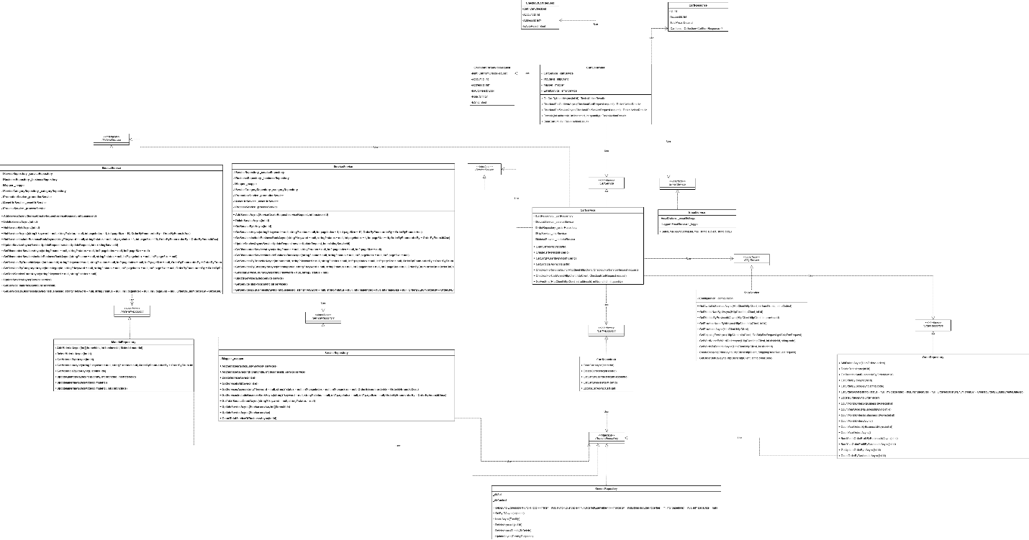

3.4.2 Sequence Diagram
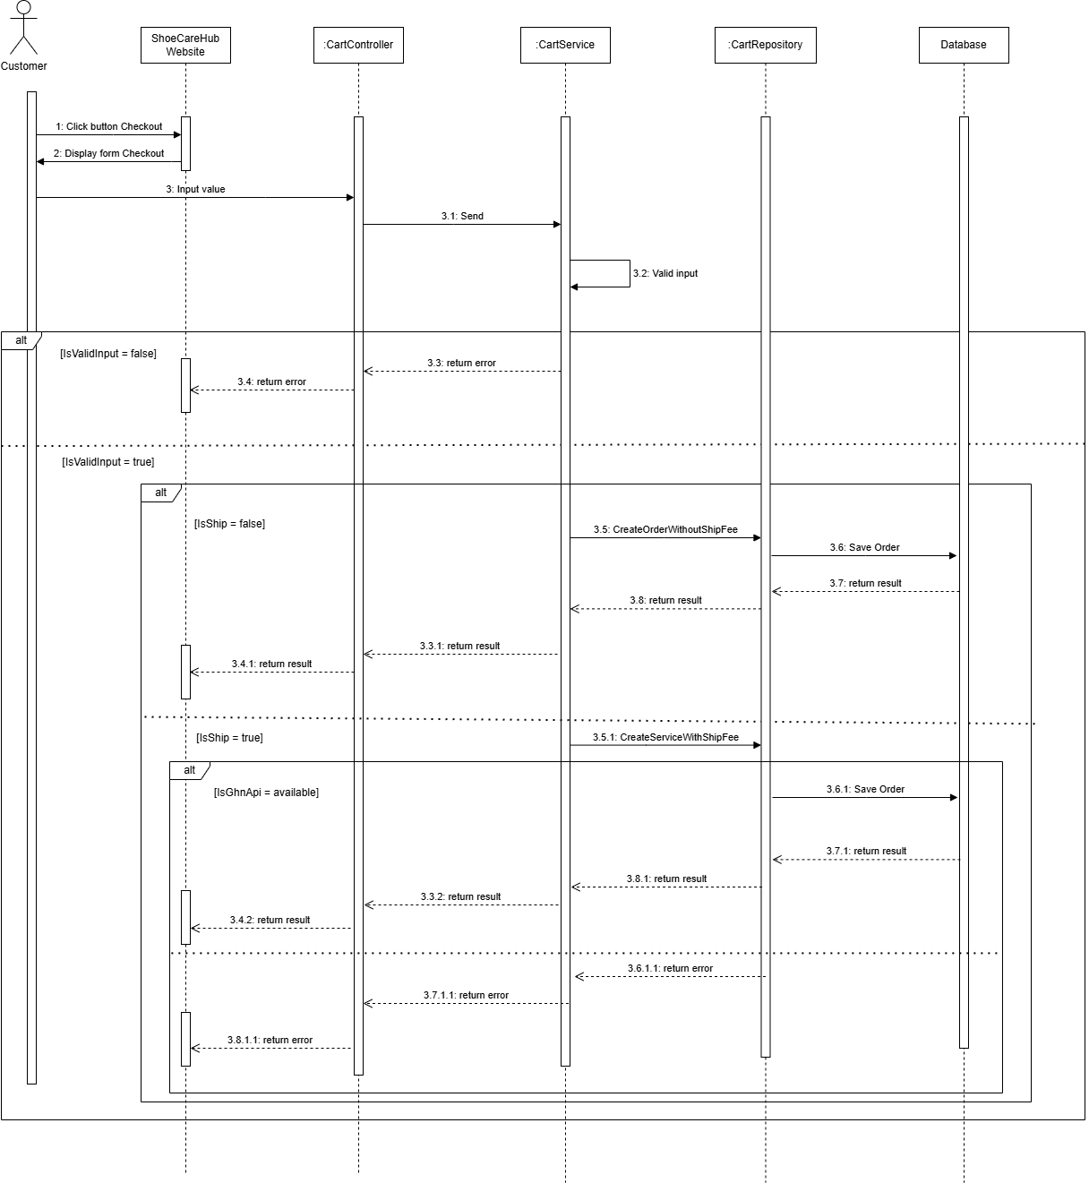

3.4.3 Activity Diagram
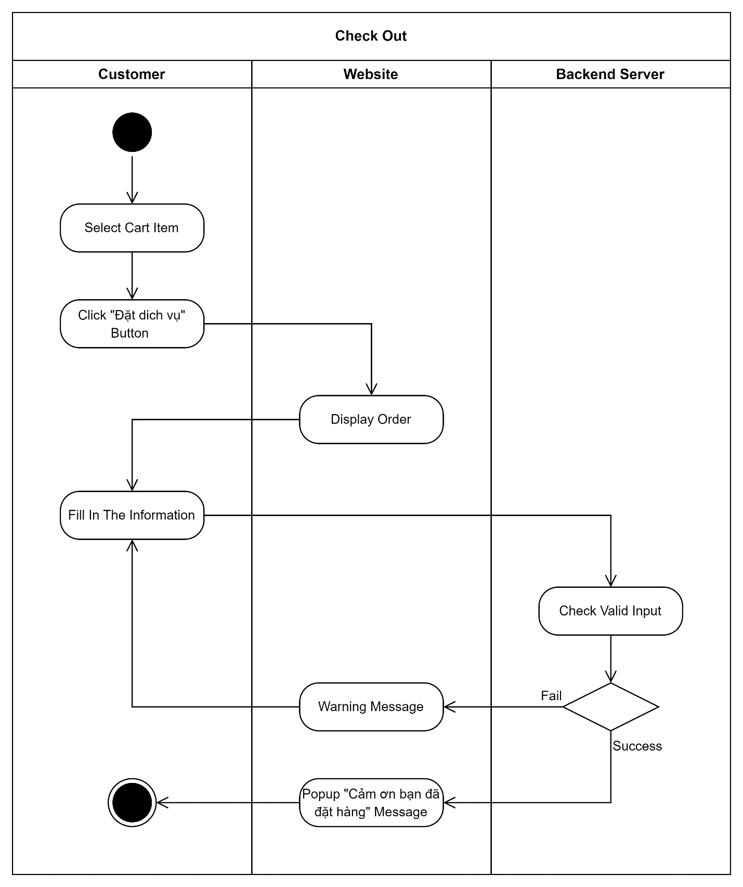

3.5 Create Feedback

3.5.1 Class Diagram

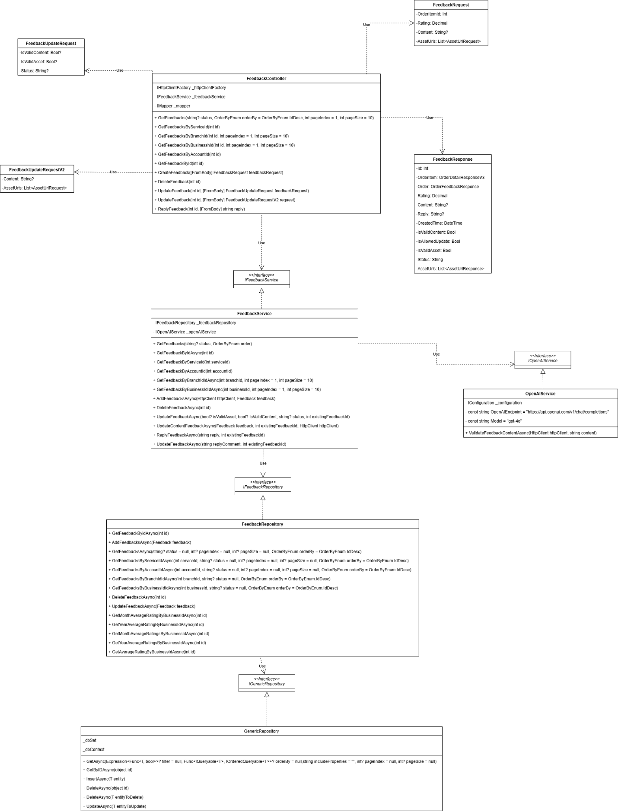

3.5.2 Sequence Diagram

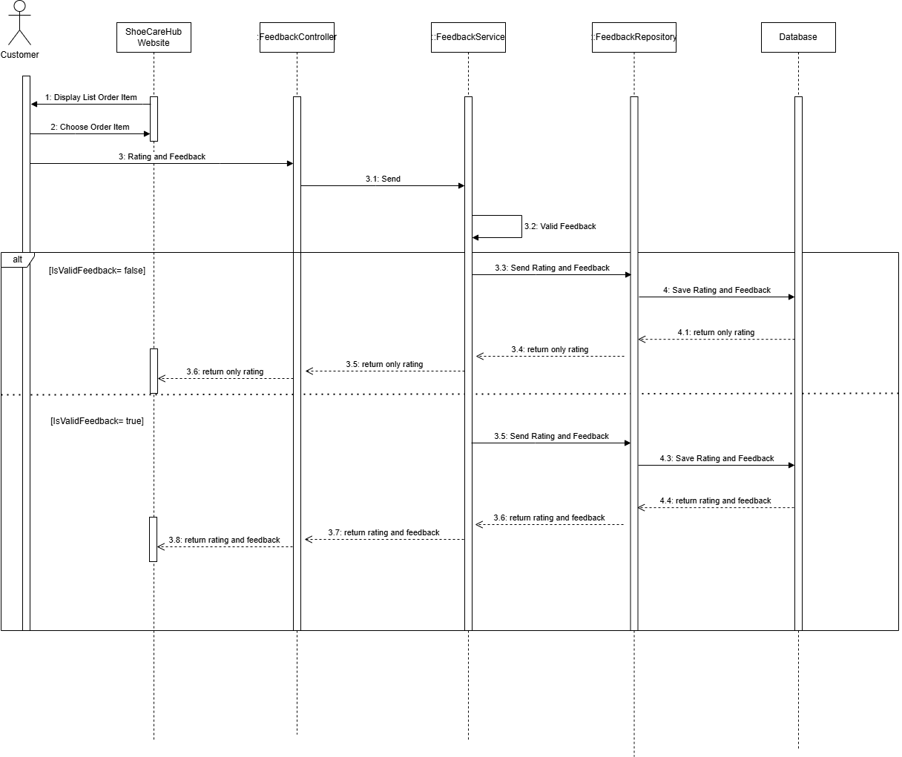

3.5.3 Activity Diagram
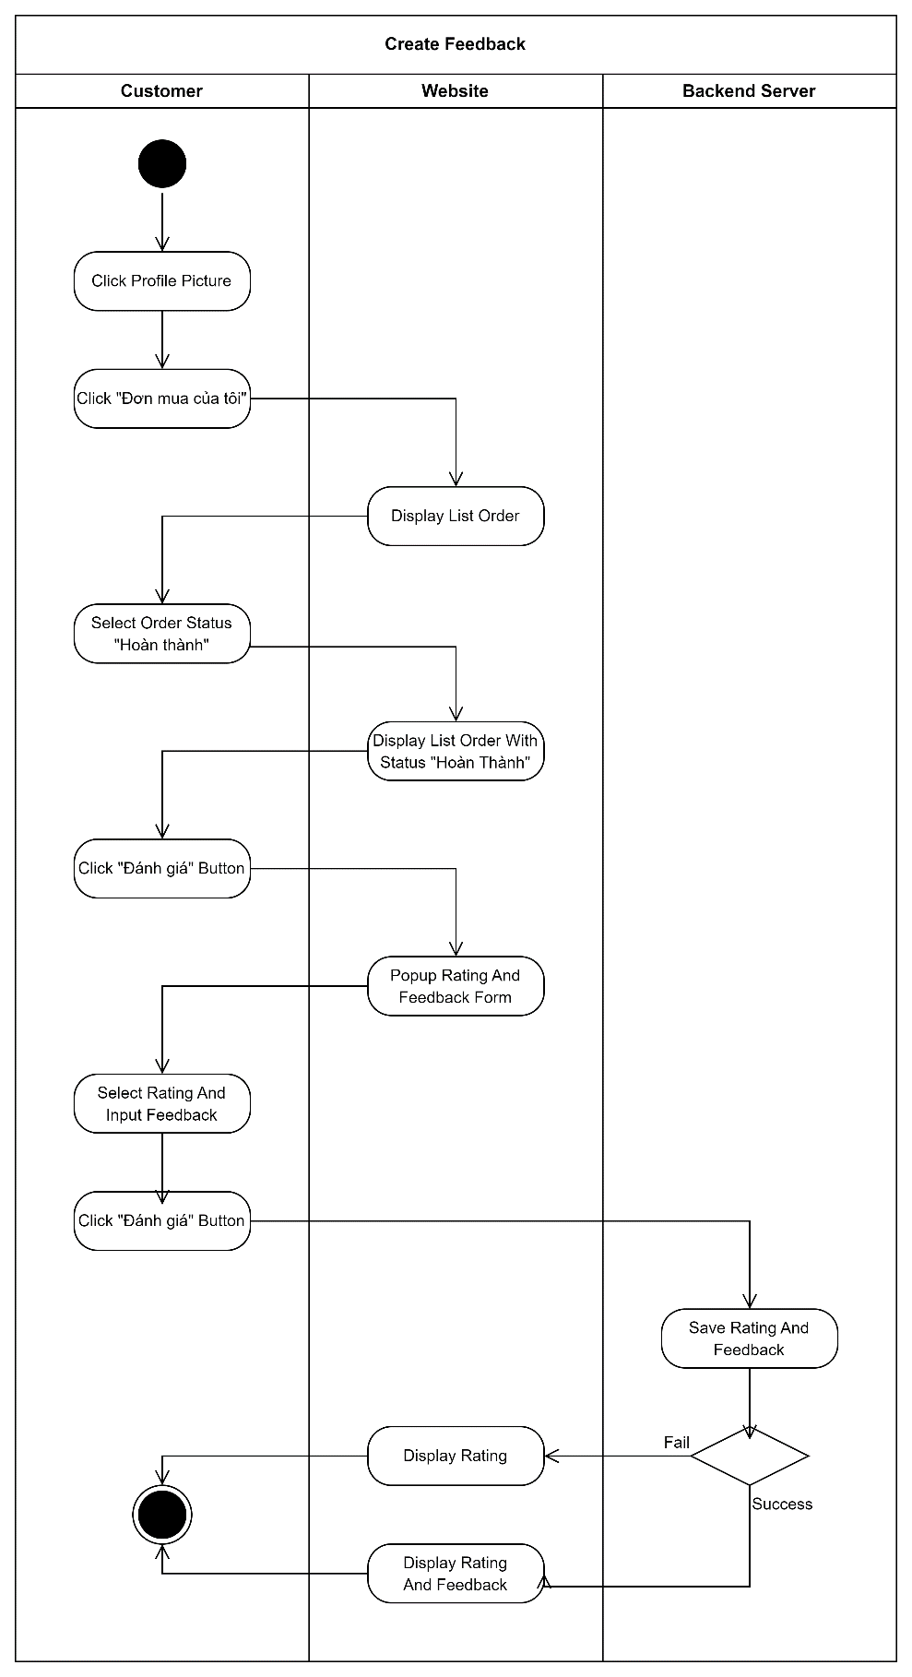

3.6 Register Business

3.6.1 Class Diagram
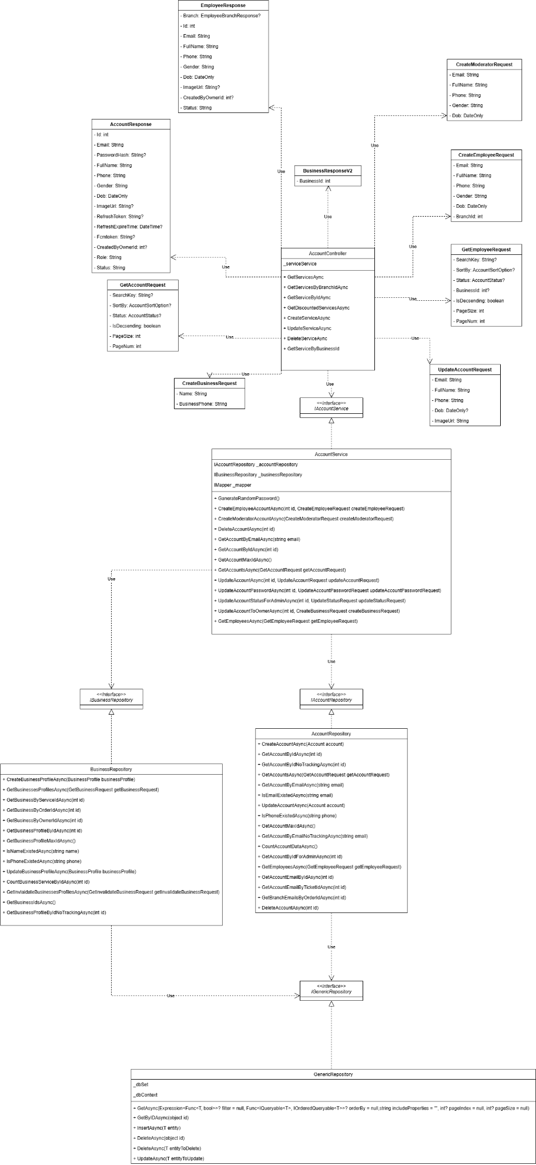

3.6.2 Sequence Diagram

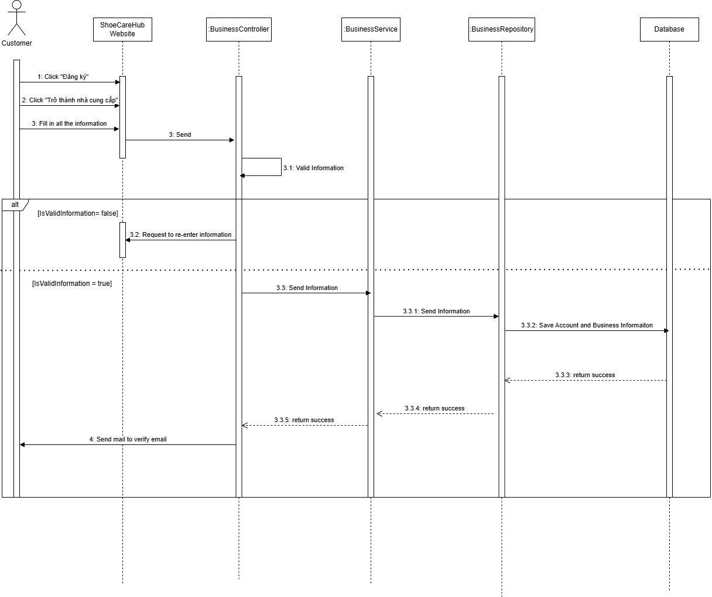

3.6.3 Activity Diagram
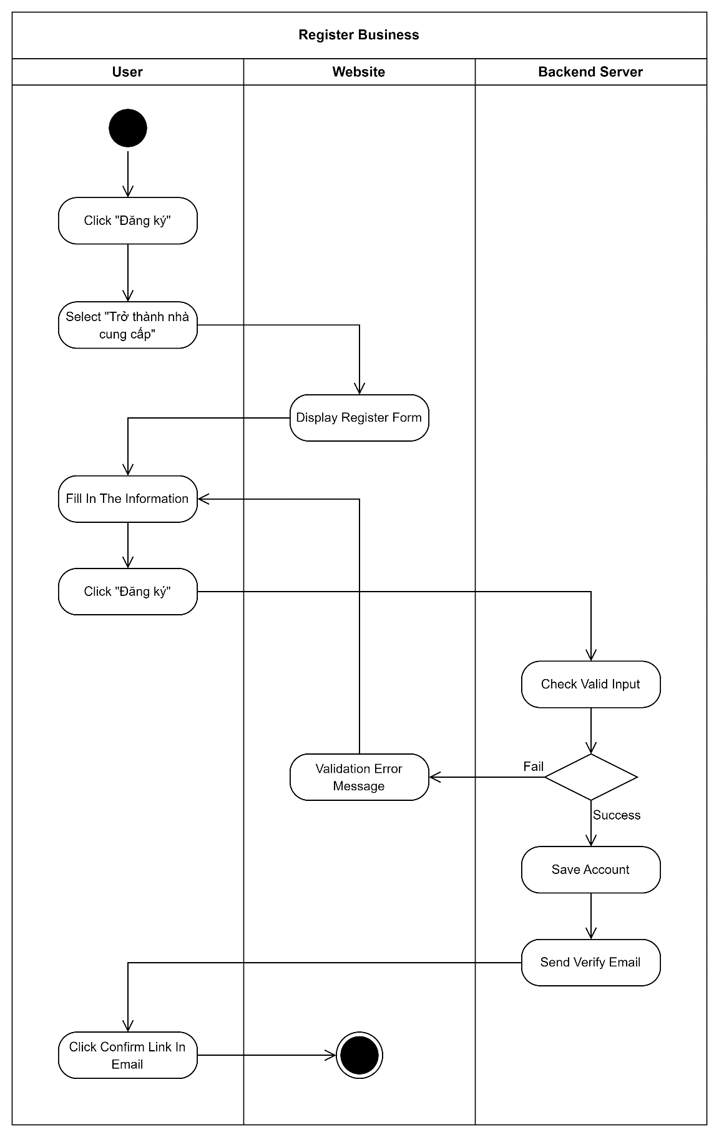

3.7 Create Ticket

3.7.1 Class Diagram

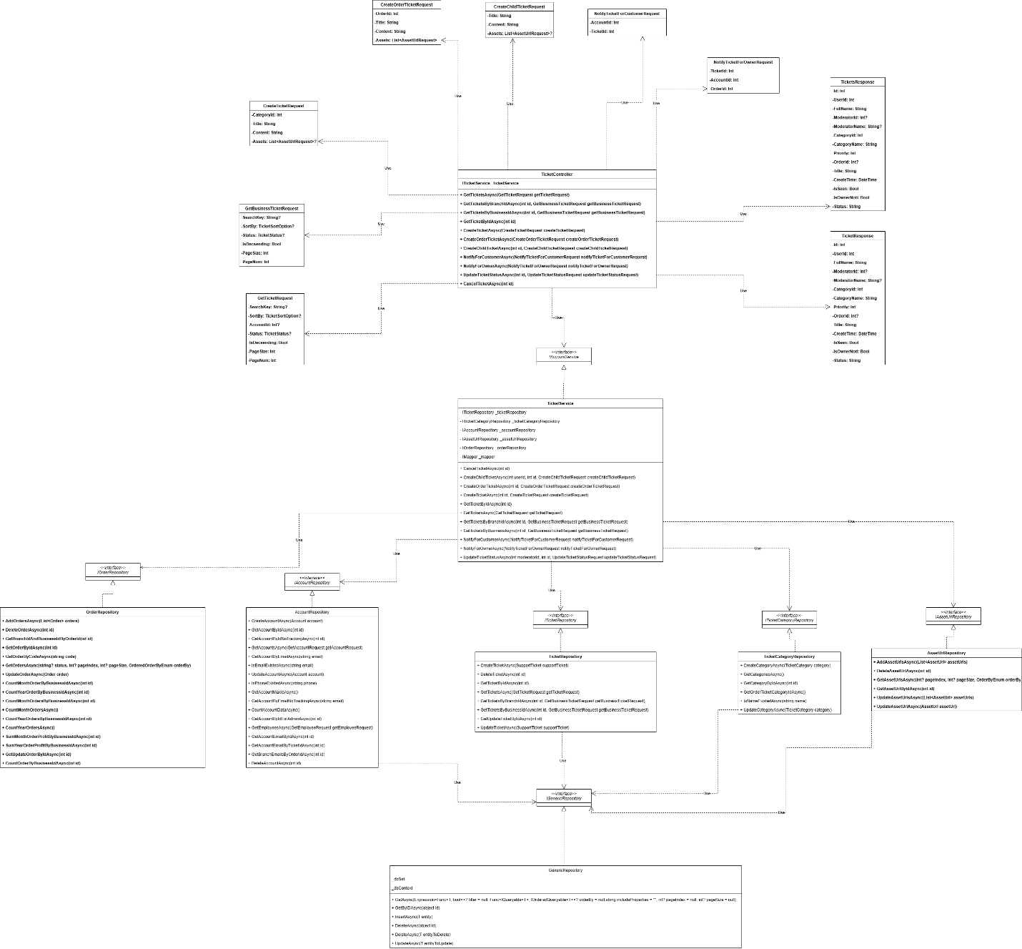

3.7.2 Sequence Diagram

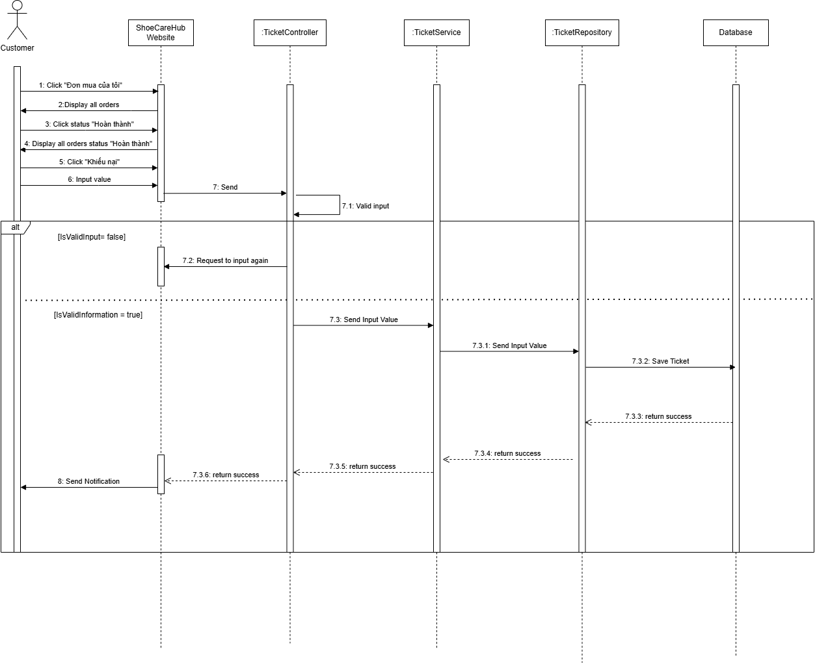

3.7.3 Activity Diagram
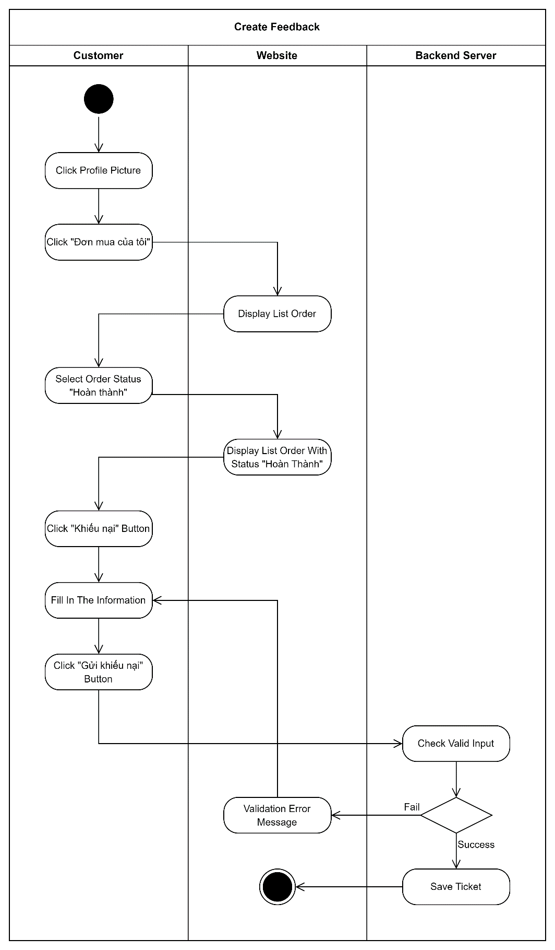

3.8 State Diagram

3.8.1 Business State Diagram
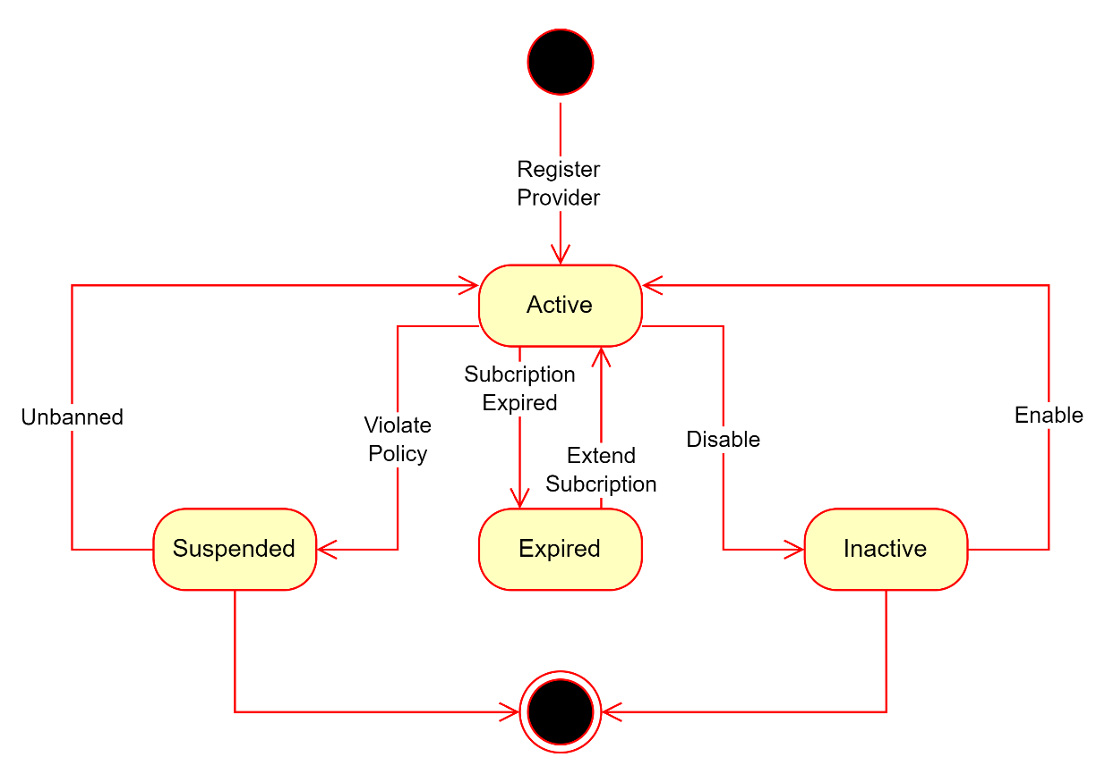

3.8.2 Branch State Diagram
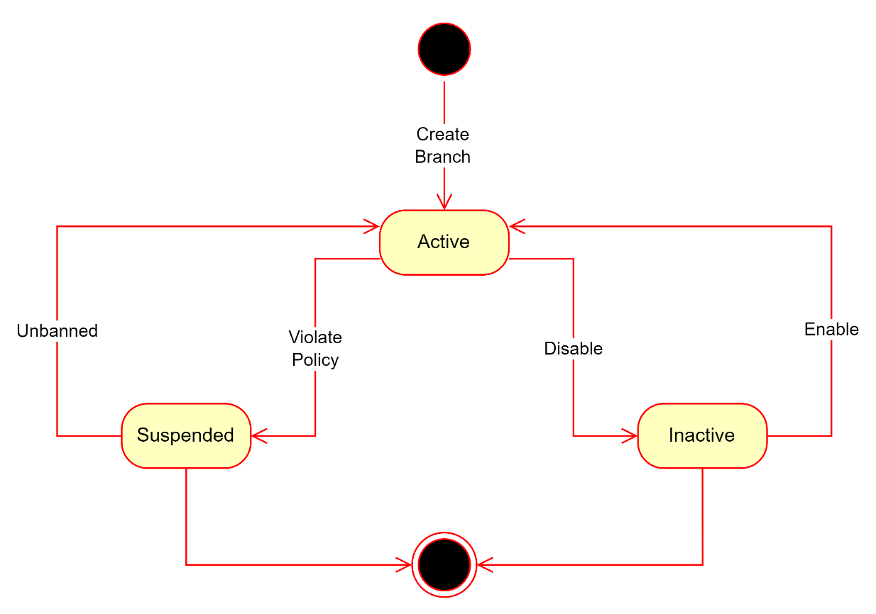

3.8.3 Order State Diagram
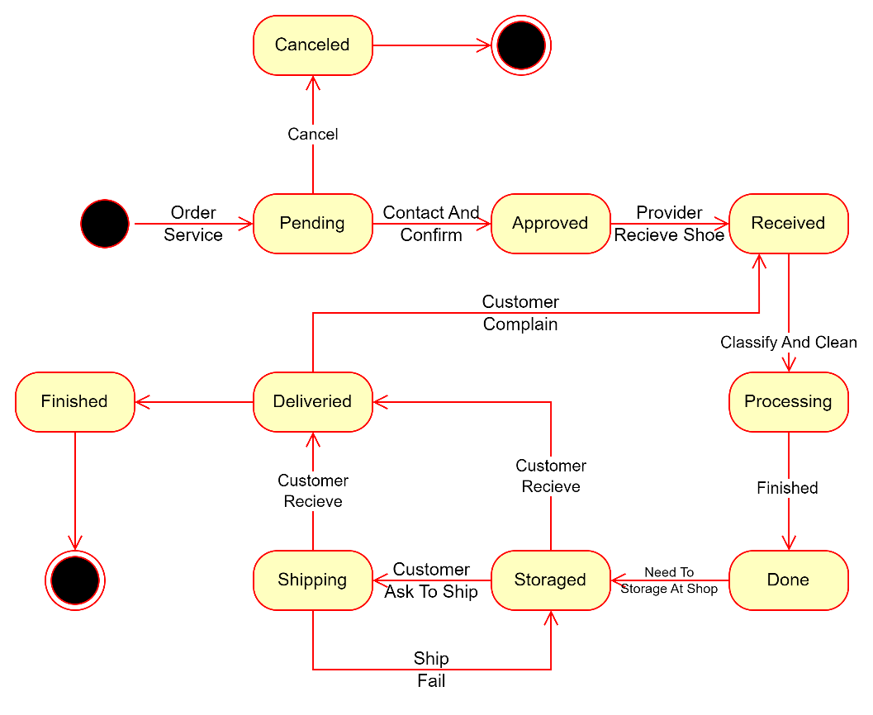

3.8.4 Promotion State Diagram
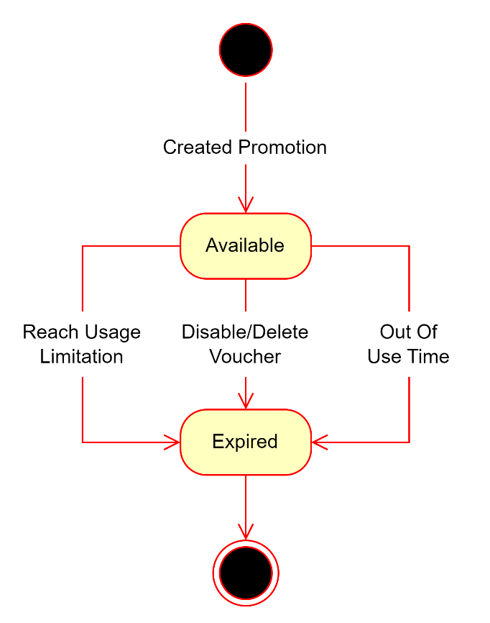

3.8.5 Service State Diagram
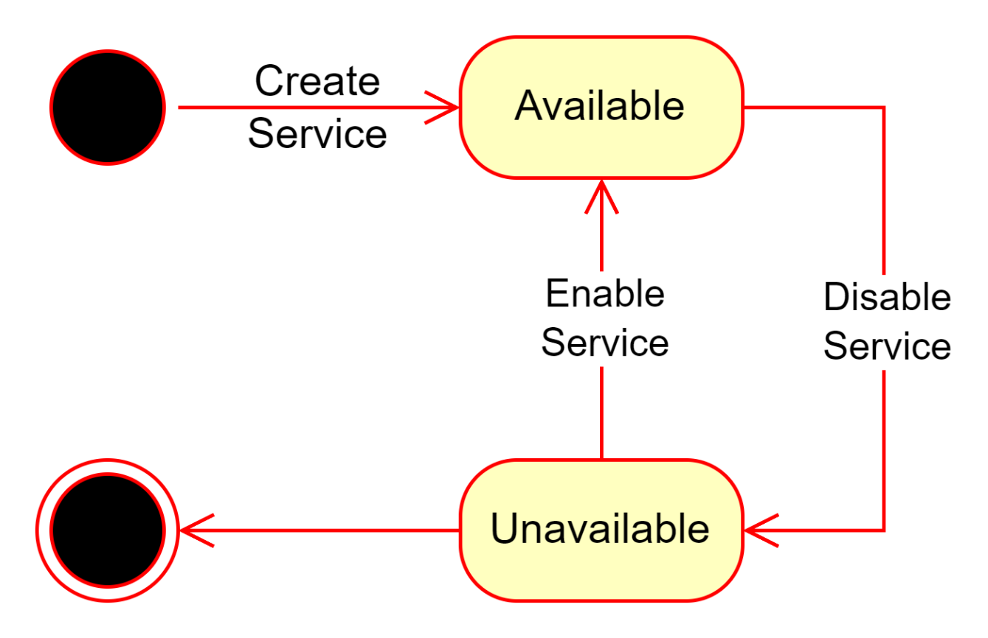

3.8.6 Support Ticket State Diagram
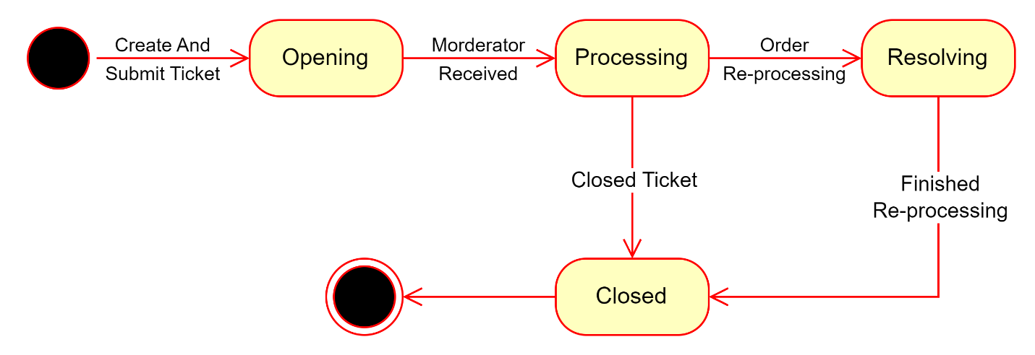

3.8.7 Transaction State Diagram
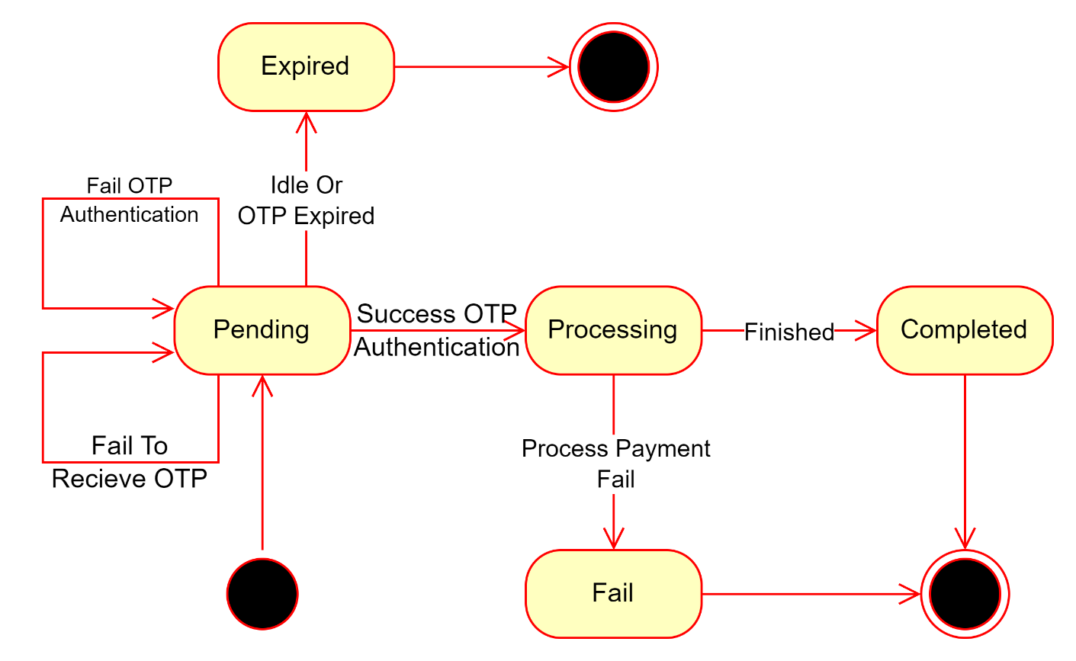

3.8.8 Account State Diagram
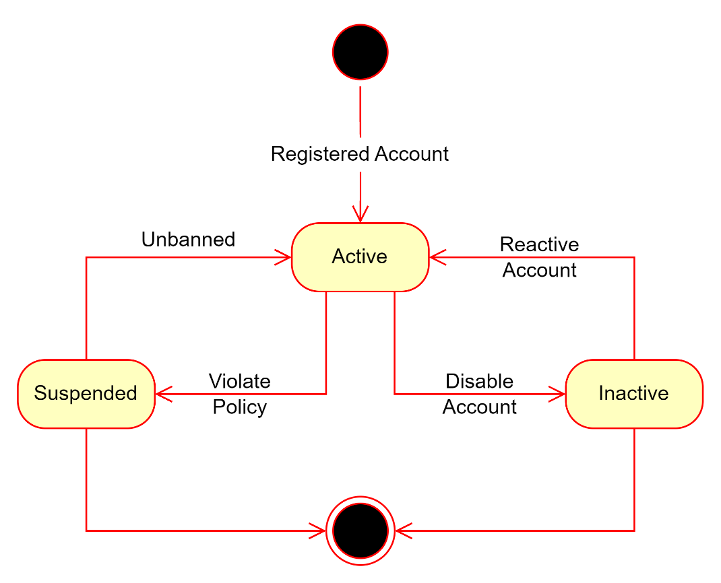

4. Ranking Algorithm

4.1 Theory and Practice:
The algorithm analyzes business raking score from the rating and sale volume from the previous month. It sorts all the raking score of each business in the platform, this helps the business to known if their business is in the top or not.

4.2 Calculation Formula:
_ Using Penalty Factor: a value added to the ranking formula to reduce the overwhelming influence of one factor, ensuring a balance among other factors.
_ Algorithm: Sore = Rating * (1 + 0.3 * $\sqrt{Sale Volume}$)
- Rating: average month feedback rating of business.
- 0.3: penalty factor
- Sale Volume: total finished order in month of business.

V. Software Testing Documentation

1. Scope of Testing
Feature | Function | Role | Description
Account | Register | Customer | This function allow guest to register with the role customer after providing the required fields
 | Login | Admin,  Owner,  Employee,  Customer,  Moderator | This function allow users already has an account log in to the system with required fields
 | Logout |  | This function allows log out of system
 | Change password |  | This function allows change password with login system
 | Forgot password |  | This function allows change password with forgot password
Service | Get list service | Customer,  Guest,  Owner,  Employee | This function allows the user to get all the services in the system
 | Get detail of service |  | This function allows the user to get details about the service in the system
 | Create service | Owner | This function allows manager to create service
 | Update service |  | This function allows manager to update service
Package | Get list package | Admin,  Owner | This function allows to get all the package
 | Get detail package |  | This function allows to get details about the package
 | Create package | Admin | This function allows the admin to create package
 | Update package |  | This function allows the admin to update package
 | Delete package |  | This function allows the admin to delete package
 | Package registration | Owner | This function allows administrators to register packages
Service’s Category | Get list Service’s Category | Admin,  Owner | This function allows to get all the service’s category
 | Get detail Service’s Category | Admin | This function allows admin to get details about the service’s category
 | Create Service’s Category |  | This function allows the admin to create service’s category
 | Update Service’s Category |  | This function allows the admin to update service’s category
Transaction | Get list Transaction | Admin,  Owner | This function allows to get all the transaction
Branch | Get list branch | Owner | This function allows the owner to get all the branch
 | Get detail branch |  | This function allows the owner to get details about the branch
 | Create branch |  | This function allows the owner to create branch
 | Update branch |  | This function allows the owner to update branch
Business | Create business | Customer | This function allows the customer to create the business
 | Get detail business | Owner | This function allows the owner to view the business
 | Update business |  | This function allows the owner to update the business
Feedback | Get list feedbacks | Admin,  Owner | This function allows to get all the feedback
 | Get detail feedback |  | This function allows to get details about the feedback
 | Create feedback | Customer | This function allows the customer to create feedback
 | Update feedback |  | This function allows the customer to update feedback
 | Review feedback | Admin | This function allows the admin to review feedback
Order | Get list orders | Owner,  Employee,  Customer | It allows users to get a list of all orders
 | Get detail order | Owner,  Employee | It allows users to get details about the orders
 | Update order |  | This function allows users to update the information about their orders.
 | Create order | Customer | This function allows the customer to create an order
Ticket | Get list ticket | Customer,  Owner,  Employee,  Moderator,  Admin | It allows users to get a list of all tickets
 | Get detail ticket |  | It allows users to get details about the tickets.
 | Respond ticket |  | This feature allows users to update information and respond to tickets
 | Create ticket | Customer | This feature allows customers to create a ticket when there is a problem that needs support from the system.
Category Ticket | Get list category ticket | Admin | It allows the admin to get a list of all category tickets
 | Get detail category ticket |  | It allows the admin to get details about the category ticket
 | Update category ticket |  | This function allows the admin to update category ticket information
 | Create category ticket |  | This function allows the admin to create category ticket information
Employee | Get list employee | Owner | It allows owners to get a list of all employees
 | Get detail employee |  | It allows owners to get details about the employee.
 | Create employee |  | This function allows the owner to create employees
Material | Get list material | Owner | It allows owners to get a list of all materials
 | Get detail material |  | It allows owners to get details about the material
 | Update material |  | This function allows owners to update material information
 | Create material |  | This function allows the owner to create material
User | Get list user | Admin | It allows admins to get a list of all users
 | Get detail user |  | It allows the admin to get details about the user
 | Update user |  | This function allows admins to update user access rights, including enabling or disabling accounts.
 | Create moderator |  | This function allows the admin to create a moderator
Store | Get list store | Admin | It allows admins to get a list of all stores
 | Get detail store |  | It allows admins to know detailed information about the stores on the system
 | Update store |  | This function allows admins to update user access rights, including enabling or disabling accounts.
 | View store landing page | Customer | This function allows customers to view the services and branches of the store.

2. Test Strategy

2.1 Testing Types
Objective | Technique | Completion criteria
Testing the verification and validation of units of code | Unit Testing | Method, class, etc.
Testing the entire software system to ensure its functionality | System Testing | Software requirements, executed test cases, functional requirements, etc.
Testing different components of the system when they are combined together | Integration testing | Modules
Testing application environment in real situations | End-to-end testing | Database, third-party payment, etc.

2.2 Test Levels
Type of Tests | Test Level
 | Unit | Integration | System | Acceptance
Function Testing | X | X | X
User Interface Testing | X |  | X

2.3 Supporting Tools
Purpose | Tool | Vendor/In-house | Version
API | Postman | Postman | 11.3.0
API | Swagger | Open Source | 7.1.0

3. Test Plan

3.1 Human Resources
Worker/Doer | Role | Specific Responsibilities/Comments
Lê Ngô Hiệp Quốc | Leader | Planning, verifying test deliverables, do interface testing as planned
Phan Danh Ngọc | Member | Planning, verifying test deliverables, do interface testing as planned
Nguyễn Minh Hiếu | Member | Planning, verifying test deliverables, do interface testing as planned
Hà Thị Phương Thảo | Member | Planning, verifying test deliverables, do interface testing as planned

3.2 Test Environment
Purpose | Tool | Provider | Version
Browser Testing | Google Chrome | Google Chrome | 124.0.6367.60
Browser Testing | Microsoft Edge | Microsoft Edge | 11

3.3 Test Milestones
Milestone Task | Start Date | End Date
Register | 30/11/2024 | 30/11/2024
Login | 30/11/2024 | 30/11/2024
Logout | 30/11/2024 | 30/11/2024
Change password | 30/11/2024 | 30/11/2024
Forgot password | 30/11/2024 | 30/11/2024
Get list services | 30/11/2024 | 30/11/2024
Get detail of service | 30/11/2024 | 30/11/2024
Create service | 30/11/2024 | 30/11/2024
Update service | 30/11/2024 | 30/11/2024
Get list services | 30/11/2024 | 30/11/2024
Get detail of service | 30/11/2024 | 30/11/2024
Create service | 30/11/2024 | 30/11/2024
Update service | 30/11/2024 | 30/11/2024
Get list packages | 30/11/2024 | 30/11/2024
Get detail of package | 30/11/2024 | 30/11/2024
Create package | 30/11/2024 | 30/11/2024
Update package | 30/11/2024 | 30/11/2024
Package registration | 30/11/2024 | 30/11/2024
Update service’s category | 30/11/2024 | 30/11/2024
Get list service’s category | 30/11/2024 | 30/11/2024
Get detail of service’s category | 30/11/2024 | 30/11/2024
Create service’s category | 30/11/2024 | 30/11/2024
Update service’s category | 30/11/2024 | 30/11/2024
Get list of transaction | 30/11/2024 | 30/11/2024
Get list branches | 30/11/2024 | 30/11/2024
Get detail of branch | 30/11/2024 | 30/11/2024
Create branch | 30/11/2024 | 30/11/2024
Update branch | 30/11/2024 | 30/11/2024
Get list feedbacks | 30/11/2024 | 30/11/2024
Get detail of feedback | 30/11/2024 | 30/11/2024
Create feedback | 30/11/2024 | 30/11/2024
Update feedback | 30/11/2024 | 30/11/2024
Review feedback | 30/11/2024 | 30/11/2024
Get list orders | 30/11/2024 | 30/11/2024
Get detail order | 30/11/2024 | 30/11/2024
Update order | 30/11/2024 | 30/11/2024
Create order | 30/11/2024 | 30/11/2024
Get list ticket | 30/11/2024 | 30/11/2024
Get detail ticket | 30/11/2024 | 30/11/2024
Respond ticket | 30/11/2024 | 30/11/2024
Create ticket | 30/11/2024 | 30/11/2024
Get list category ticket | 30/11/2024 | 30/11/2024
Get detail category ticket | 30/11/2024 | 30/11/2024
Update category ticket | 30/11/2024 | 30/11/2024
Create category ticket | 30/11/2024 | 30/11/2024
Get list employee | 30/11/2024 | 30/11/2024
Get detail employee | 30/11/2024 | 30/11/2024
Create employee | 30/11/2024 | 30/11/2024
Get list material | 30/11/2024 | 30/11/2024
Get detail material | 30/11/2024 | 30/11/2024
Update material | 30/11/2024 | 30/11/2024
Create material | 30/11/2024 | 30/11/2024
Get list user | 30/11/2024 | 30/11/2024
Get detail user | 30/11/2024 | 30/11/2024
Update user | 30/11/2024 | 30/11/2024
Create moderator | 30/11/2024 | 30/11/2024
Get list store | 30/11/2024 | 30/11/2024
Get detail store | 30/11/2024 | 30/11/2024
Update store | 30/11/2024 | 30/11/2024
View store landing page | 30/11/2024 | 30/11/2024

4. Test Cases & Test Reports
- Test Case: FA24SE026_TranNgocNhuQuynh_TestCase.xlsx
- Test Report: FA24SE026_TranNgocNhuQuynh_TestReport.xlsx

VI. Release Package & User Guides

1. Deliverable Package
No. | Deliverable Item | Description
01 | Project Backlog | FA24SE026_TranNgocNhuQuynh_Backlog.xlsx
02 | Source Codes | Frontend: FA24SE026_TranNgocNhuQuynh_FE.zip  Backend: FA24SE026_TranNgocNhuQuynh_ BE.zip
03 | Database Script(s) | FA24SE026_TranNgocNhuQuynh_ DatabaseScript.sql  FA24SE026_TranNgocNhuQuynh_ DataScript.sql
04 | Final Report Document | FA24SE026_TranNgocNhuQuynh_FinalReport.docx
05 | Test Cases Document | FA24SE026_TranNgocNhuQuynh_TestReport.xlsx  FA24SE026_TranNgocNhuQuynh_UnitTest.xlsx
06 | Slide | FA24SE026_TranNgocNhuQuynh_Silde.ppt

2. Installation Guides

2.1 System Requirements

2.1.1 Hardware Requirements
PC | Minimum | Maximum
Internet connection | Cable, Wi-fi | Cable, Wi-fi
Processor | Intel Core i5 | Intel Core i7
Memory | 8GB RAM | 16GB RAM
Storage | HDD 256GB | SSD 256GB
Web Browser | Google Chrome  Microsoft Edge | Google Chrome v131.0.6778.103  Microsoft Edge v131.0.2903.86

2.1.2 Software requirements
Component | Name And Version | Description
Operating System | Windows 10 | Operating system for building production
DBMS | SQLServer 2022 | Used to manage database
.NET | .NET SDK 8.0,  .NET Core 8.0 Runtime | Use to run back-end server
ReactJS | ReactJS 18.3.1 | Use to run front-end server
IDE | Visual Studio 2022,  Visual Studio Code | Use to write, edit and run code

2.2 Installation Instruction

2.2.1 Setup Frontend Website Application
- Install Visual Studio Code by following guidelines link: https://code.visualstudio.com/docs/setup/windows
- Install npm through Visual Studio Code or you can install npm via NodeJS: https://nodejs.org/en/
- Clone the FE source code: git clone https://github.com/ngocpd2001/ShoeCareHub_FE
- Open git bash and enter:
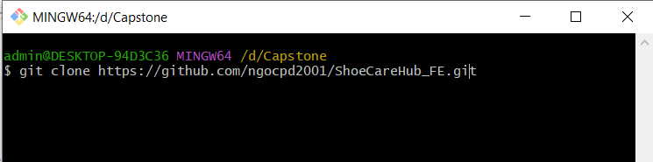
- Open terminal in visual studio:
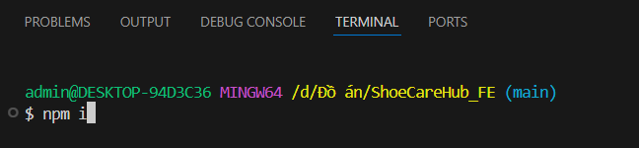
- Open terminal in visual studio to start:
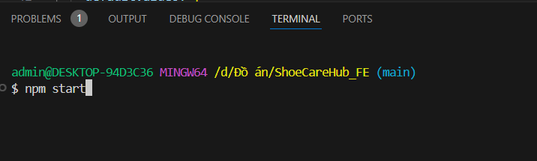

2.2.3 Setup Database
- Install SQL Server 2022 by following Microsoft guidelines: https://learn.microsoft.com/en-us/sql/database-engine/install-windows/install-sql-server?view=sql-server-ver16

2.2.3 Setup Backend Website Application
- Install Visual Studio 2022 by following guidelines link: https://visualstudio.microsoft.com/downloads/
- Clone the source code: git clone https://github.com/SEP490-TP4SCS/TP4SCS.BE.git
- Open TP4SCS.Solution.sln file with Visual Studio 2022:
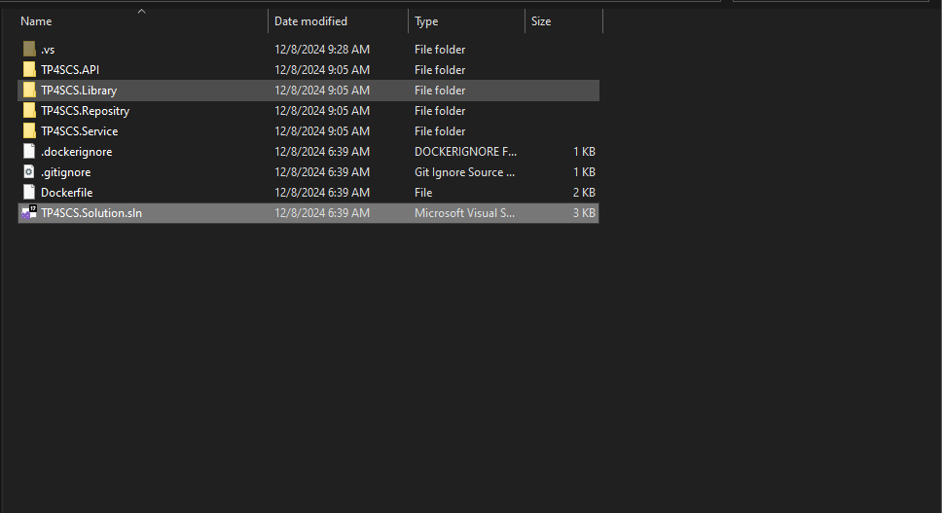
- Test the source code by click the green outline triangle to run:
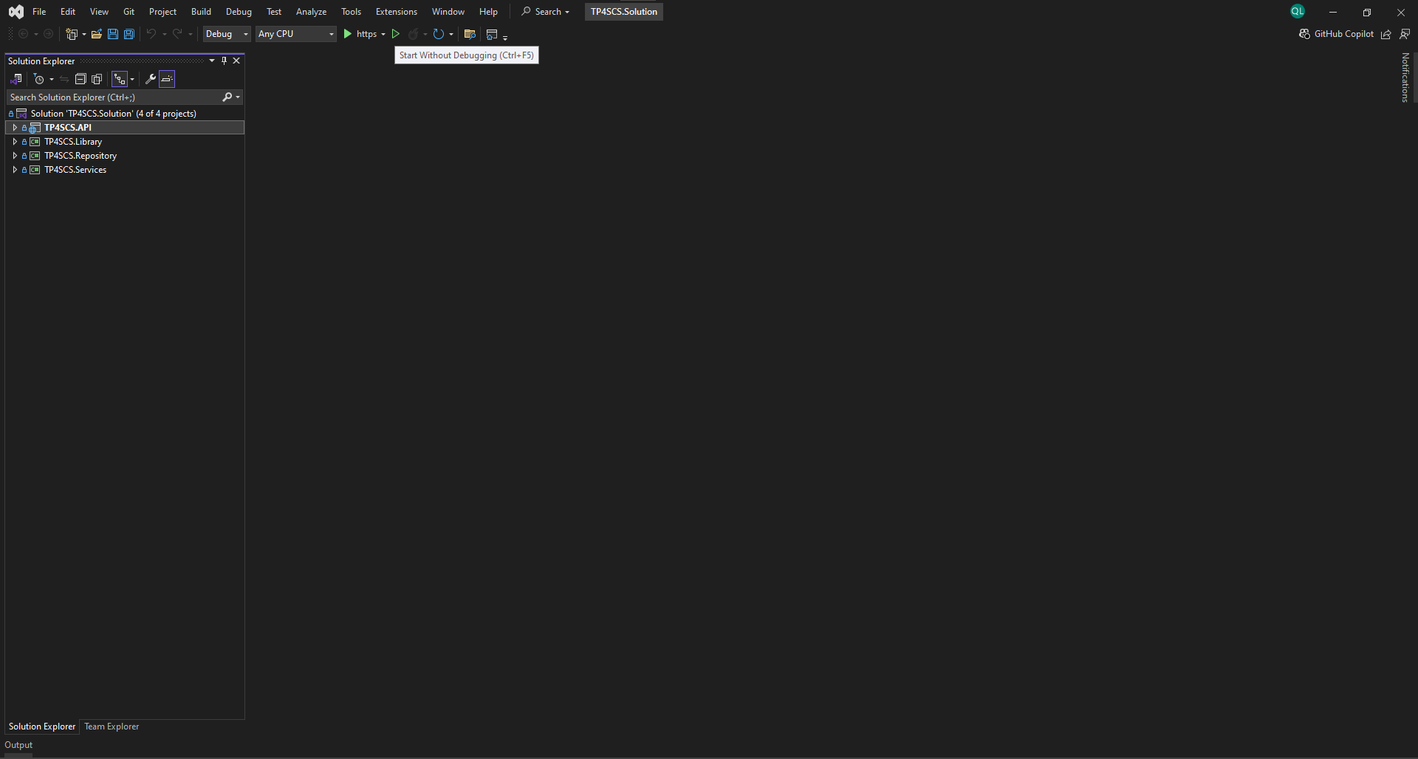

3. User Manual

3.1 Overview
ShoeCareHub is a platform that connect between those shoe service provider and customer. At customer web application, it provides feature such as: manage personal information, view service, service feedback, business ranking, order service, … At business web application, it provides feature such as: manage business, manage branch and employee, manage order, view feedback, …
With this project we have 4 main workflows:
No. | Workflow | Actor
01 | Register | Guest
02 | Process Order | Customer, Owner, Employee
03 | Process Support Ticket | Customer, Owner, Employee, Moderator
04 | Feedback | Customer, Owner, Employee, Moderator

3.2 Register Flow

3.2.1 Customer Register Flow
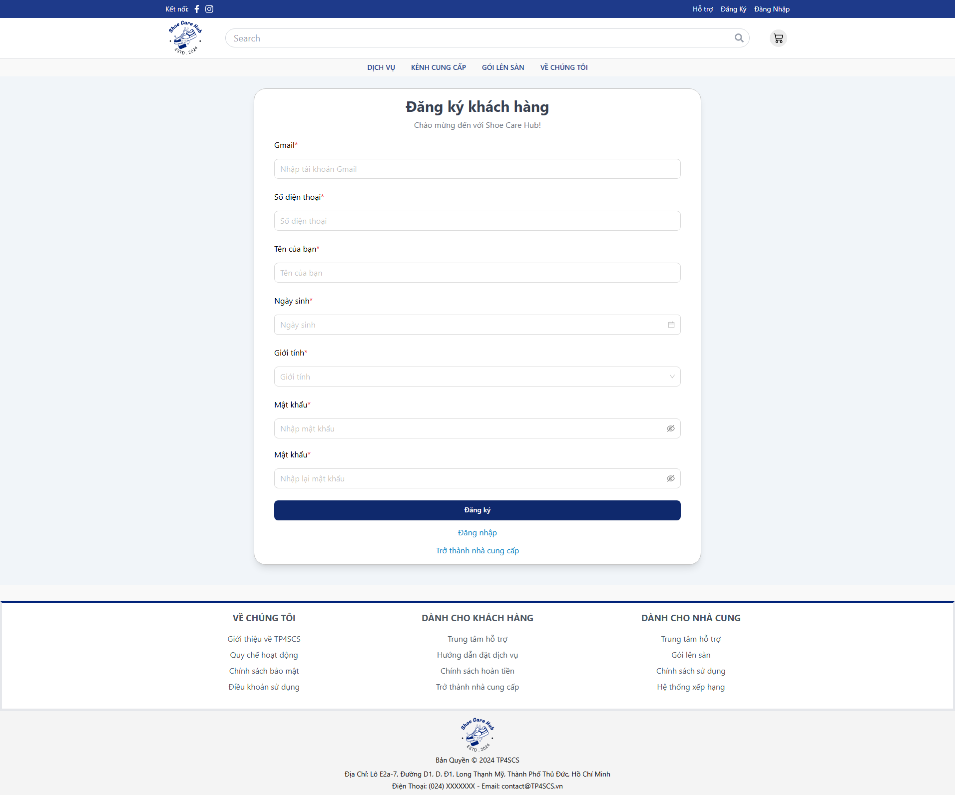
- At Login Page, click “Đăng ký”.
- Fill all require fields with valid data.
- Click “Đăng ký”.
- Check your registered email.
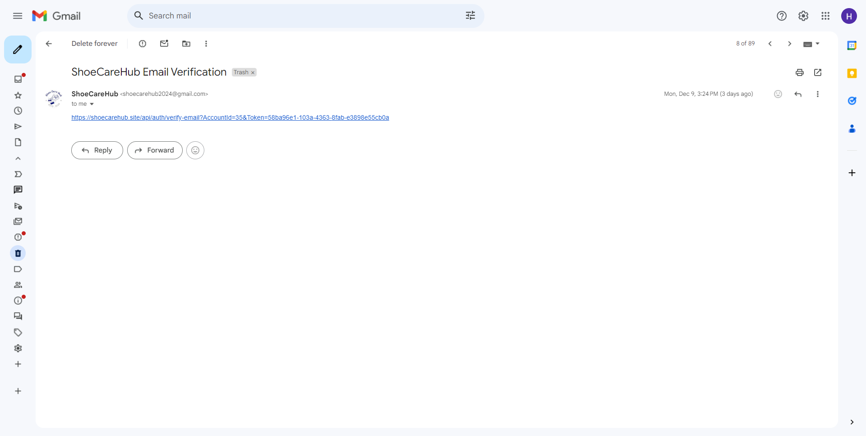
- Click on the given link

3.2.2 Owner Register Flow
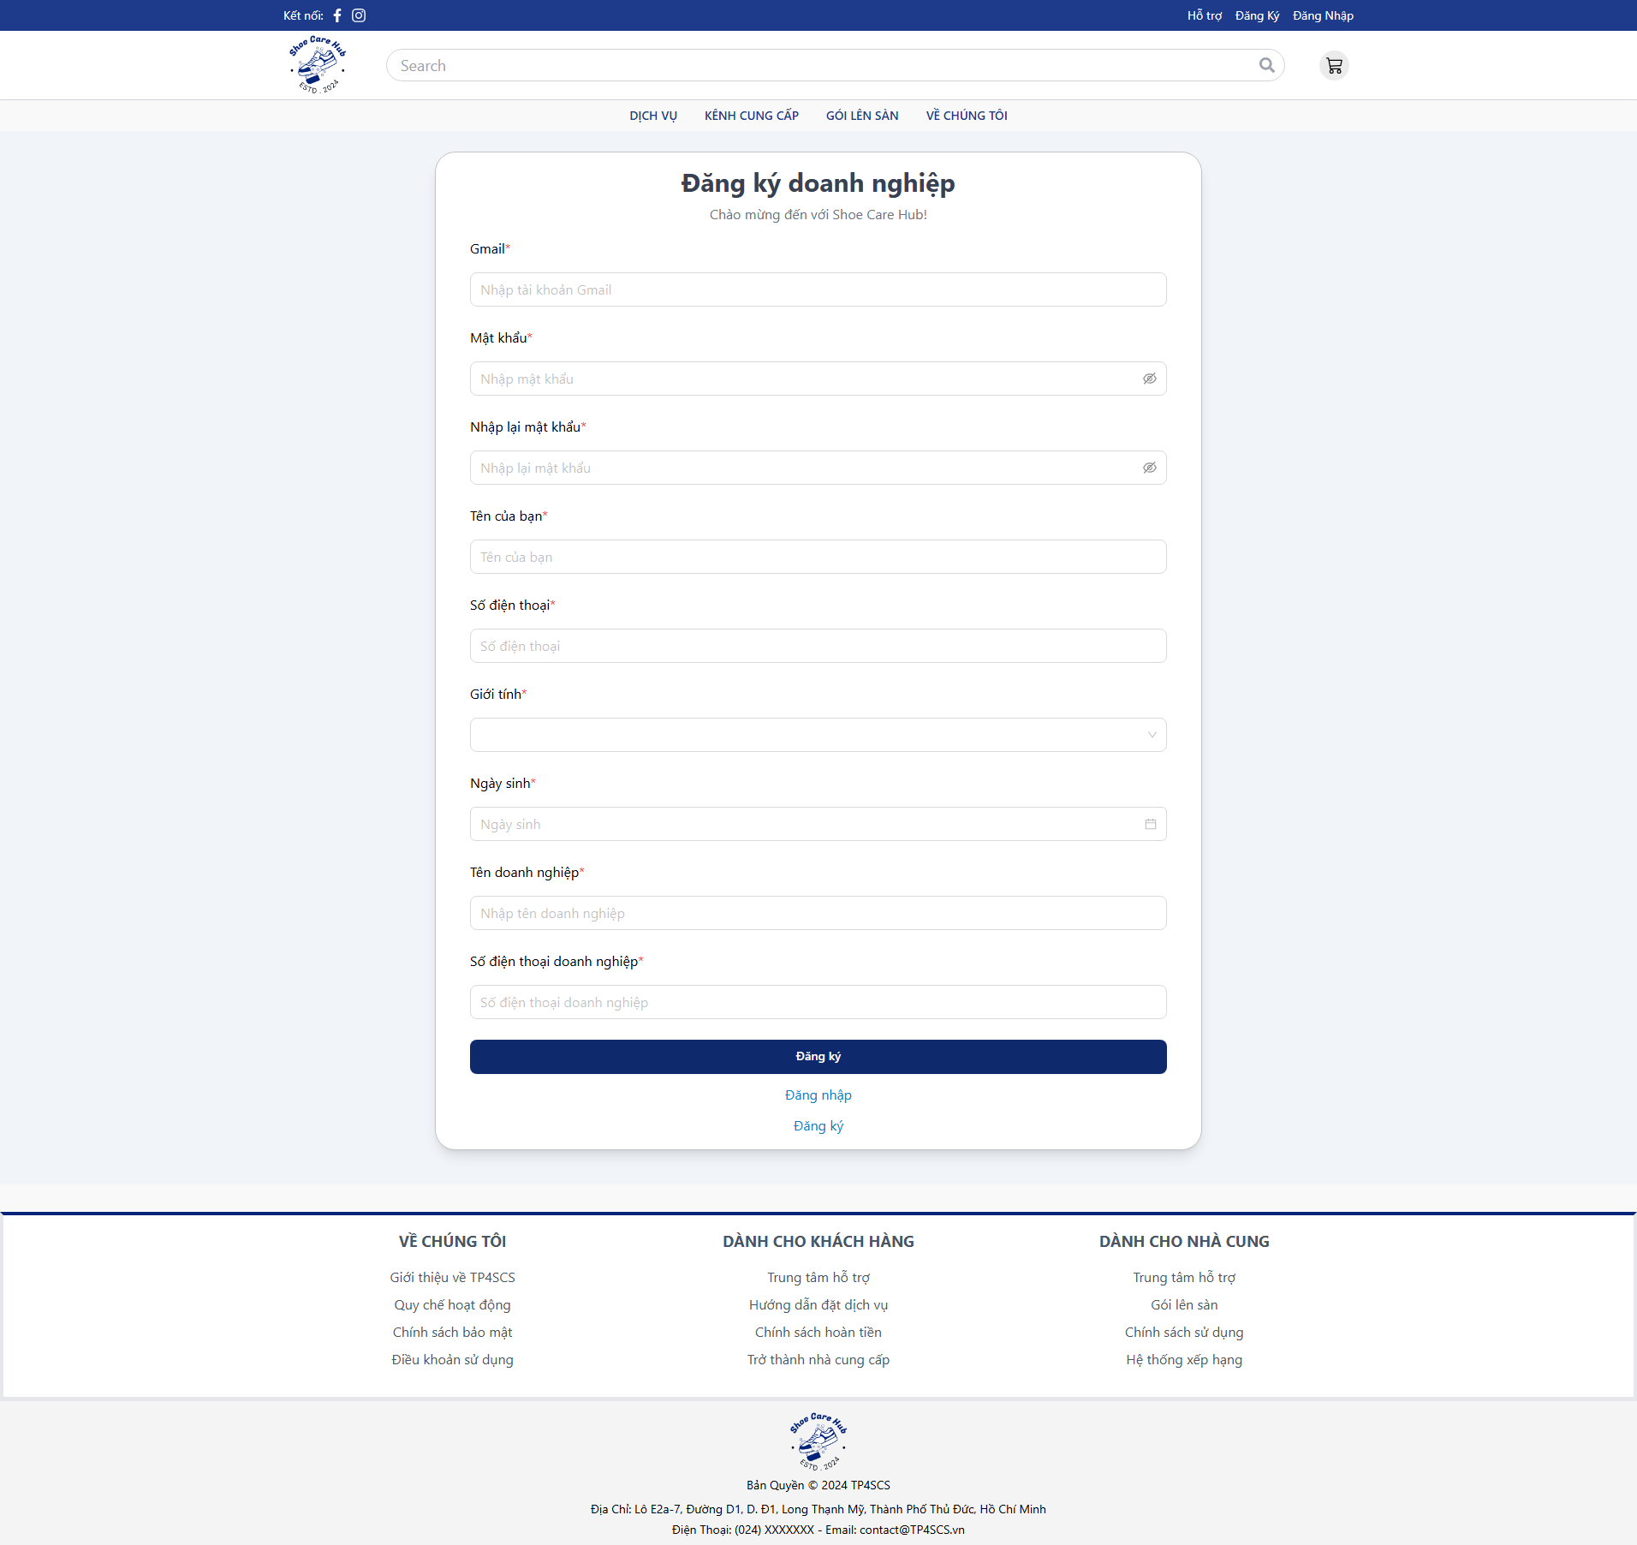
- At Login Page, click “Trở thành nhà cung”.
- Fill all require fields with valid data.
- Click “Đăng ký”.
- Check your registered email.

- Click on the given link
- Login to registered owner account.
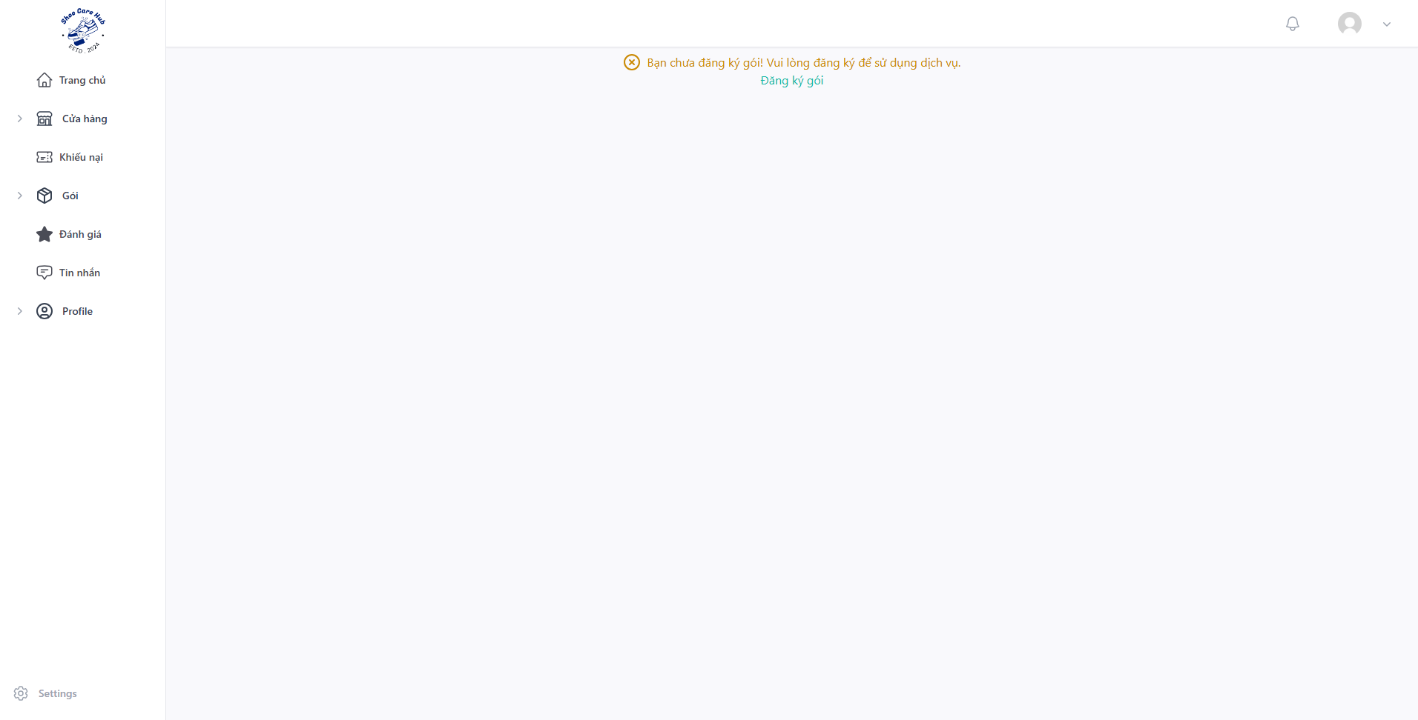
- Click “Đăng ký gói”
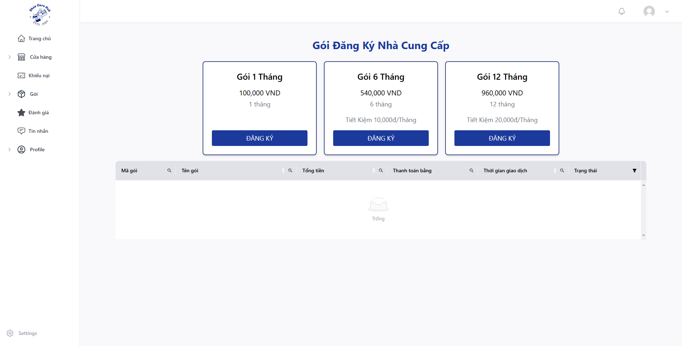
- Choose pack that you want to use and click “ĐĂNG KÝ”.
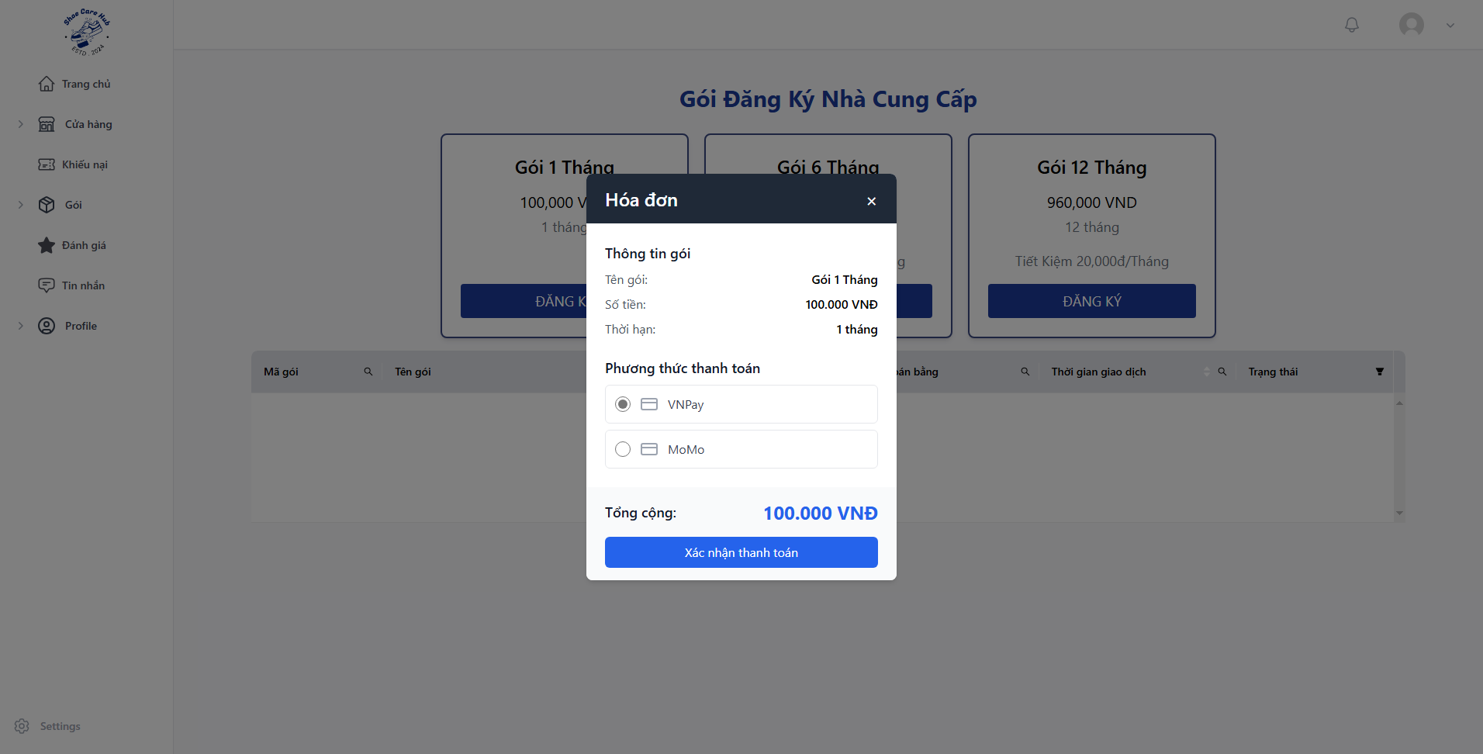
- Choose payment method and click “Xác nhận thanh toán”.
- Process payment with your VnPay or MoMo account.

3.3 Process Order Flow

3.3.1 Owner Create Service
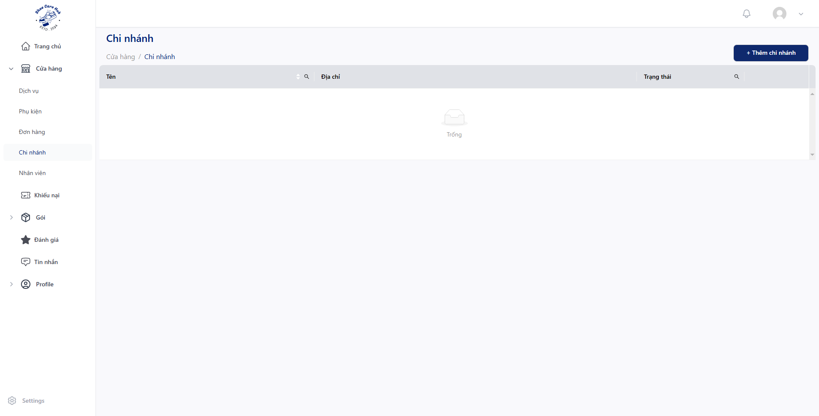
- Click “Cửa hàng” then click “Chi nhánh” and click “Thêm chi nhánh”.
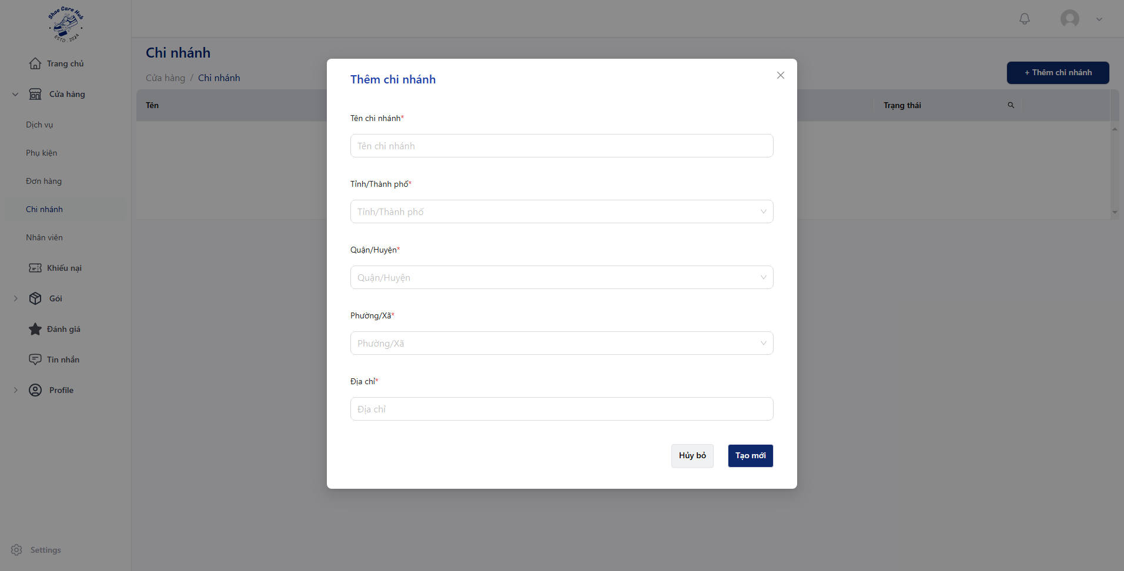
- Fill all require fields with valid data and then click “Tạo mới”.
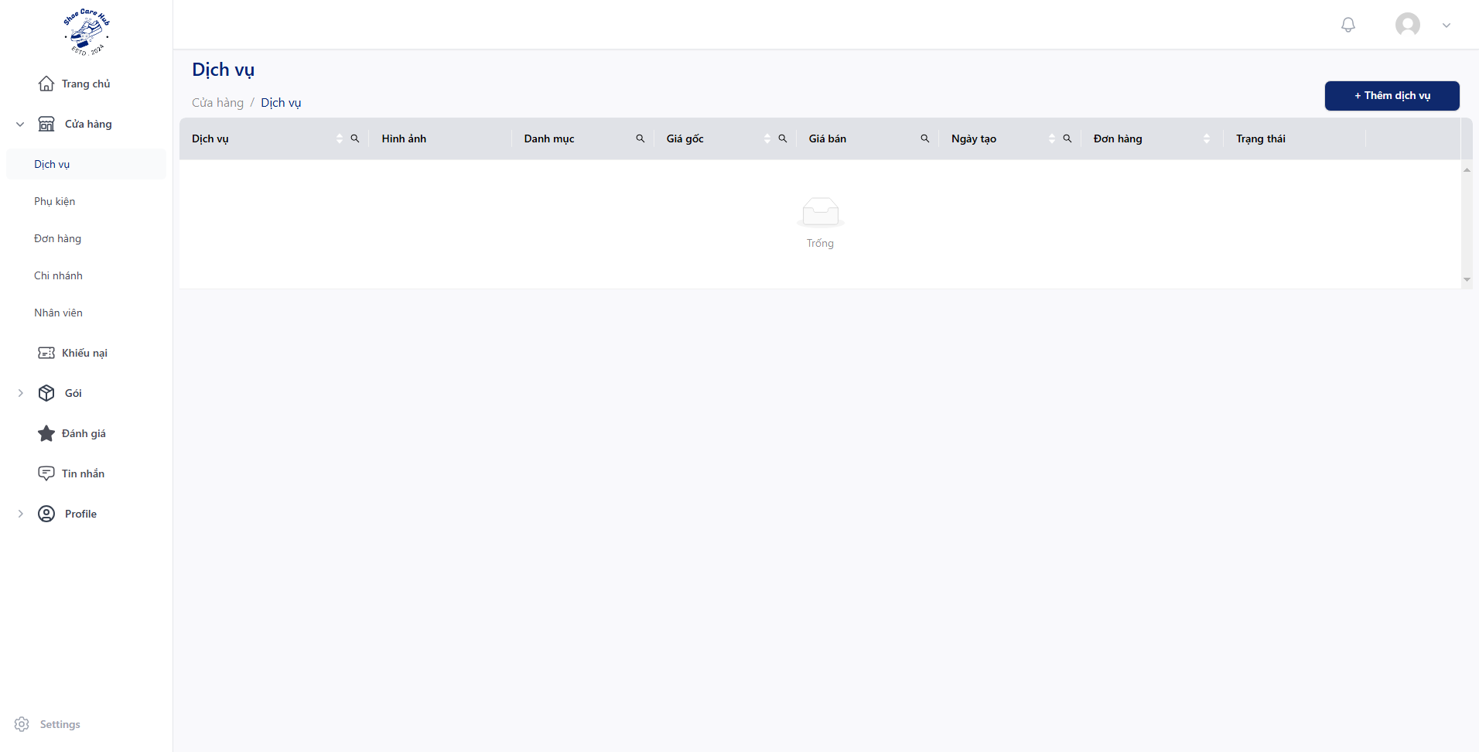
- Click “Cửa hàng” then click “Dịch vụ” and click “Thêm dịch vụ”.
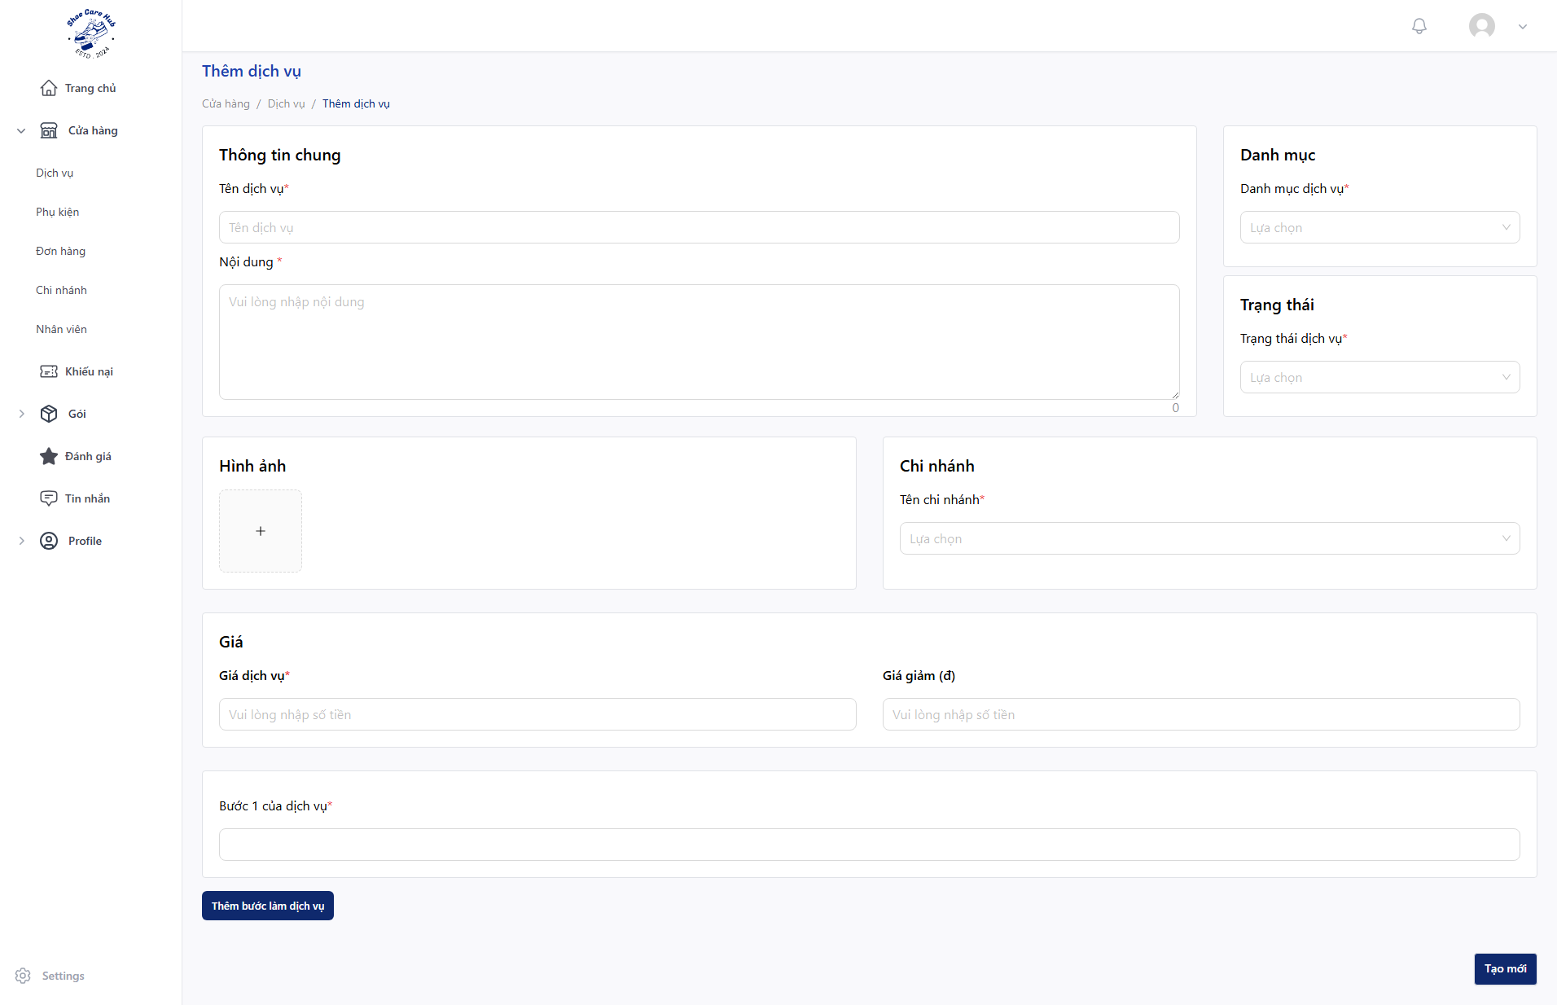
- Fill all require fields with valid data and then click “Tạo mới”.

3.3.2 Customer Order Service
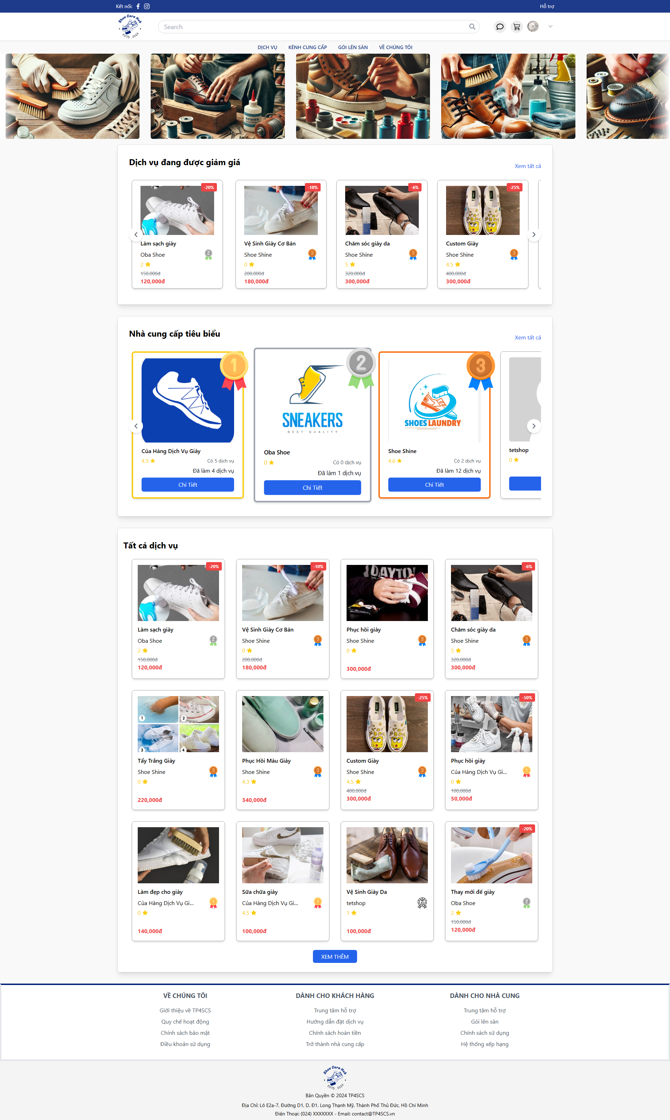
- At Home Page, click on any service you want.

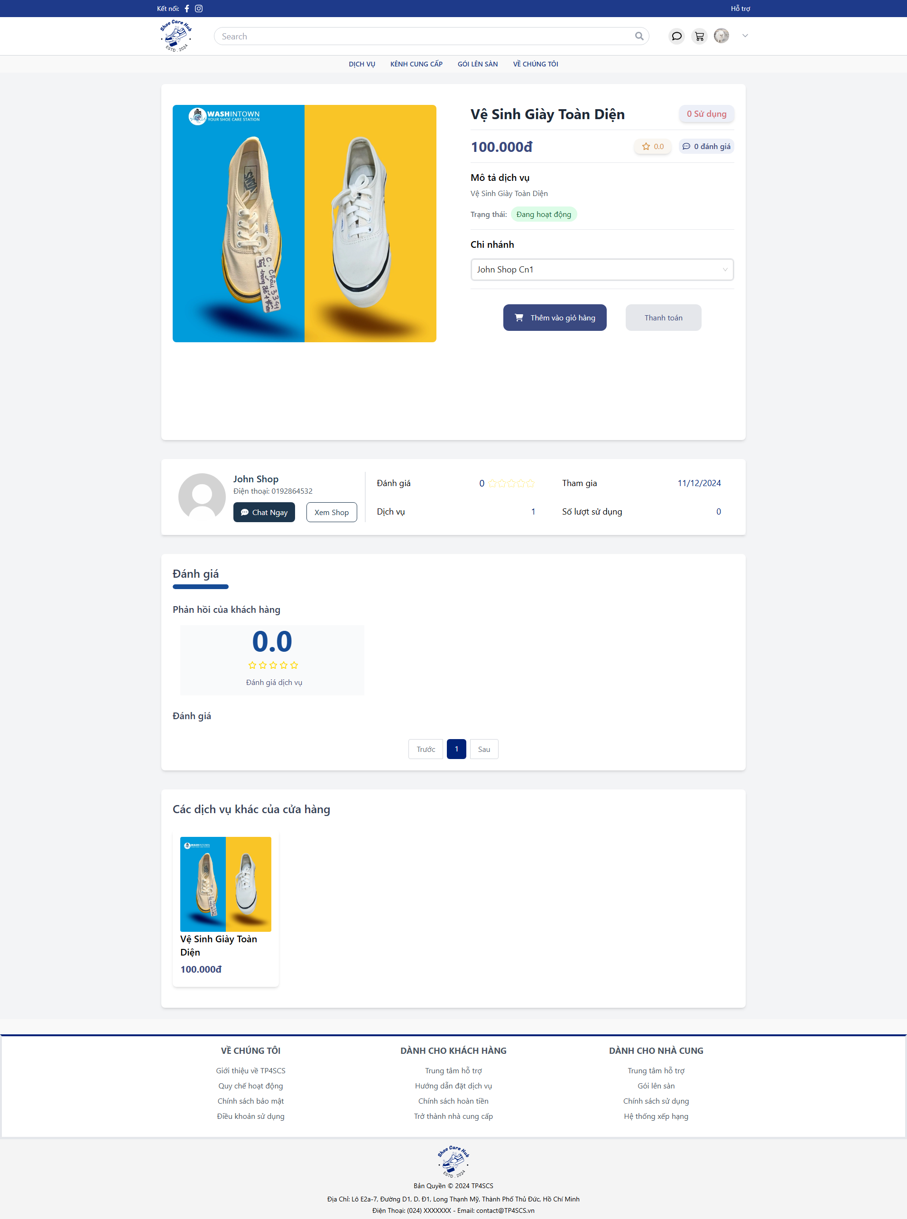
- Choose the branch you want and click “Thanh toán”.

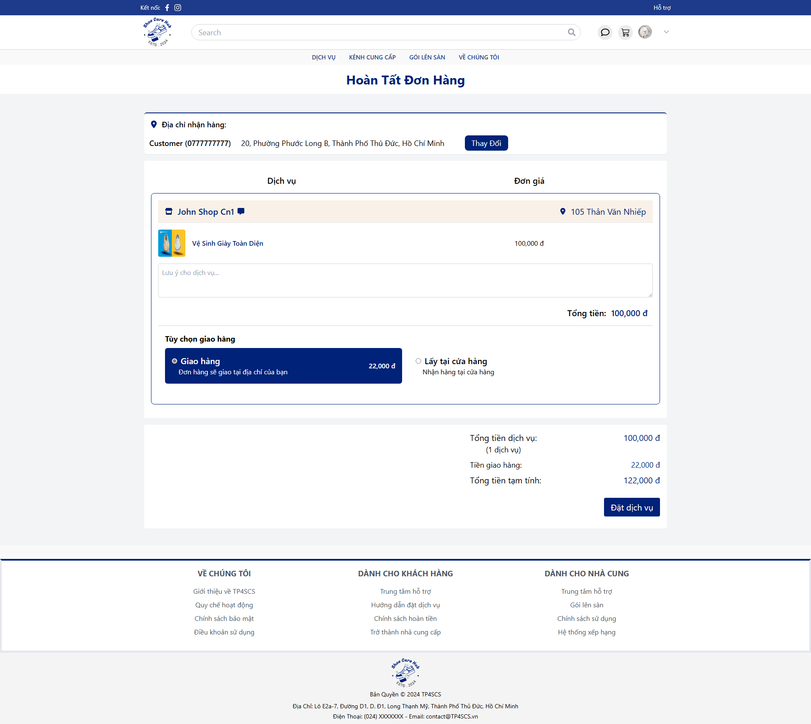
- Choose your created address by clicking “Thay Đổi”.
- Choose ship method you want by click on “Giao hàng” or “Lấy tại cửa hàng”.
- Click “Đặt dịch vụ”.

3.3.3 Owner Process Service
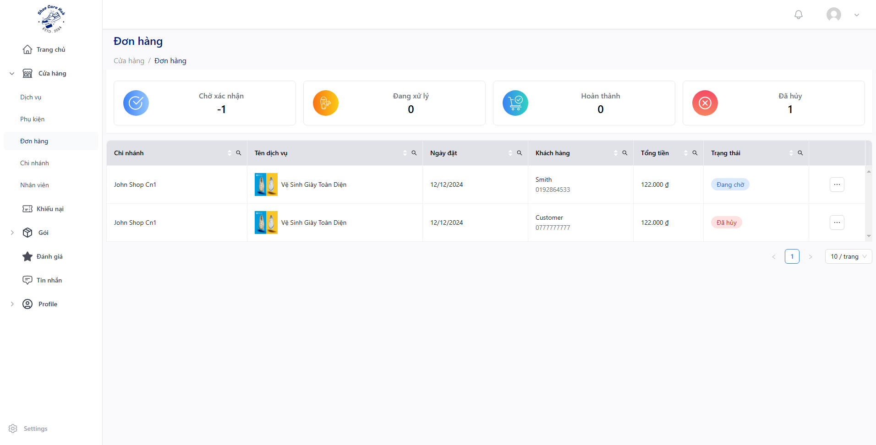
- Click “Cửa hàng” then click “Đơn hàng” and click “”.
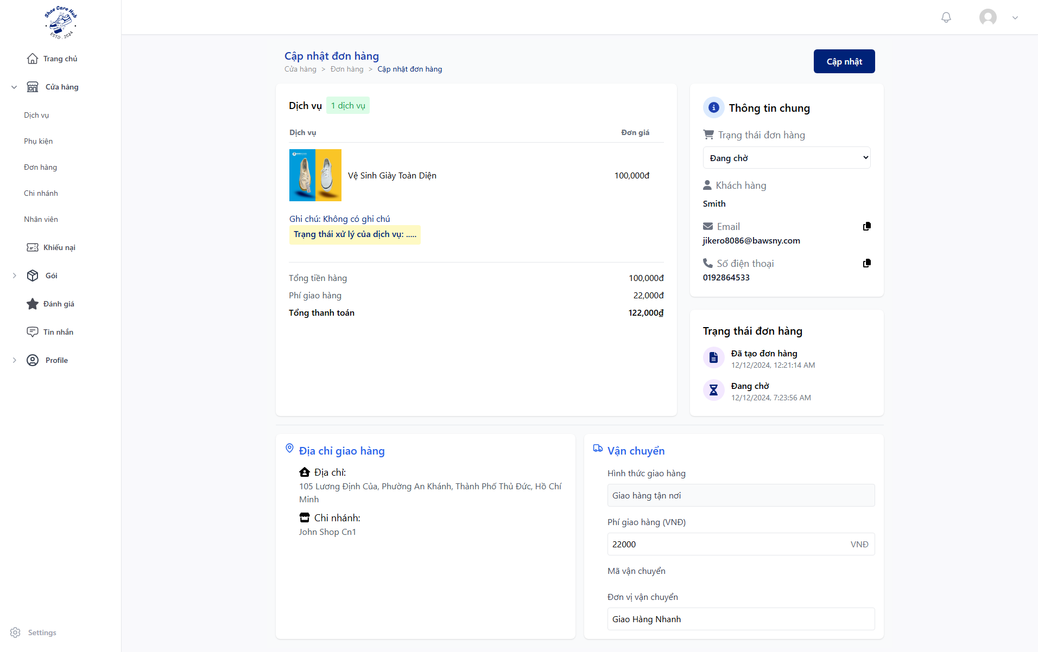
- Click “Trạng thái đơn hàng” and choose “Đã xác nhận” to process order or “Đã huỷ” to cancel the order and click “Đồng ý” then “Cập nhập”.
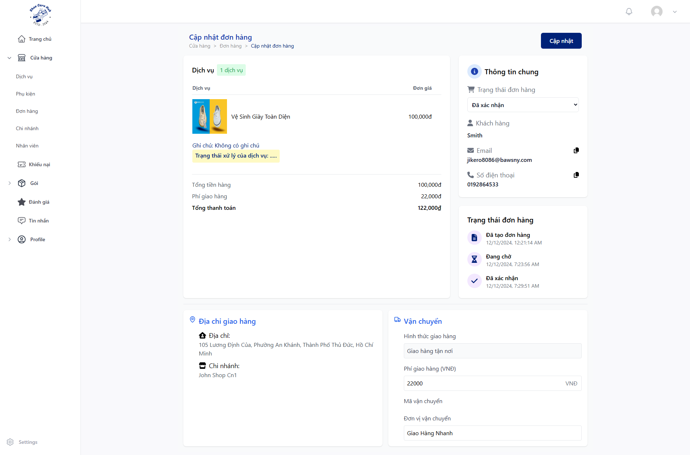
- Click “Trạng thái đơn hàng” and choose “Đã nhận” and click “Đồng ý” then “Cập nhập”.
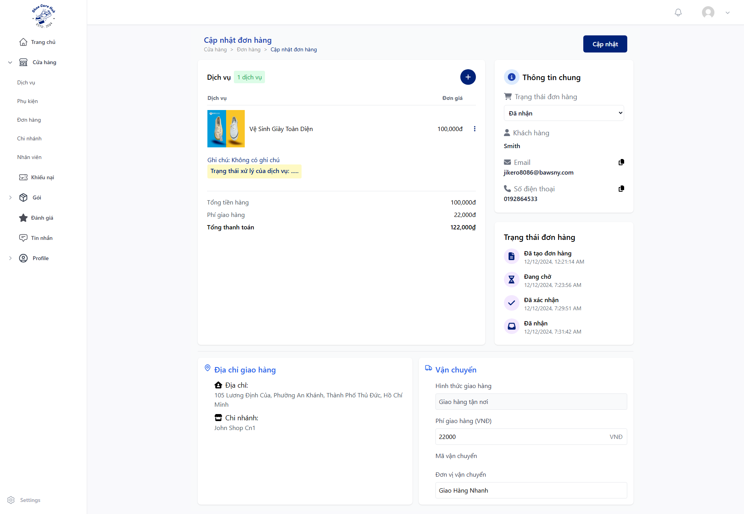
- Click “Trạng thái đơn hàng” and choose “Đang xử lý” and click “Đồng ý” then “Cập nhập”.
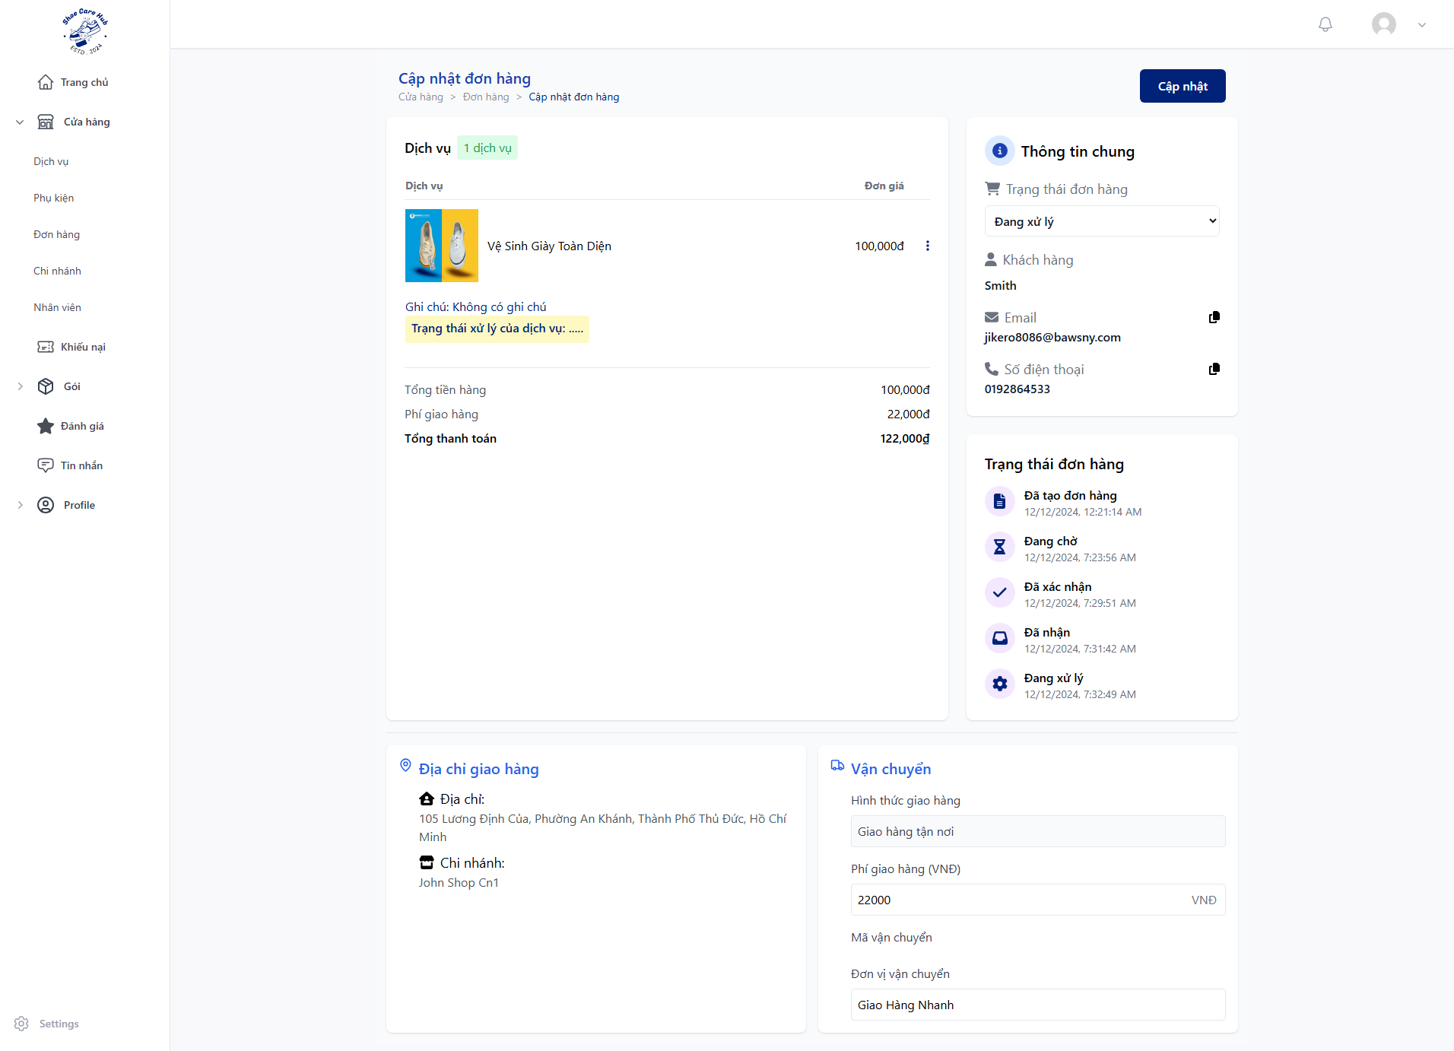
- Click “$⋮$” then “Cập nhập dịch vụ”.
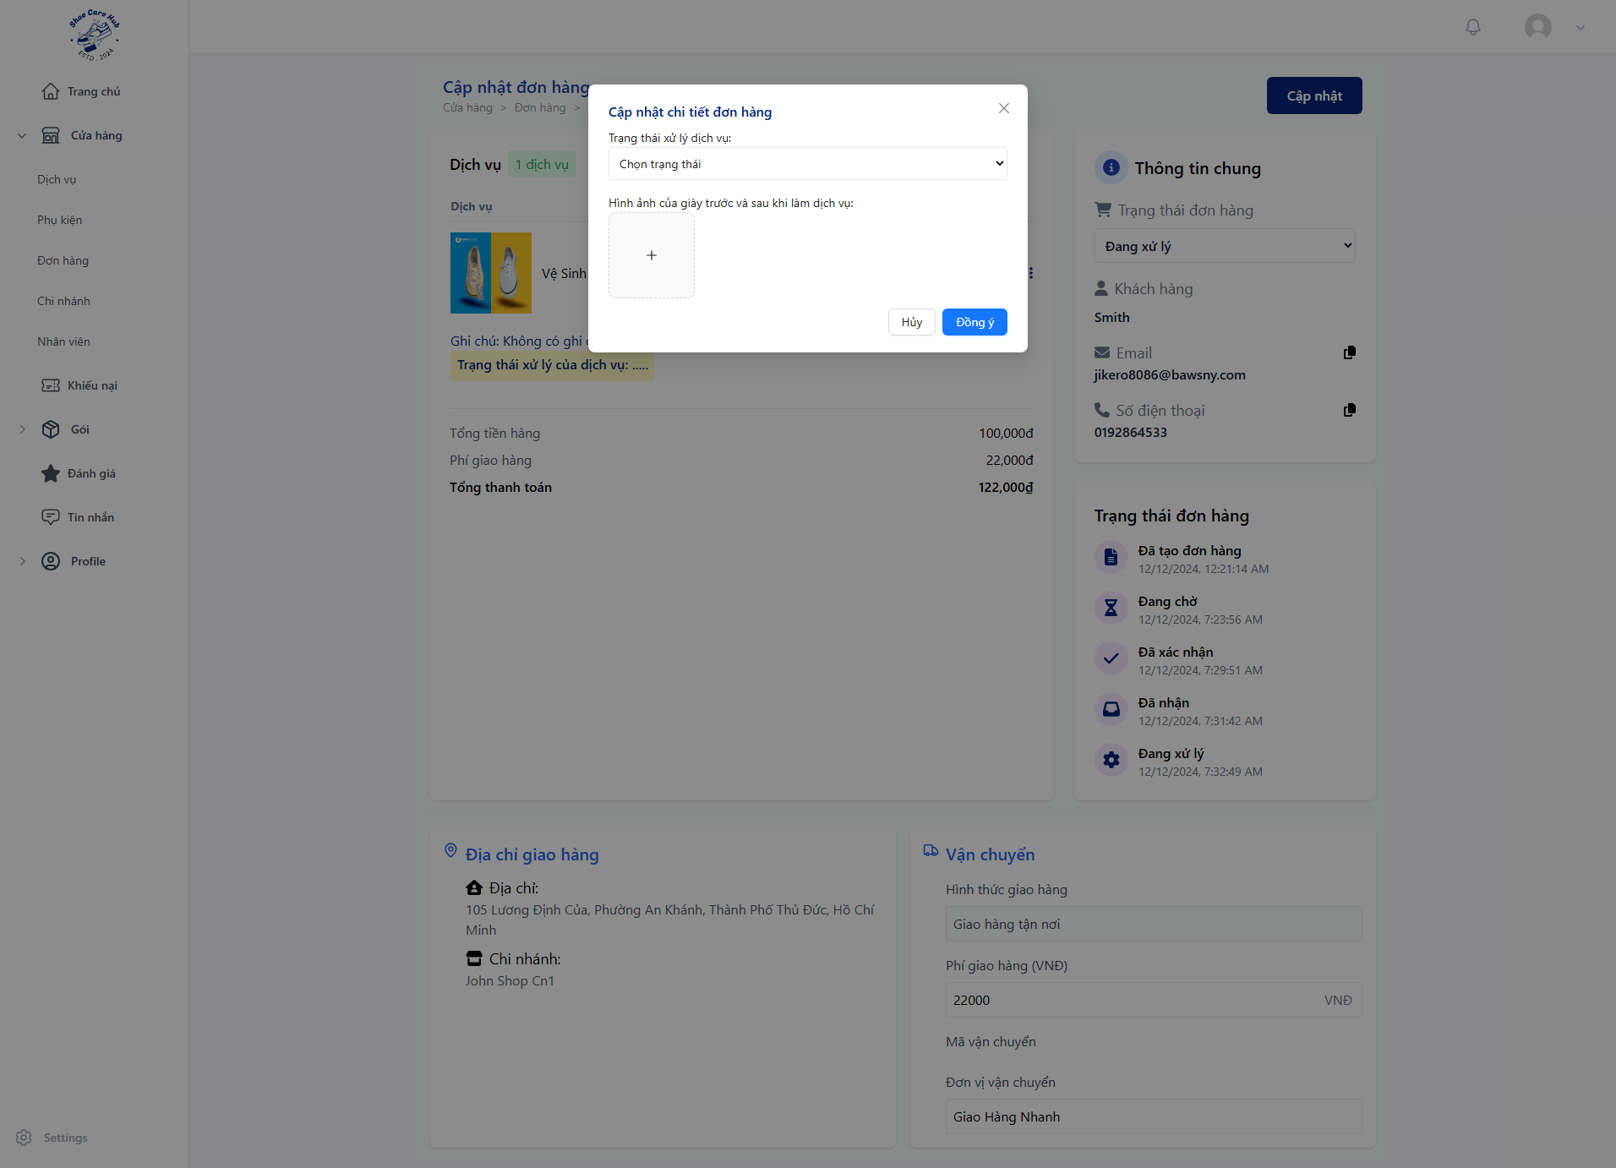
- Update service process at “Trạng thái xử lý dịch vụ”.
- Upload service process image at “Hình ảnh của giày trước và sau khi làm dịch vụ”.
- Click “Đồng ý”.
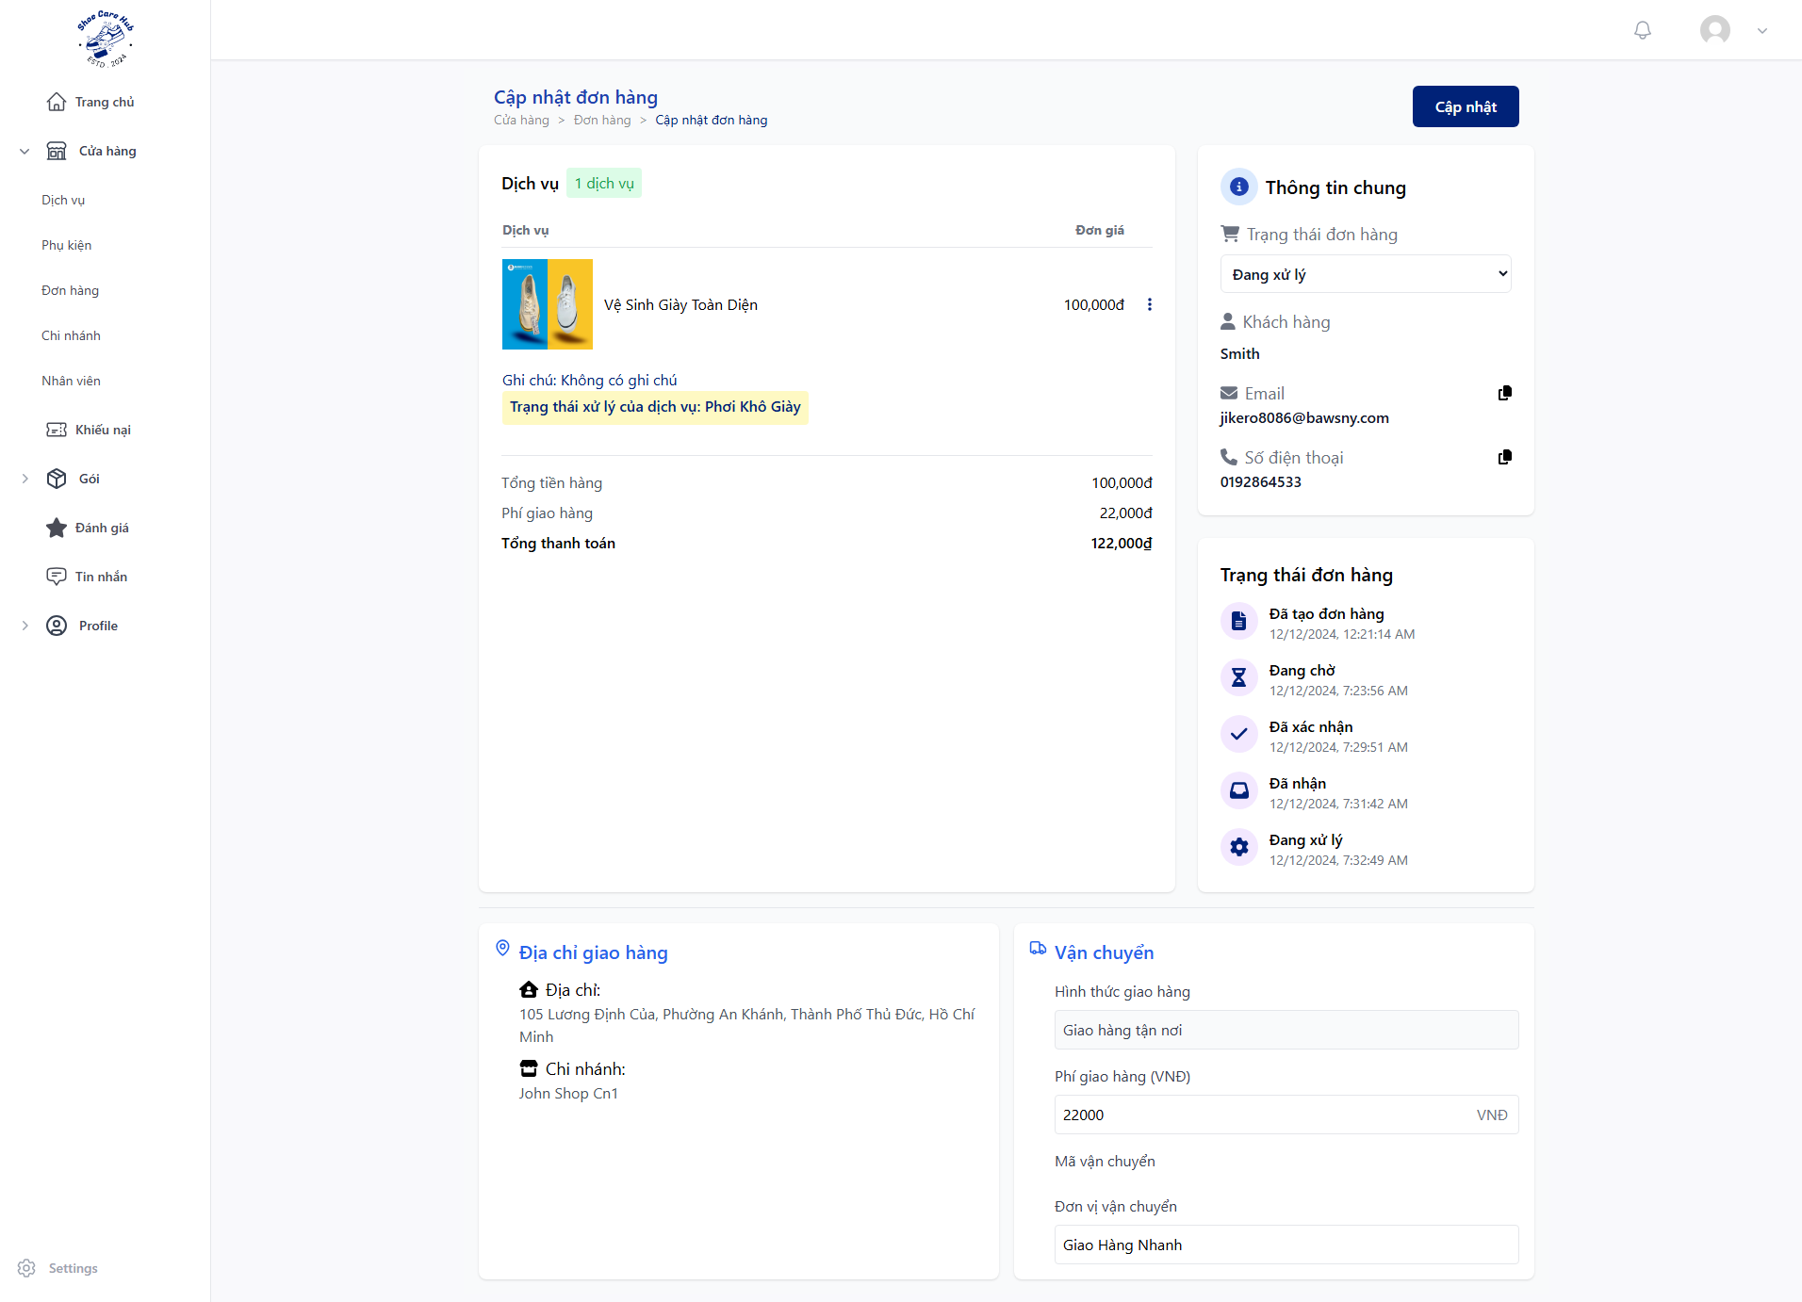
- Click “Trạng thái đơn hàng” and choose “Lưu trữ” and click “Đồng ý” then “Cập nhập”.
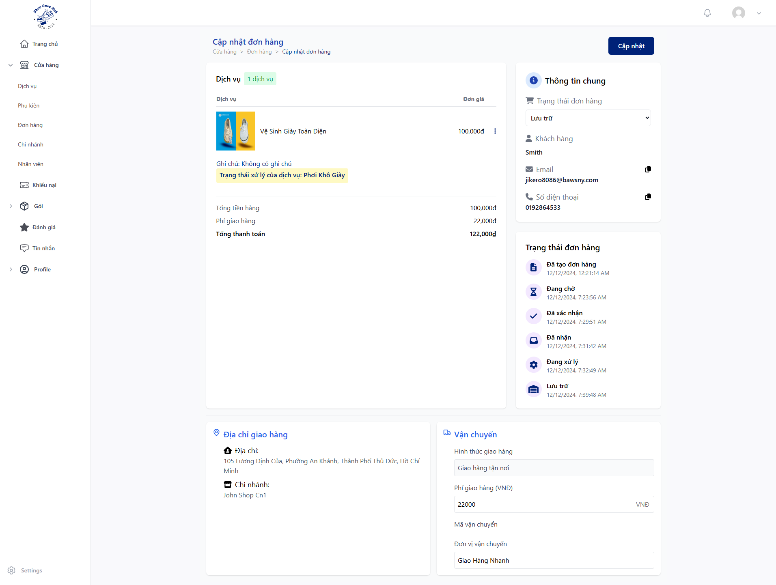
- Click “Trạng thái đơn hàng” and choose “Đang giao hàng” if have to ship, “Đã giao hàng” if take at shop or “Quá hạn nhận giày” if shoe is abandoned and click “Đồng ý” then “Cập nhập”.
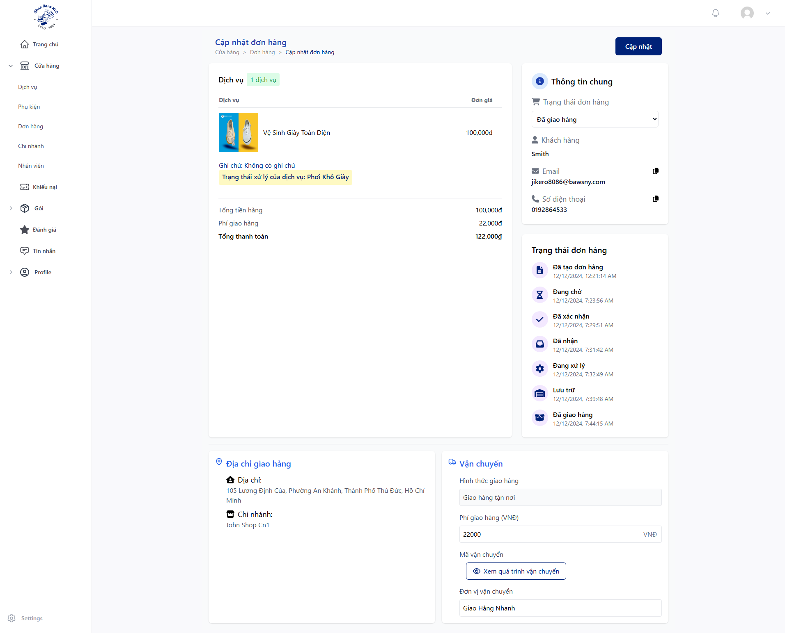
- Click “Trạng thái đơn hàng” and choose “Hoàn Thành” and click “Đồng ý” then “Cập nhập”.

3.3.4 Customer Check Order
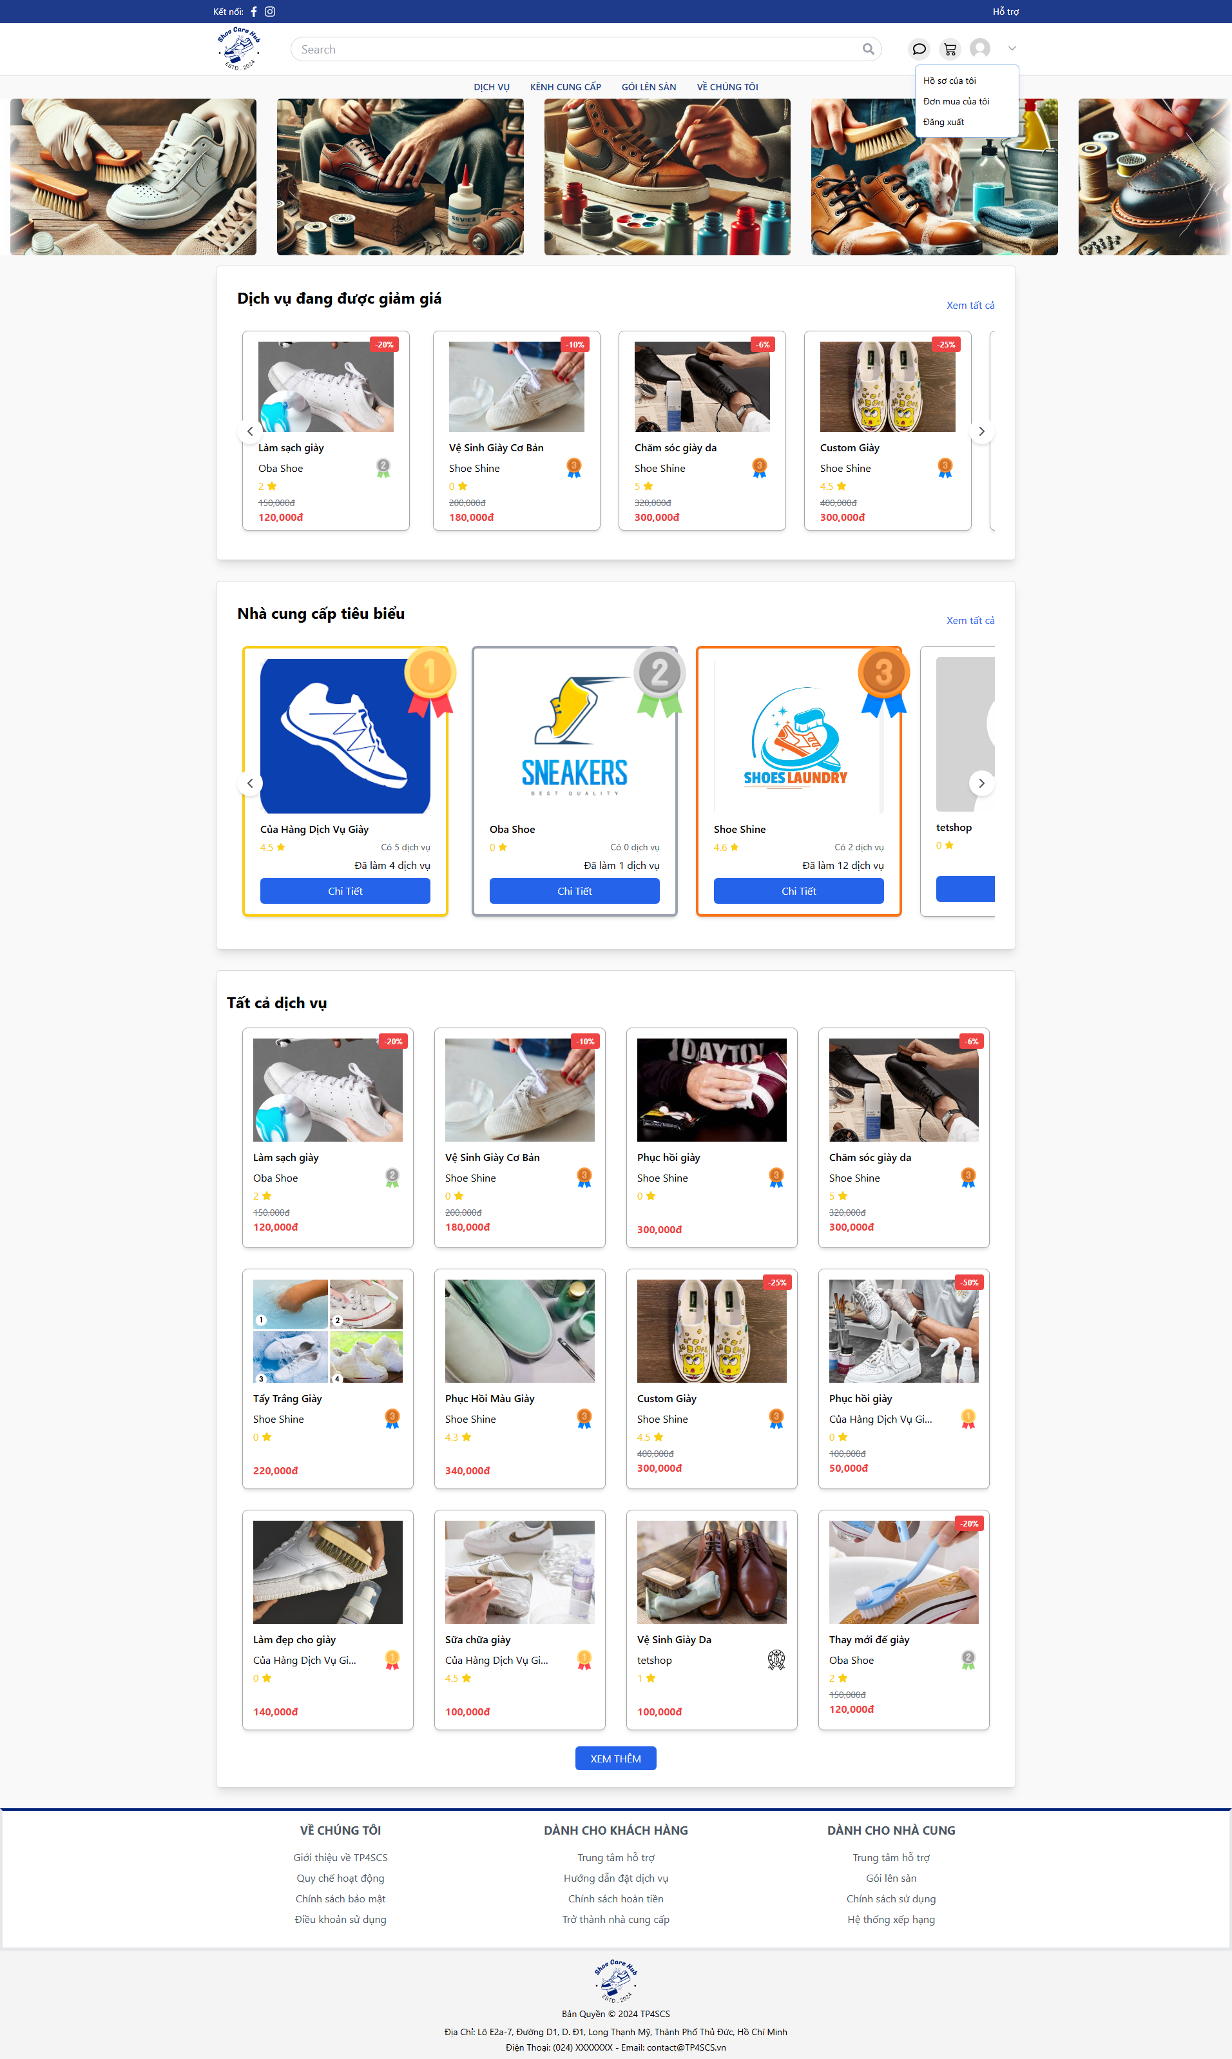
- At Home Page, click avatar icon the click “Đơn mua của tôi”.
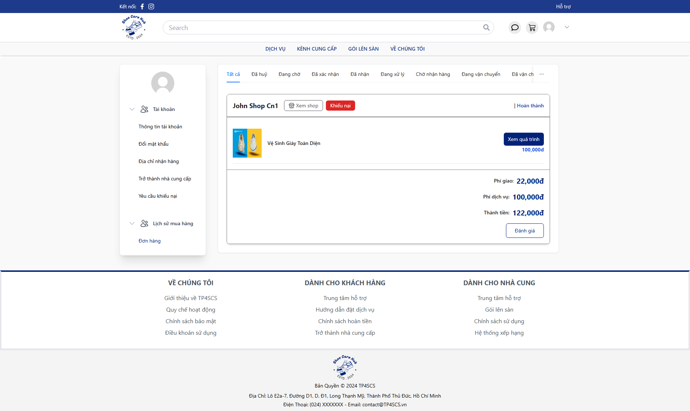

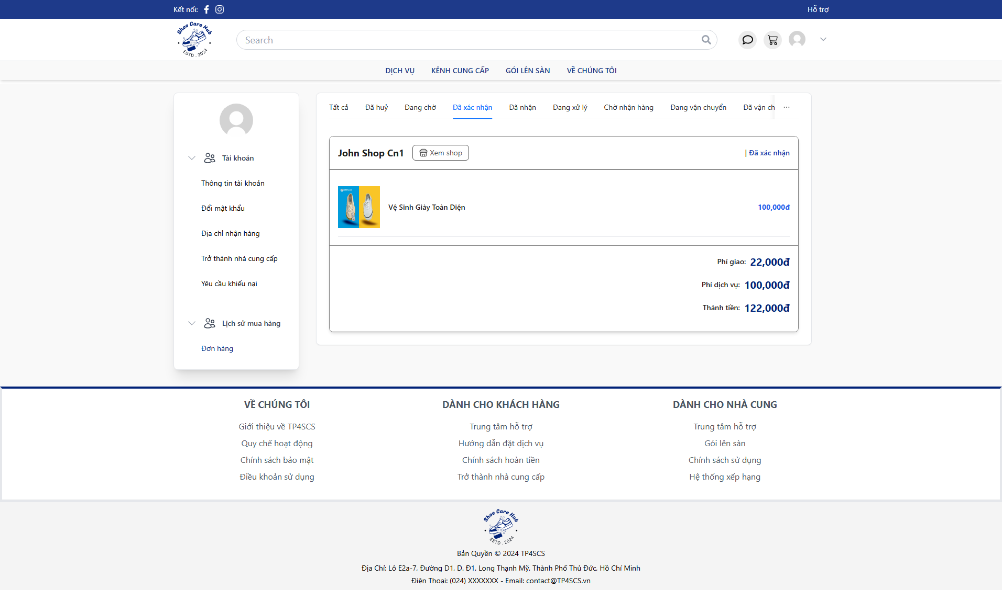
- Click “Đã xác nhận” to view approved order.
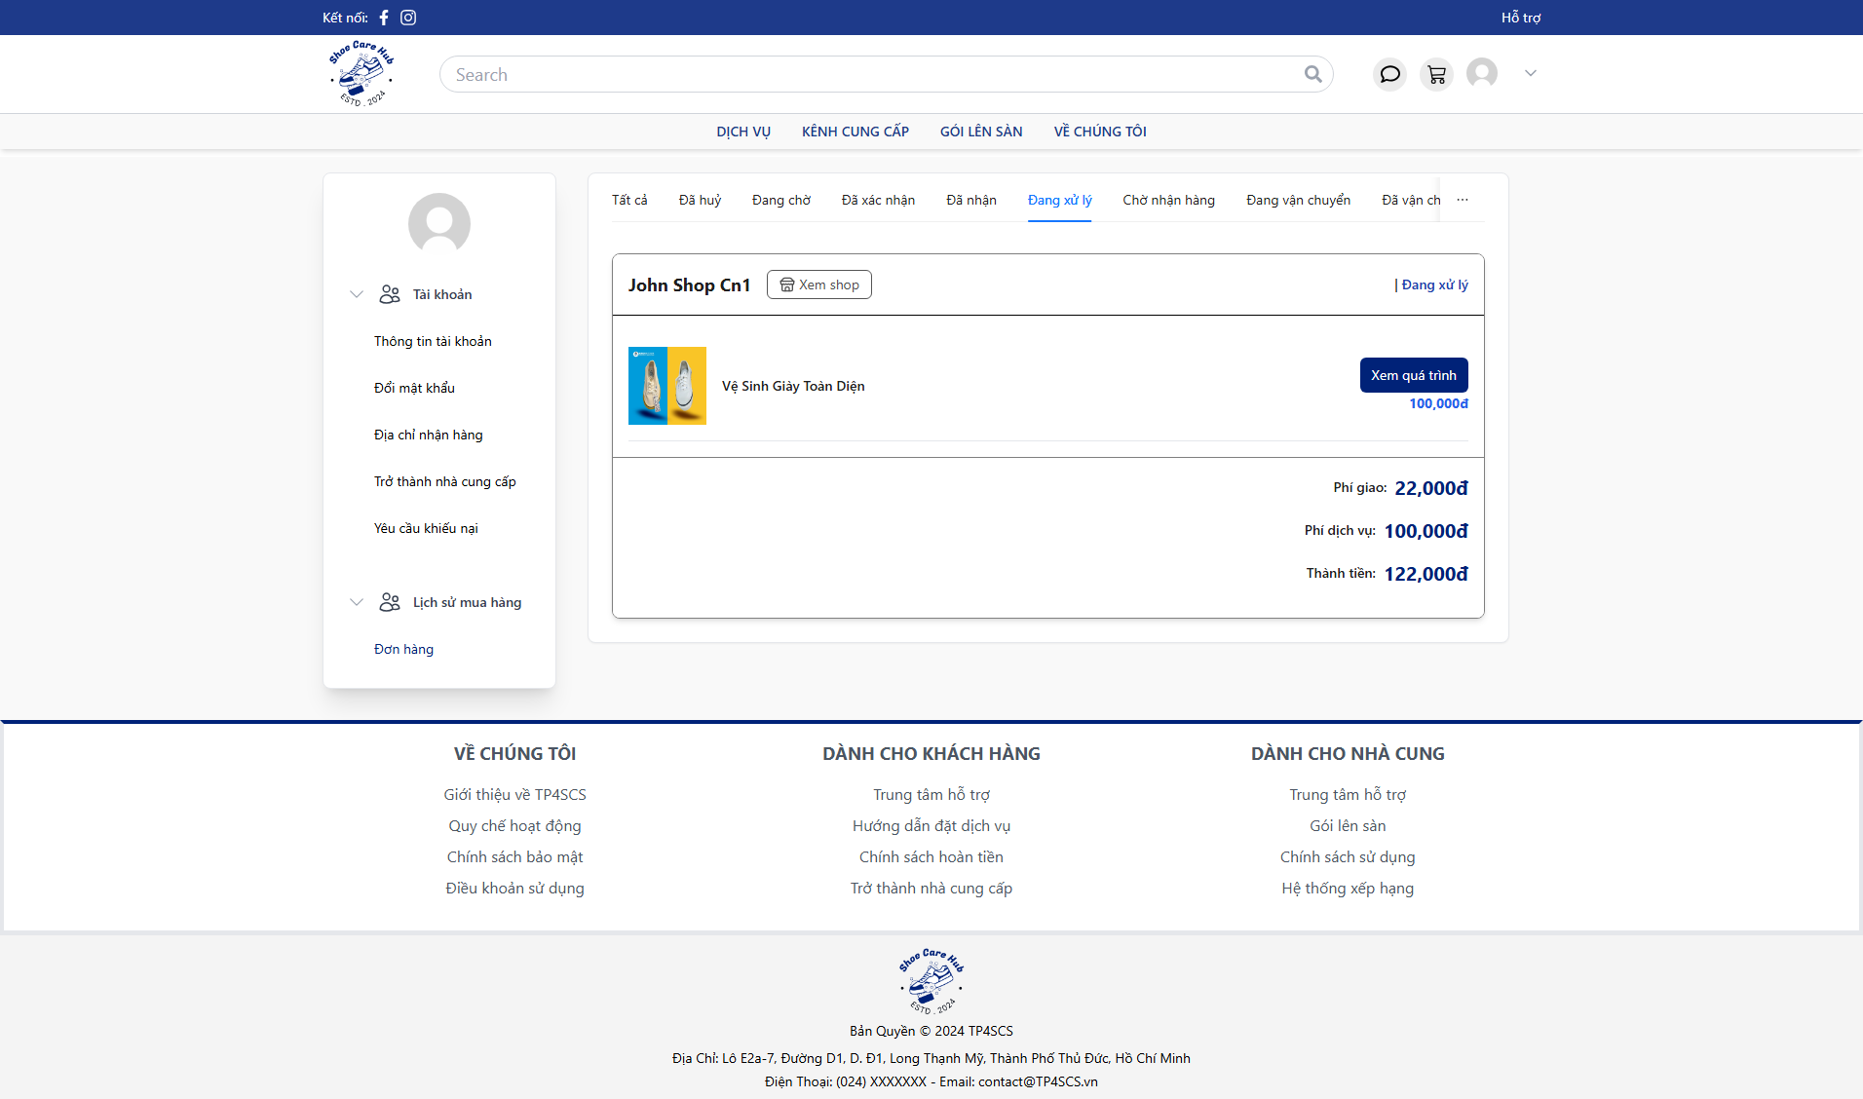
- Click “Đang xử lý” to view processing order.
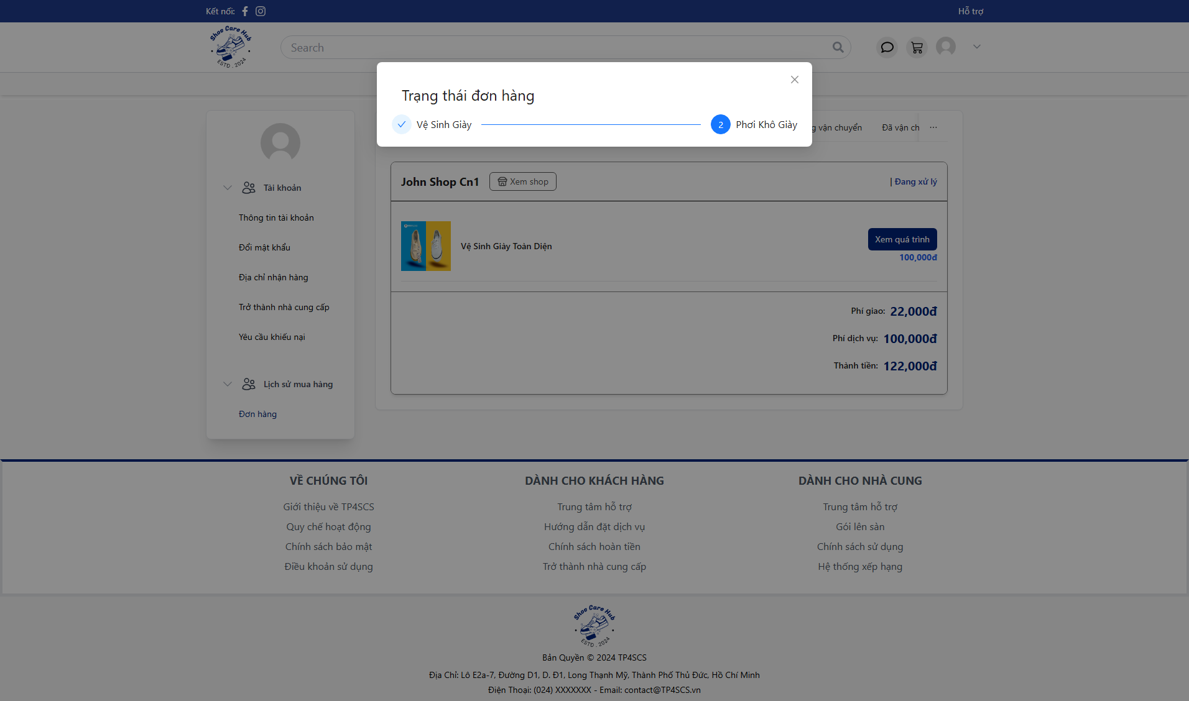
- Click “Xem quá trình” to view order process state.
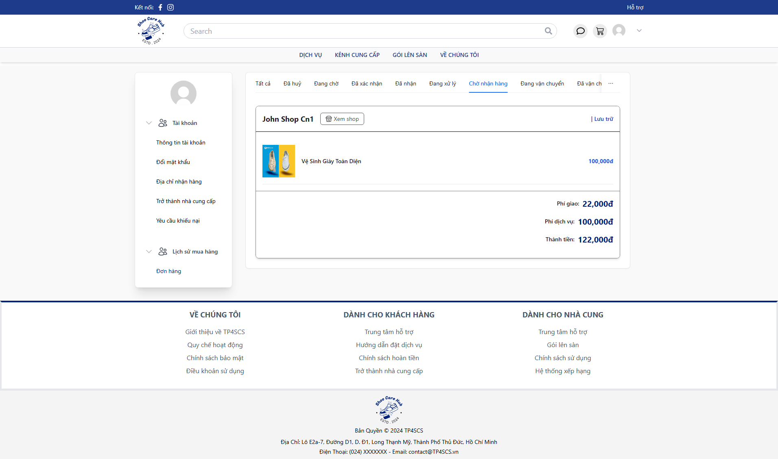
- Click “Chờ nhận hàng” to view storage order after finish process.
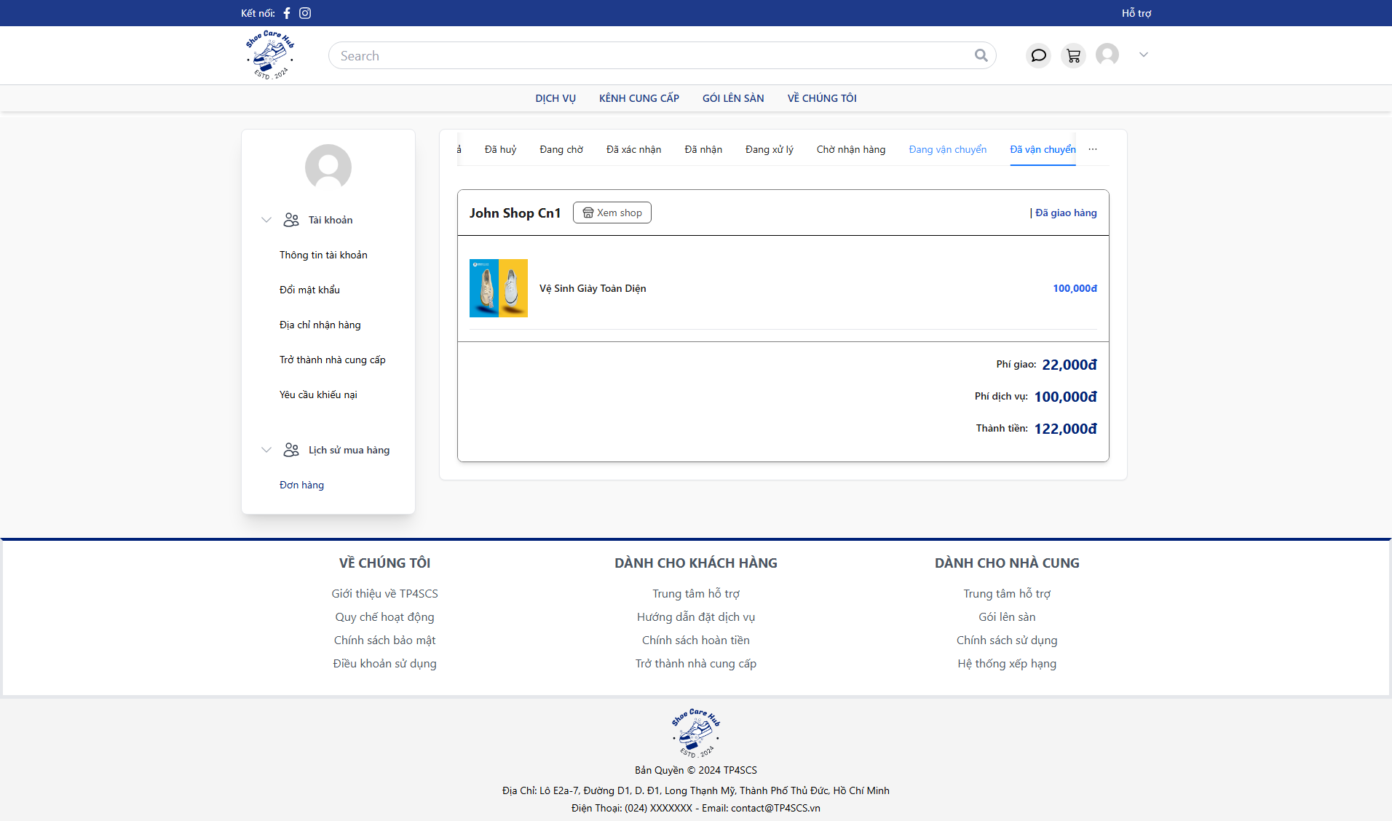
- Click “Đã vận chuyển” to view shipped order.

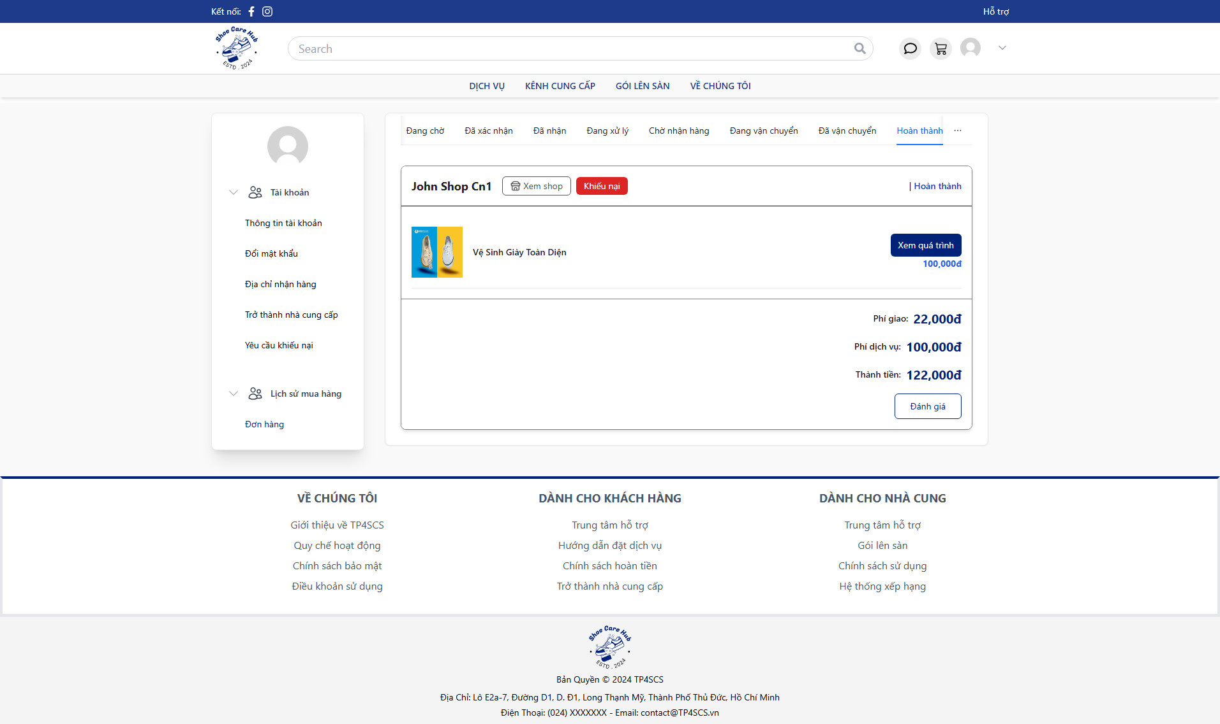
- Click “Hoàn thành” to view finished order.

3.4 Process Support Ticket Flow

3.4.1 Customer Create Ticket

- At Home Page, click avatar icon the click “Hồ sơ của tôi”.
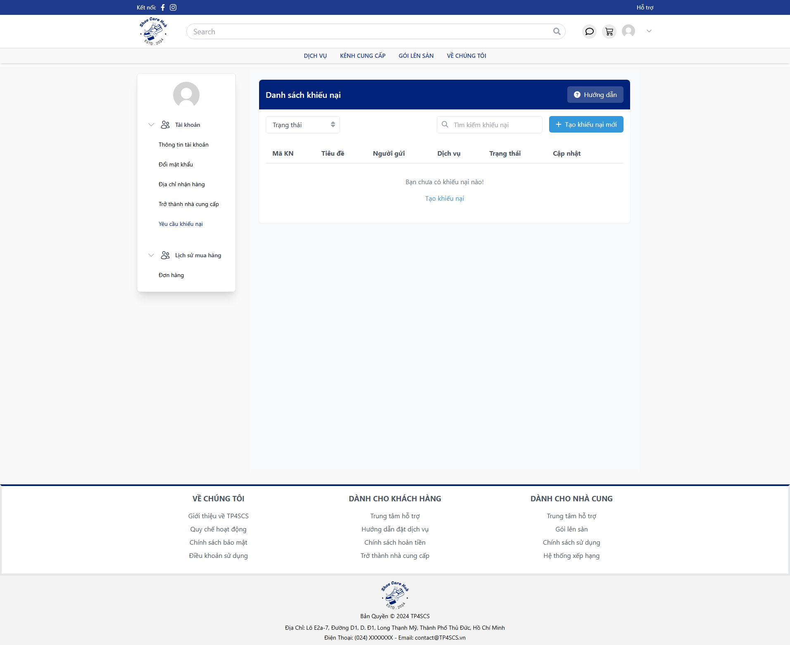
- Click “Yêu cầu khiếu nại” then click “Tạo khiếu nại mới”.
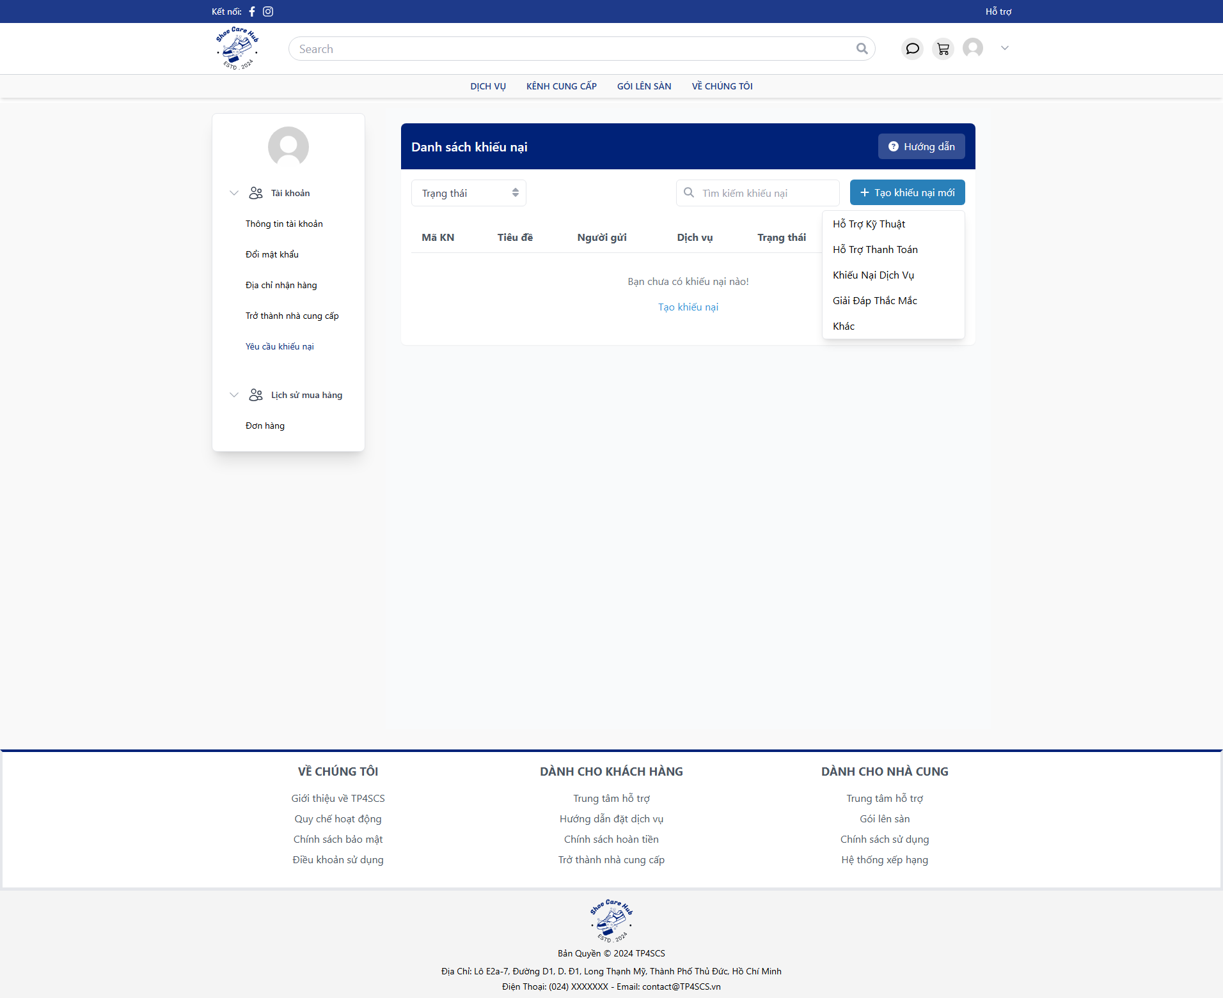
- Choose ticket category.
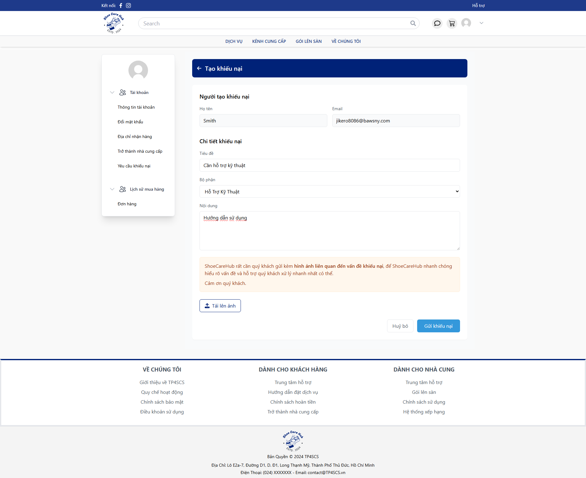
- Fill all require fields with valid data then click “Gửi khiếu nại”.
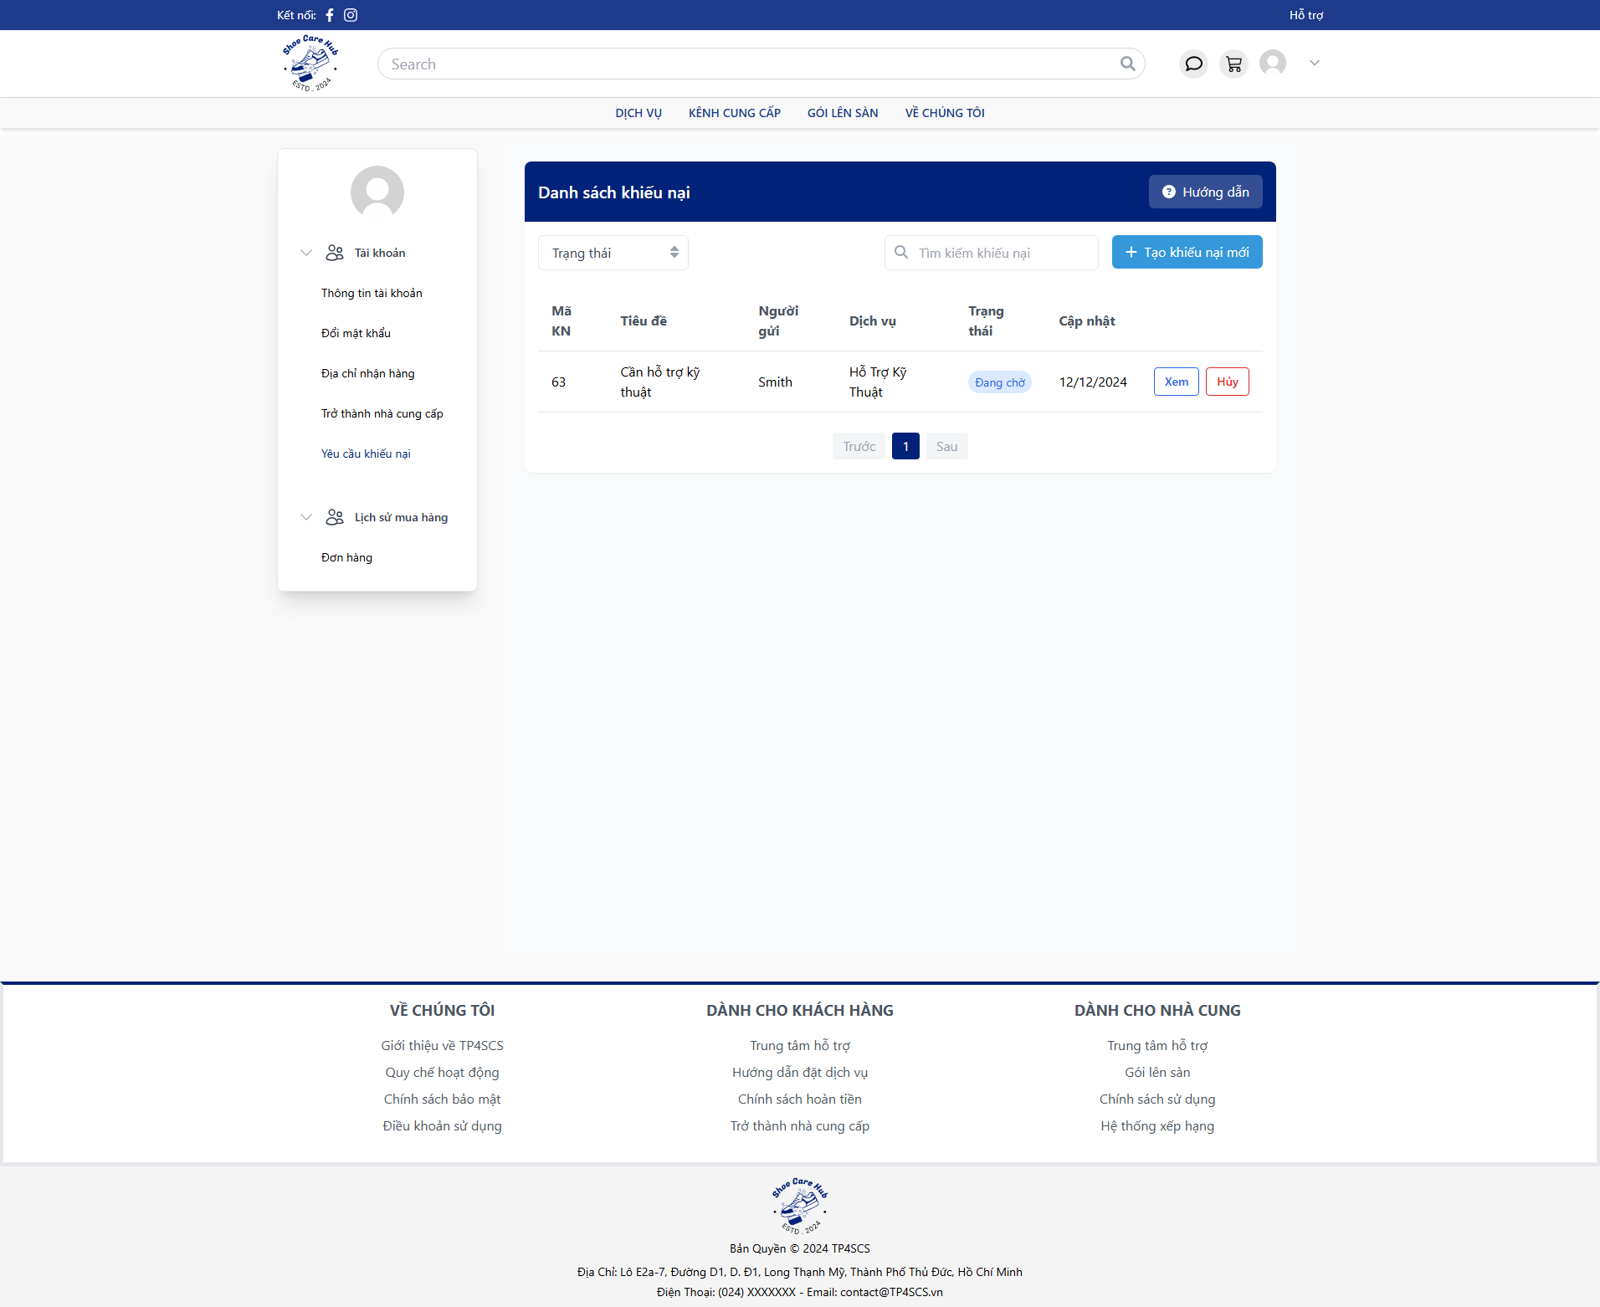
- After create can view the ticket detail by click “Xem” or cancel ticket by click “Huỷ”.

3.4.2 Moderator Process Ticket
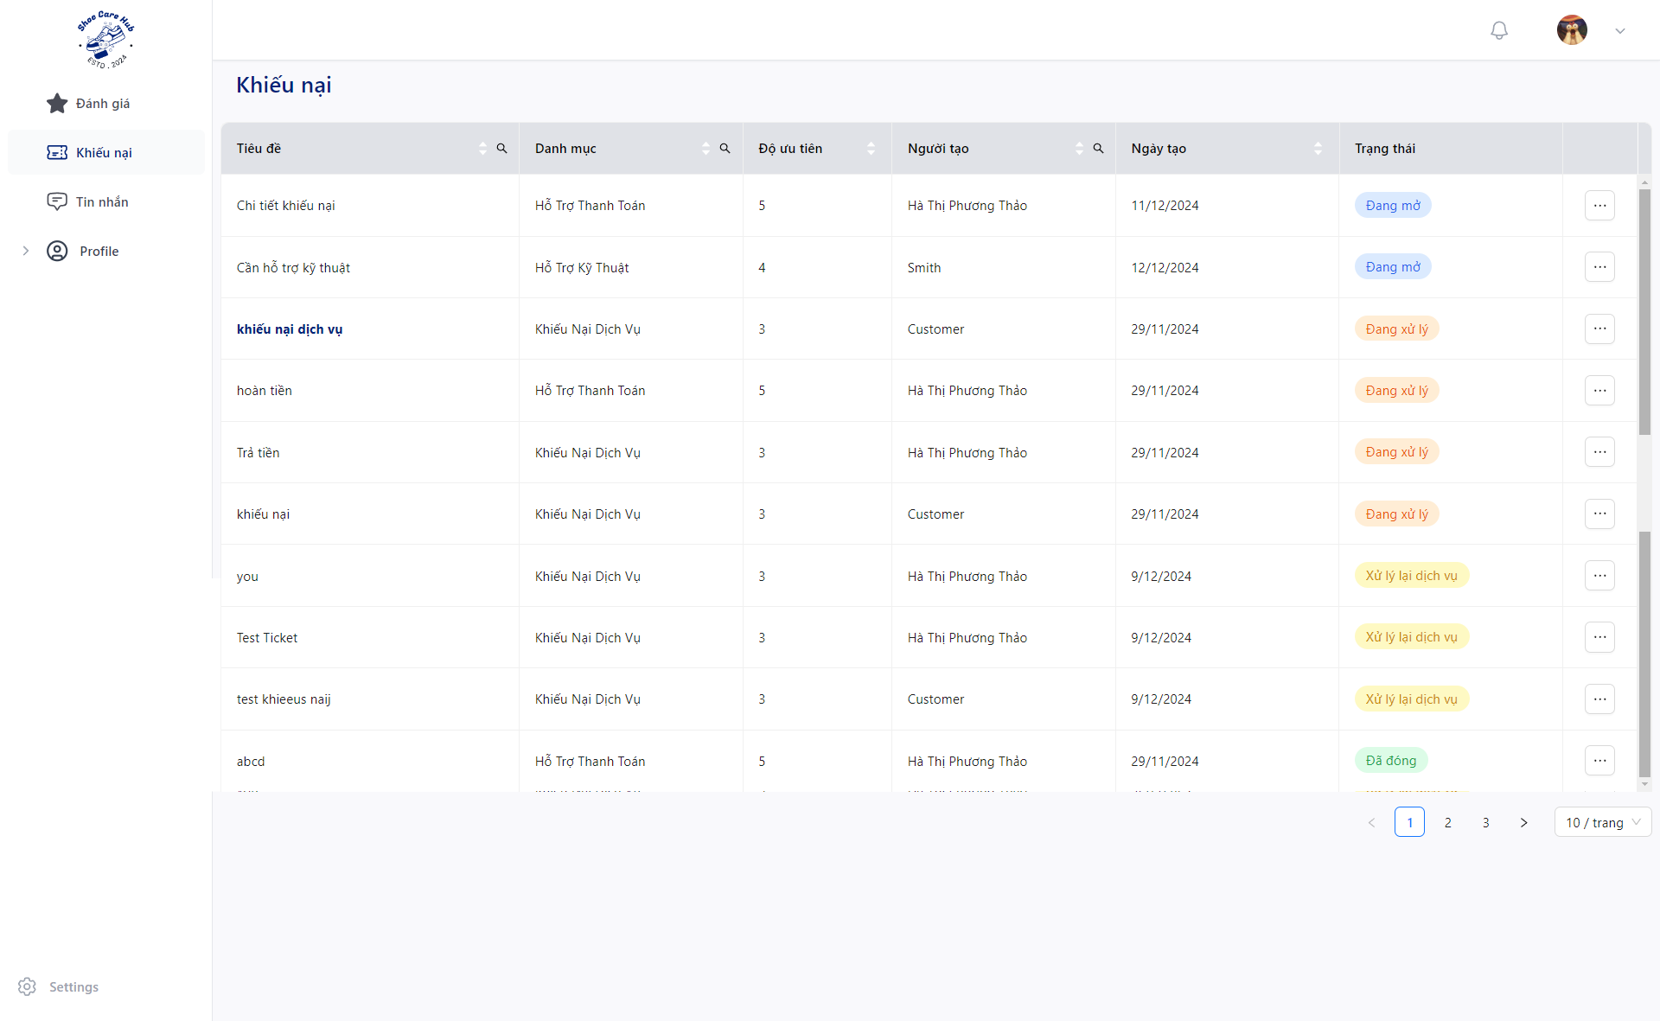
Click “Khiếu nại” and click “” to specific ticket then click “Cập nhập”.
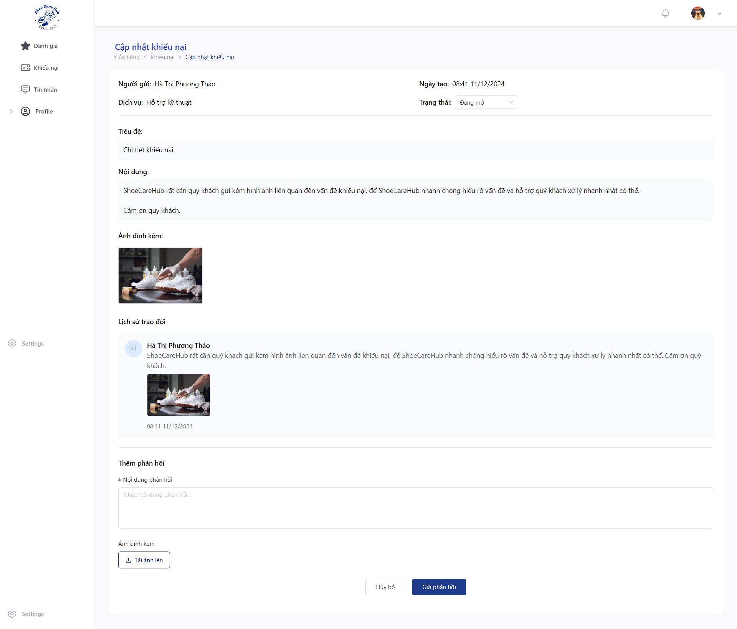
- Click “Trạng thái” and choose “Đang xử lý” the click “Đồng ý” to process the ticket.

- Fill valid data at “Nội dung phản hồi” for response ticket.
- Click “Tải ảnh lên” to upload asset for the response.
- Click “Gửi phản hồi” to send ticket response.
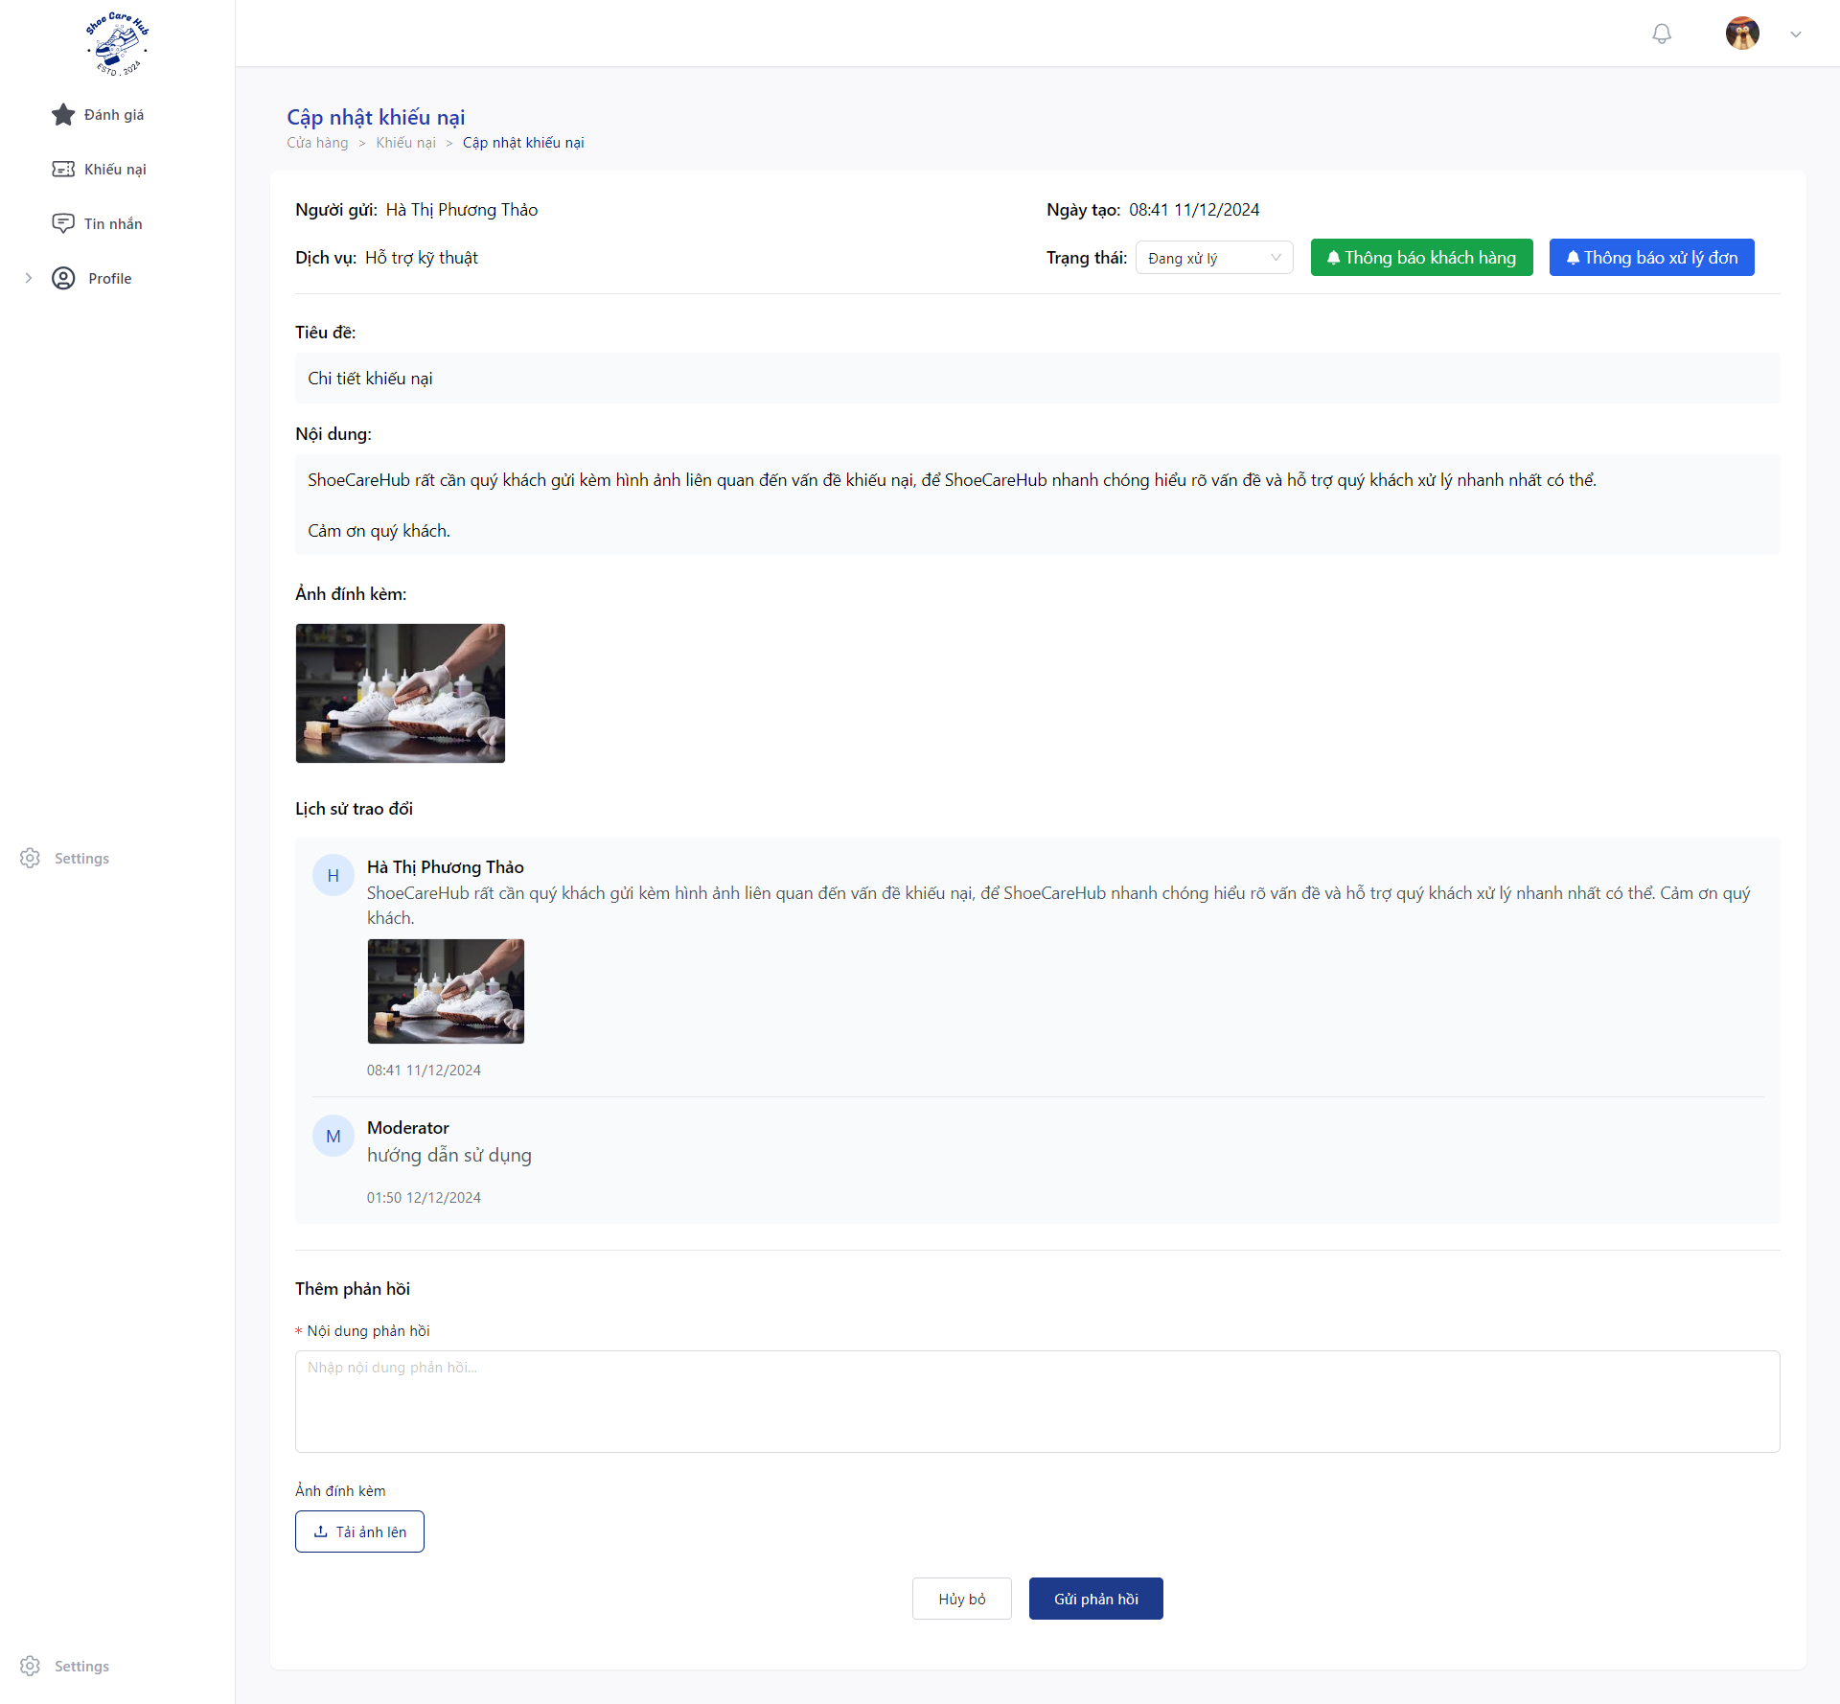
- Click “Thông báo cho khách hàng” to send email notification for customer before close.
- Click “Trạng thái” and choose “Đống” the click “Đồng ý” to close the ticket.
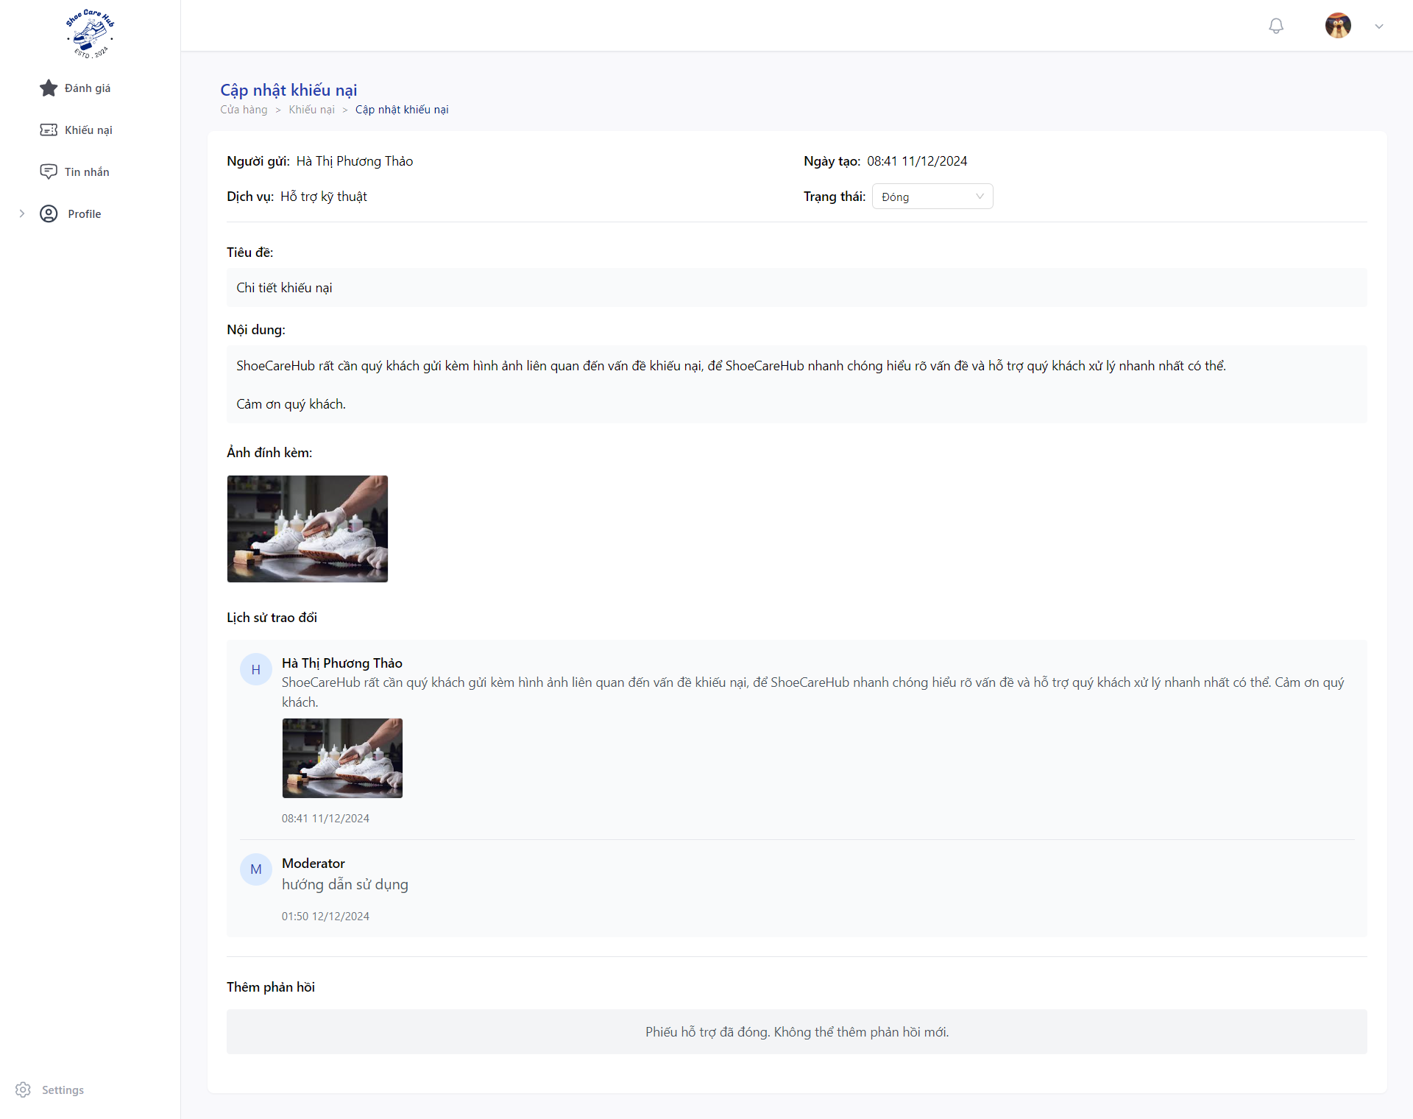

3.4.3 Customer Check Ticket
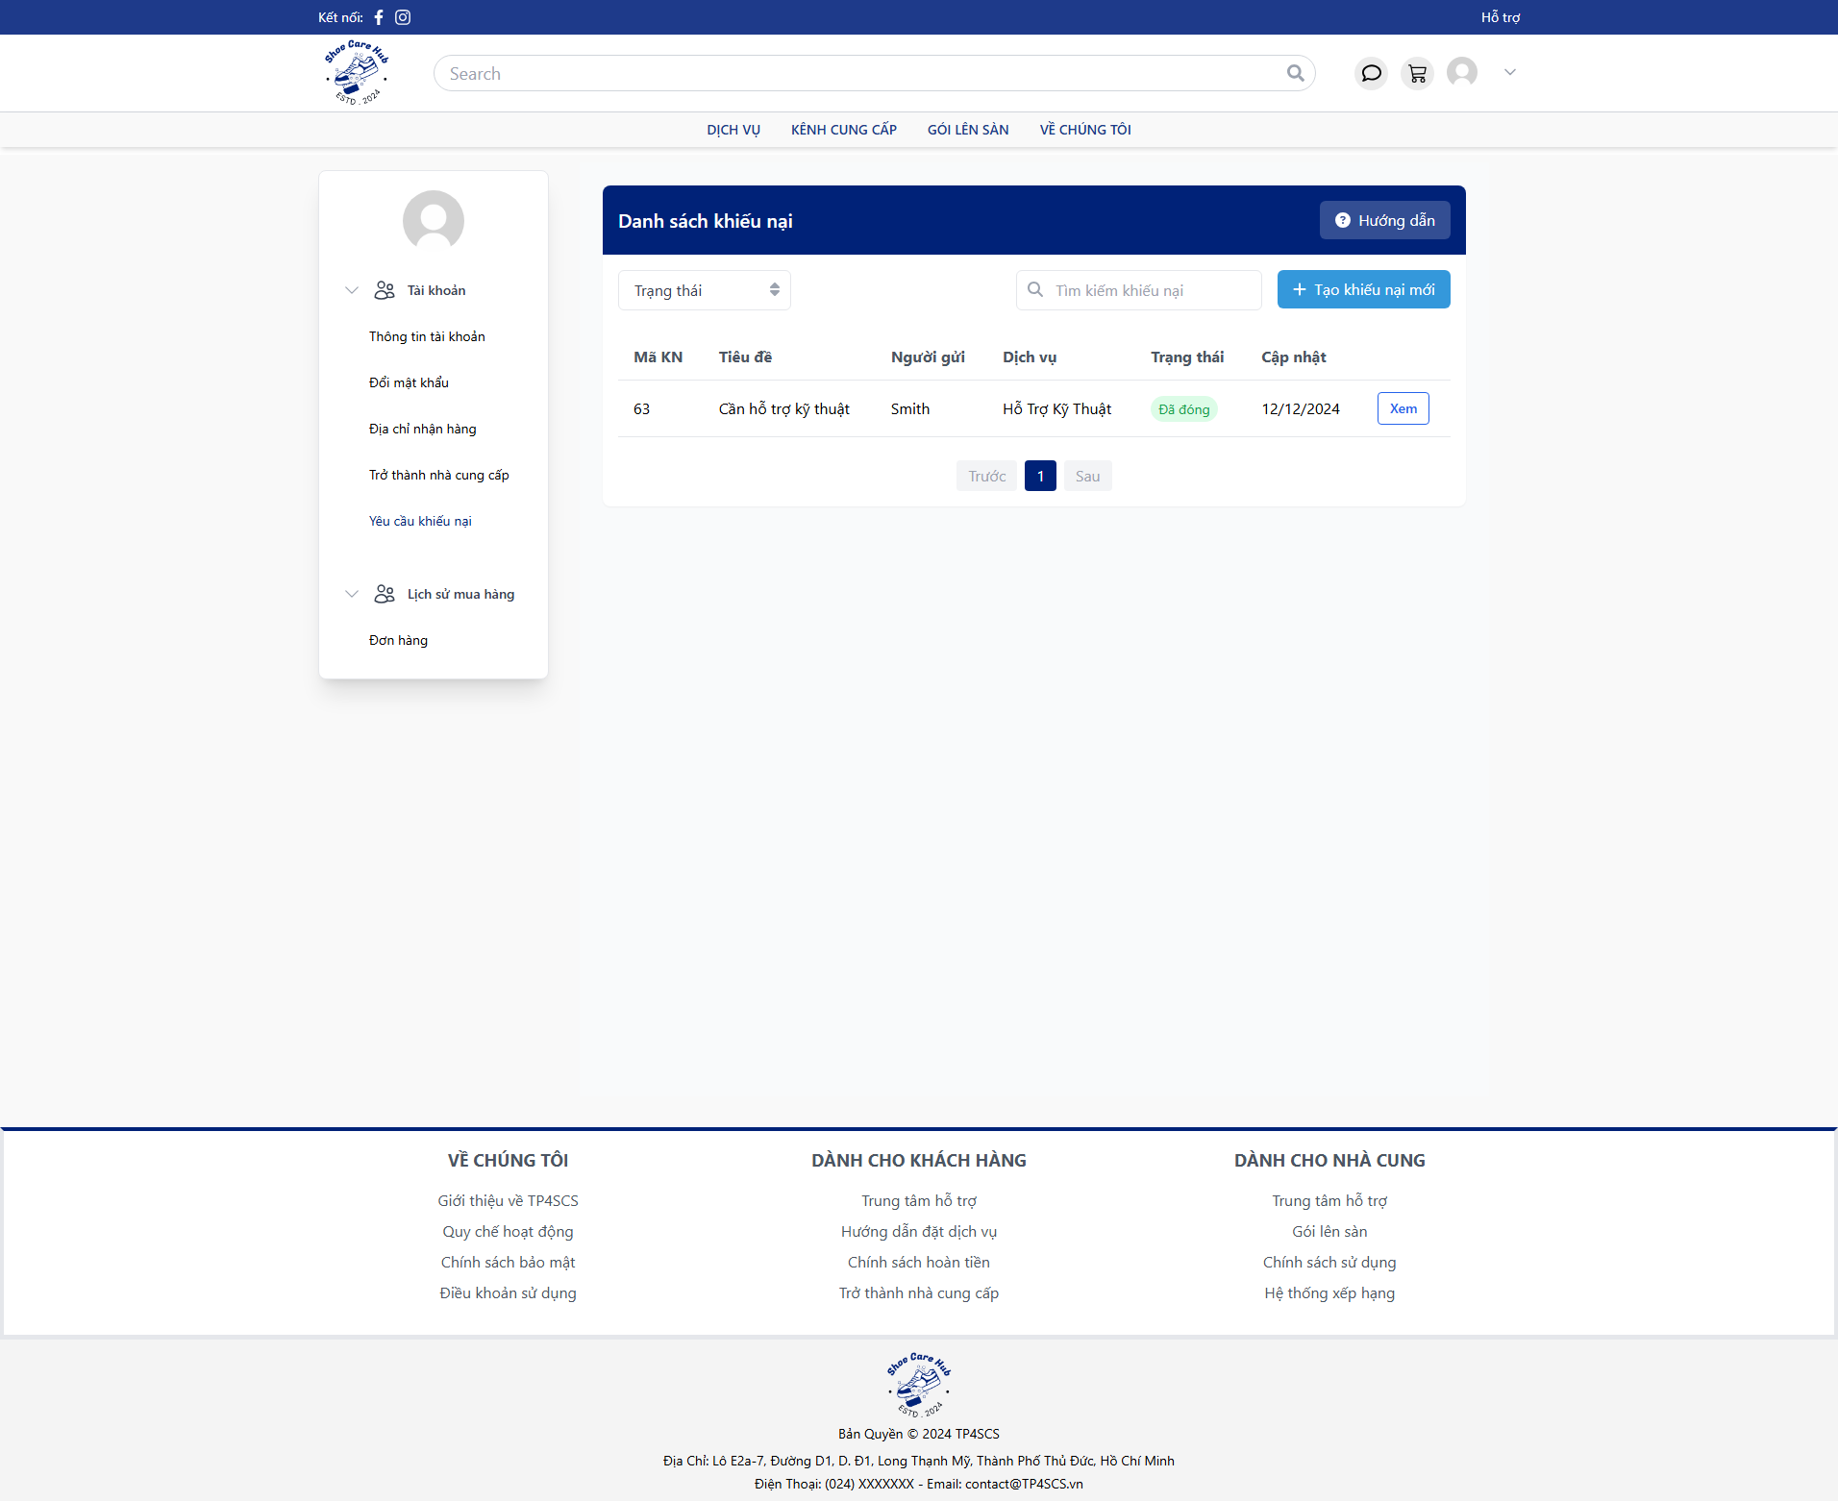
- Go to “Yêu cầu khiếu nại” then click to “Xem”.
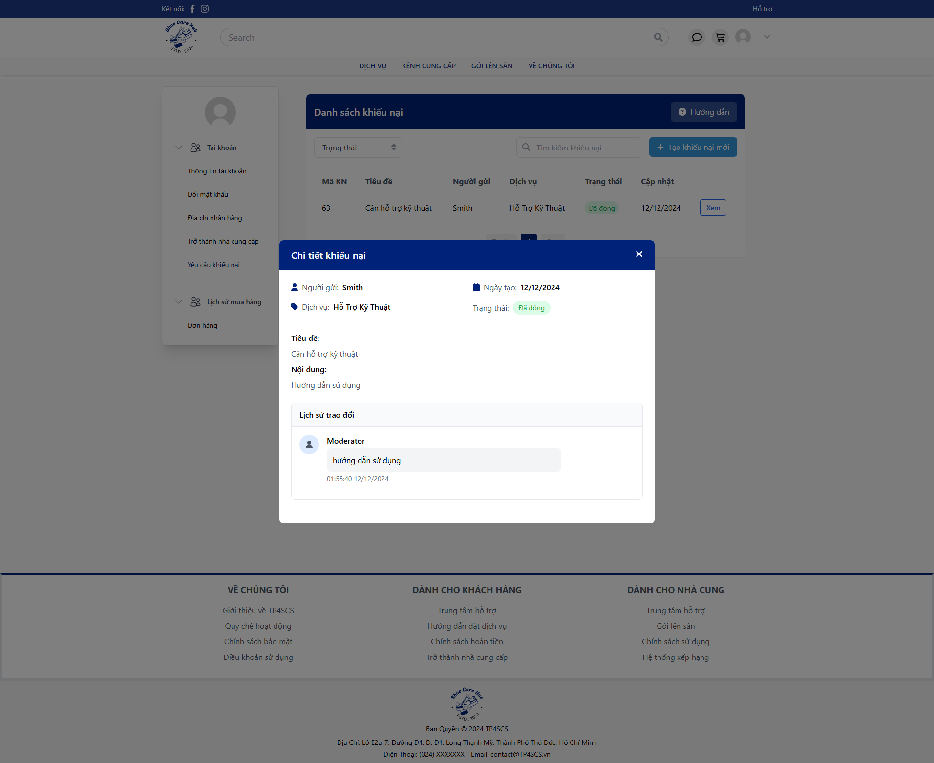

3.5 Feedback Flow

3.5.1 Customer Create Feedback

- Go to “Đơn mua của tôi” then choose finished order by click “Hoàn thành”.
- Click “Đánh giá” to create new feedback.
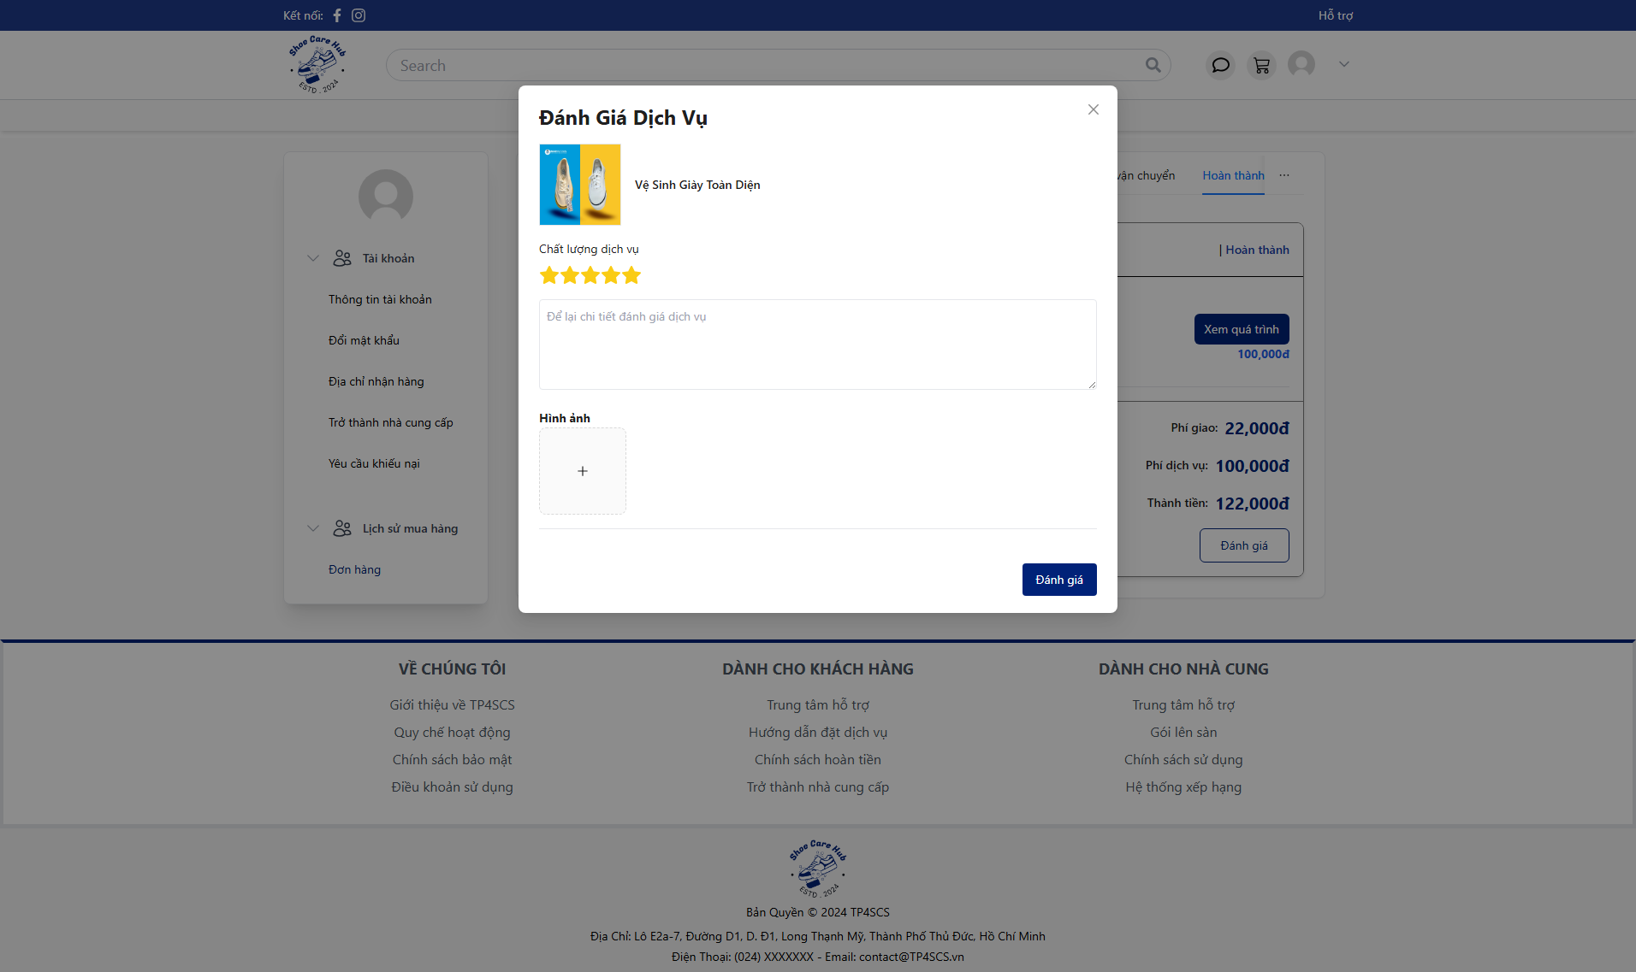
- Fill all feedback fields with valid data then click “Đánh giá”.

3.5.2 Moderator Validate Feedback
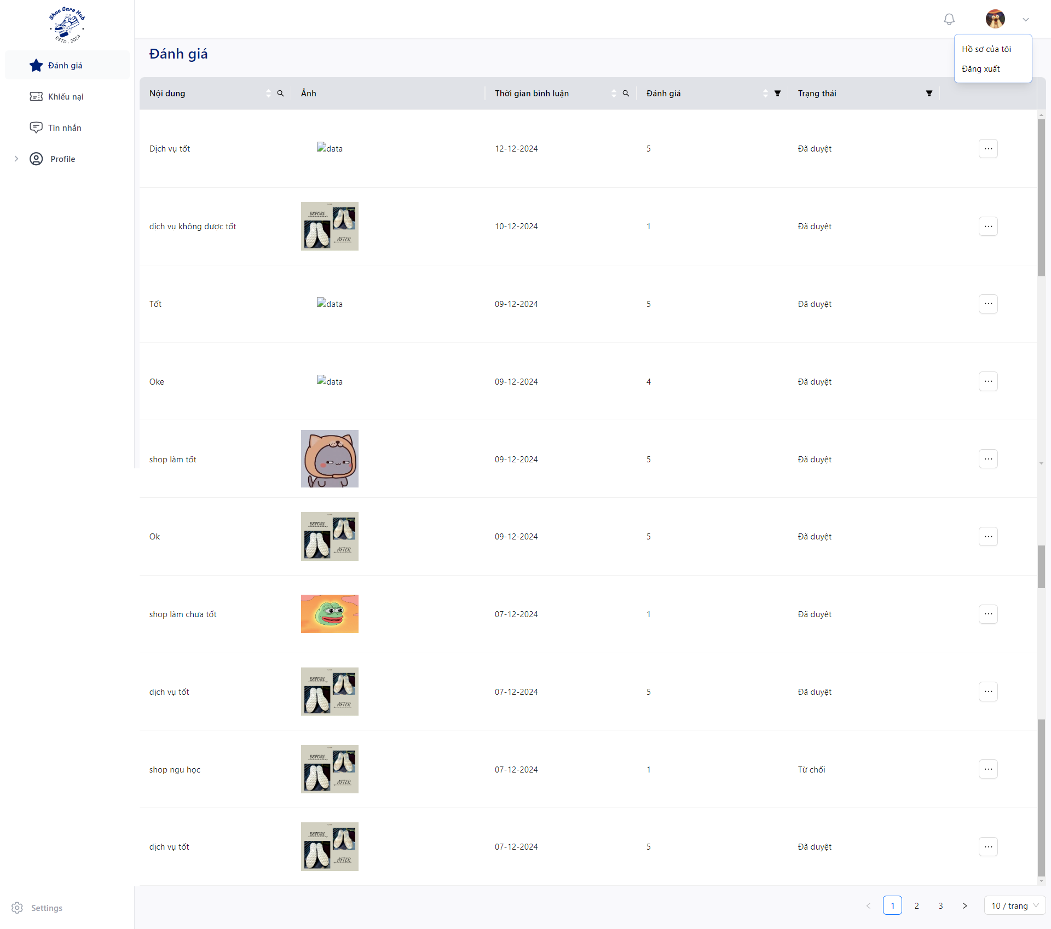
- Click to “Đánh giá” and click “” to specific feedback then click “Cập nhập”.
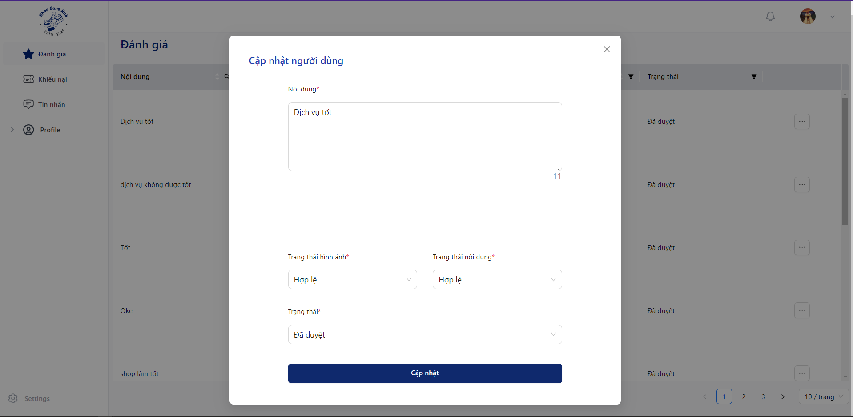
- Check feedback content.
- Choose status at “Trạng thái hình ảnh”: “Hợp lệ” for valid content, “Không hợp lệ” for invalid content.
- Choose status at “Trạng thái nội dung”: “Hợp lệ” for valid content, “Không hợp lệ” for invalid content.
- Click “Cập nhập” to validate feedback.

3.5.4 Customer Check Feedback
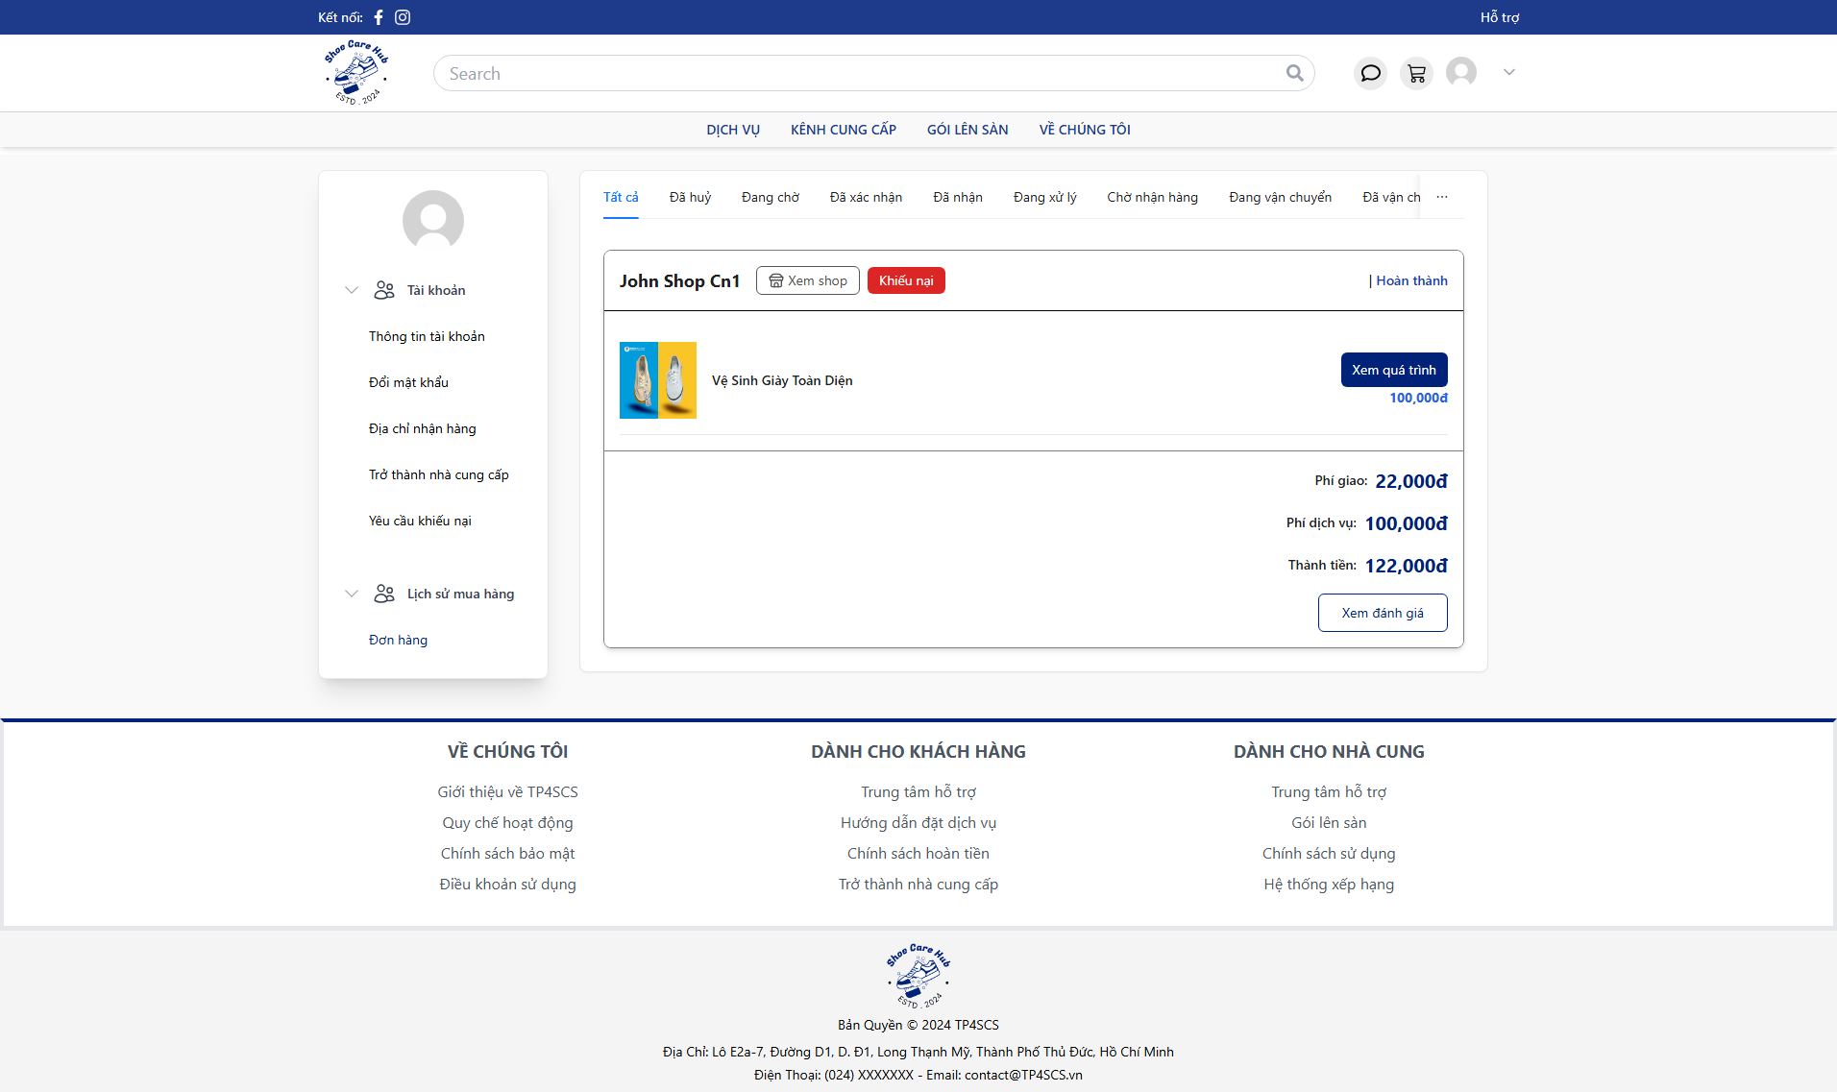
- Click “Xem đánh giá” to view the feedback validate result.
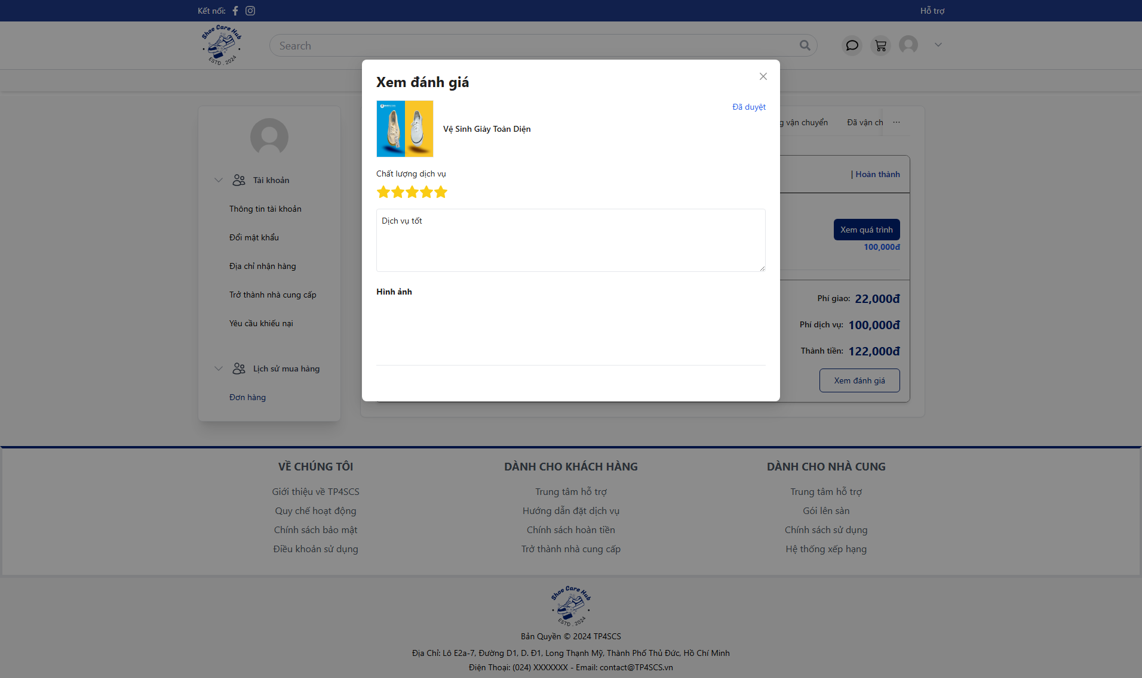

3.5.3 Owner Reply Feedback
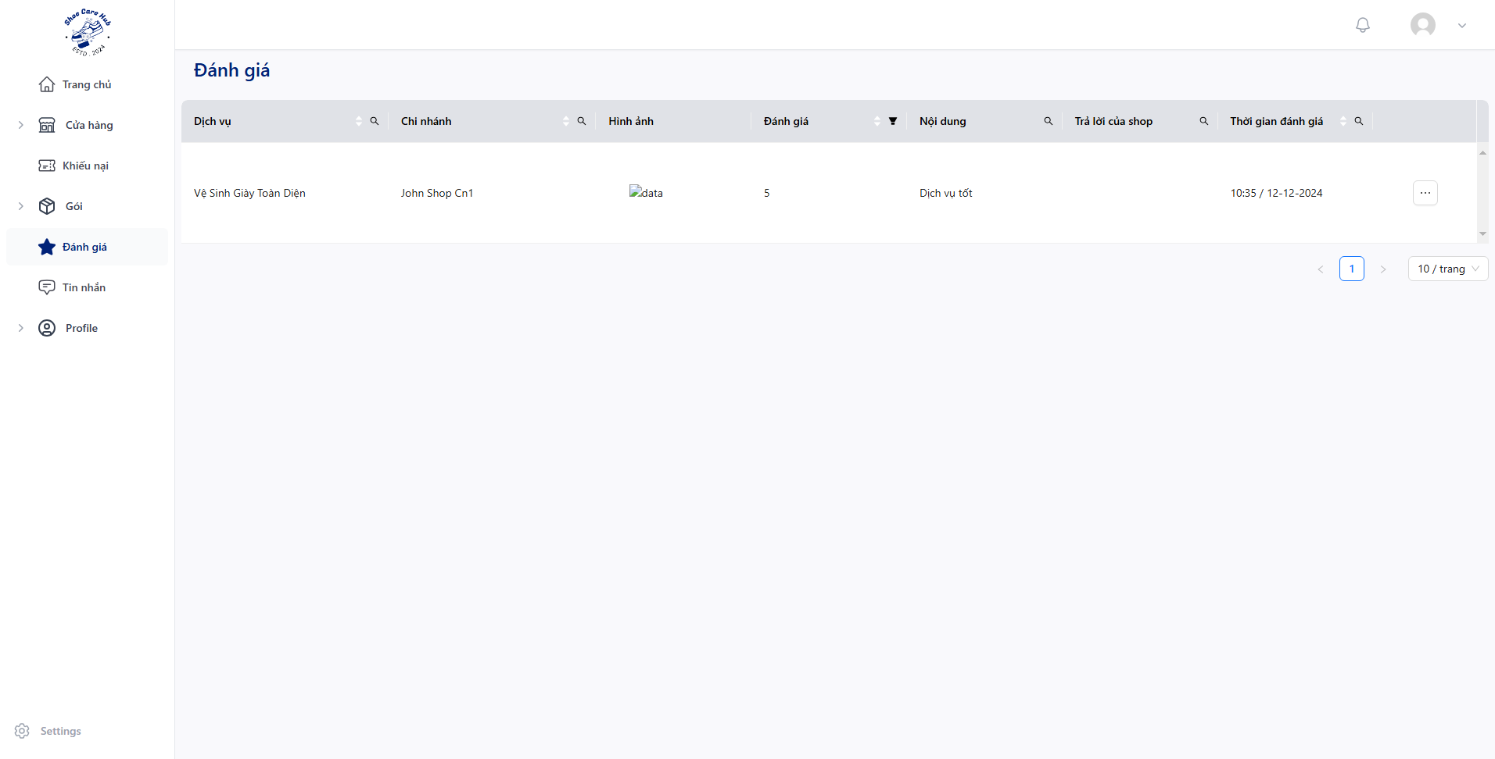
- Click “Đánh giá” to view all business’s feedback and click “” then choose “Chi tiết”.
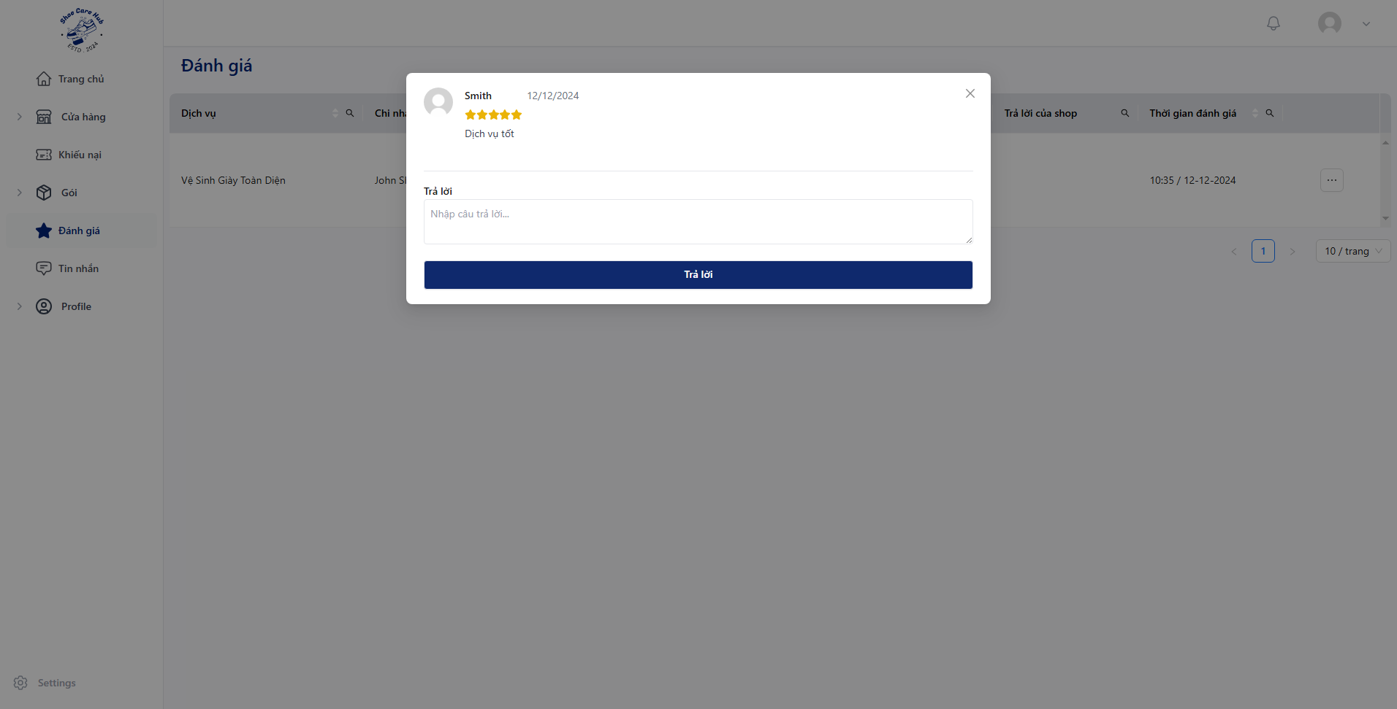
- Fill reply content then click “Trả lời”.

